2023 U.S. 50-State National Seismic Hazard Model - Overview Version 1.1
(May 1, 2023)

This paper has been modified from Version 1.0 (Steering Committee review). At the public workshop, results from Version 2.0 will be shown.

Mark D. Petersen, M.EERI¹, Peter M. Powers, M.EERI ¹, Allison M. Shumway¹, Edward H. Field, M.EERI¹, Morgan P. Moschetti, M.EERI¹, Kishor S. Jaiswal, M.EERI¹, Kevin Milner², Sanaz Rezaeian¹, Art Frankel, M.EERI³, Andrea Llenos¹, Andy Michael⁴, Jason Altekruse¹, Sean Ahdi¹, Kyle Withers¹, Charles Mueller¹, Yuehua Zeng¹, Leah Salditch¹, Nico Luco¹, Ken Rukstales¹, Julie Herrick¹, Demi Girot¹

Brad Aagaard¹, Adrian Bender⁵, Mike Blanpied⁶, Rich Briggs¹, Oliver Boyd, M.EERI¹, Rob Chase¹, Brandon Clayton¹, Chris DuRoss¹, Eileen Evans⁷, Peter Haeussler⁵, Alex Hatem¹, Kirstie Haynie¹, Elizabeth Hearn⁸, Kaj Johnson⁹, Zach Kortum¹, Simon Kwong¹, Andrew Makdisi¹, Ben Mason, M.EERI¹⁰, Dan McNamara¹¹, Devin McPhillips¹², Paul Okubo¹³, Morgan Page¹², Fred Pollitz⁴, Justin Rubenstein⁴, Bruce Shaw¹⁴, Zheng-Kang Shen¹⁵, Brian Shiro¹, James Smith, Bill Stephenson¹, Eric Thompson¹, Jessie Thompson Jobe¹, Erin Wirth³, and Rob Witter⁵

¹ U.S. Geological Survey, Geologic Hazards Science Center, Golden, CO, USA
² University of Southern California, Los Angeles, CA, USA
³ U.S. Geological Survey, Earthquake Science Center, Seattle, WA, USA
⁴ U.S. Geological Survey, Earthquake Science Center, Moffett Field, CA, USA
⁵ U.S. Geological Survey, Anchorage, AK, USA
⁶ U.S. Geological Survey, Reston, VA, USA
⁷ California State University, Northridge, Northridge, CA, USA
⁸ National Science Foundation, Portola Valley, CA, USA
⁹ Indiana University, Bloomington, IN, USA
¹⁰ Oregon State University, Corvallis, OR, USA
¹¹ Daniel McNamara Consulting, CA, USA
¹² U.S. Geological Survey, Earthquake Science Center, Pasadena, CA, USA
¹³ U.S. Geological Survey, Hawaiian Volcano Observatory, Hilo, HI, USA
¹⁴ Lamont-Doherty Earth Observatory, Palisades, NY, USA
¹⁵ University of California, Los Angeles, Los Angeles, CA, USA

ABSTRACT

The U.S. National Seismic Hazard Model for public policy applications is updated for all 50 states using the best science on earthquake seismicity, fault ruptures, ground motions, and hazard estimation. Best available or applicable science is defined as science that is based on mature, published models that are acceptable to the science community. This evaluation informs model weights based on newly available observations, expert opinions, and acceptance from external review panelists and developers. The hazard assessment applies new earthquake catalogs, decluster algorithms, gridded seismicity models, magnitude-scaling equations, fault-based structural and deformation models, multi-fault earthquake rupture forecast models, semi-empirical and simulation-based ground motion models, and site amplification models conditioned on VS30 and sedimentary depth. Resulting calculations yield hazard curves, hazard maps, uniform hazard spectra, and disaggregations which are developed for spectral accelerations with 23 oscillator periods and peak parameters and 8 site classes that are now required by the 2020 NEHRP Recommended Seismic Provisions and applied in standard public policy risk assessments. The models are tested using historical information and provide insights into epistemic uncertainties and aleatory variability that are used to assess the range of reasonable inputs and outputs. Several impact products including building design criteria, MMI intensity, ground motion scenarios, and engineering risk assessments show the potential physical and social impacts and important building provisions for assessing, planning, and mitigating the effects of future earthquakes across the U.S.

KEYWORDS

National Seismic Hazard Model, earthquake rupture-forecast, ground motion model, seismic hazard maps

INTRODUCTION

A recent joint study led by the U.S. Geological Survey (USGS) and Federal Emergency Management Agency (FEMA) forecasted a direct economic loss of $14.7 billion per year from ground shaking-related damage to buildings (Jaiswal et al., 2023). The high projected rates of earthquakes and associated economic risk as well as public safety implications from adverse earthquake effects are concerning and focused across several states of the U.S. that contain or are near active faults, areas of increased seismicity, and volcanic activity. Earthquakes are a national problem. Since the beginning of the last century, potentially damaging earthquakes have been observed across more than half of the U.S. states and territories (Figure 1, shaded states which have experienced M5+ earthquakes, historic large damaging earthquakes, and input information included in the 2023 hazard model). To assist in mitigating the effects of earthquakes, probabilistic earthquake ground motion hazard models described in this paper specify the locations, sizes, and rates of potential future earthquakes in the 50 U.S. states as well as the strength of ground motions caused by these events. This information is essential for guiding earthquake resistant building codes and other public-policy and industry-based planning tools that steer construction of buildings, highways, bridges, railroads, dams, and pipelines and can provide insights into design of critical structures, insurance rates, governmental disaster management documents, state-wide and local seismic safety plans, and many other important applications. Seismic hazard products can save lives through application of adequate life-safety based building codes, assist the public in identifying, preparing for, and mitigating against economic and infrastructure losses, and support resilient community development through effective disaster management and seismic safety planning.

For the past five decades important loss mitigation and risk evaluation tools have applied the USGS U.S. National Seismic Hazard Models (NSHMs) in assessing earthquake locations, rates, and effects for the conterminous U.S (CONUS) separated into central and eastern U.S. (CEUS) and western U.S. (WUS) regions, Alaska, and Hawaii. The NSHMs are developed and revised periodically to reflect newly published earthquake science that improves regular updates of building code seismic provisions and other policy and industry applications (e.g., Algermissen et al., 1976, Frankel et al., 1996, 2002, and Petersen et al., 1996, 2008, 2014, 2015, 2020, 2021 for CONUS; Powers et al., 2023 and Wesson et al., 2007 for Alaska; and Klein et al. 2001 and Petersen et al. 2022 for Hawaii). In addition, the NSHMs are calculated for territories of the U.S. (Mueller et al., 2010, Mueller et al., 2012, Petersen et al., 2012) that also face significant risk from earthquakes and will be revised following this 50-state update. One-year earthquake forecasts for natural and induced earthquakes in the CEUS account for industrial injection and hydrofracturing based earthquakes which are not included in these policy-based models (Petersen et al., 2015, 2016, 2017, 2018). The NSHMs are constructed using time-independent probabilistic methodologies (Baker et al., 2021; Cornell, 1968), incorporating best available/applicable earthquake science while concentrating on data and techniques that have become available more recently. Over time, hazard models have grown in complexity as our physical understanding of earthquakes and related strong ground motion evolves and as we assess innovative ways of making the probabilistic hazard information more accurate and useful. This complexity in the hazard models leads to both beneficial consequences by allowing more comprehensive inventories of earthquake data, models, science-based methods, but also resulting in complicated and sometimes non-uniform modeling and extensive computations for the hundreds of thousands of sites. The models are developed for spectral accelerations with 23 ground-motion intensity measures, and 8 site conditions (Shumway et al., 2021). Earth processes are complex and earthquakes are very difficult to forecast over short times, therefore, our analysis focuses on time-independent long-term forecasts (50 years) that can be useful for assessing long-term consequences, risk, and mitigation strategies.

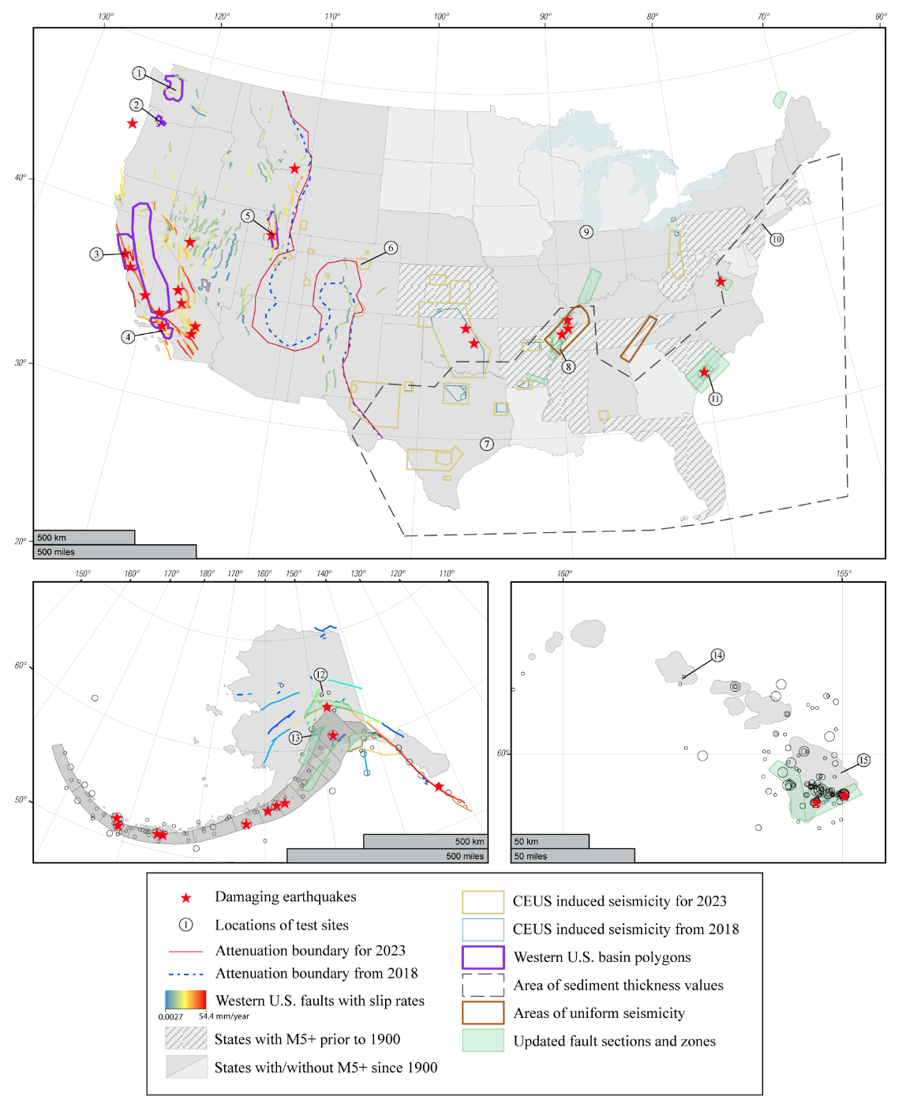
Figure 1. Maps show geologic inputs and spatial constraints for the 2023 50-State National Seismic Hazard Model. Spatial boundaries include potentially induced earthquakes for the update and the previous 2018 zones, CEUS–WUS attenuation update and 2018 boundary, western U.S. basins, and two areas of uniform seismicity. Fault sections for the western U.S. (Hatem et al., 2022a,b) and for Alaska from Bender et al. (2021) are shown shaded according to slip rates. The Alaska megathrust is represented by 14 segmented zones. Earthquake epicenters represent M7+ from the published catalog for Alaska and M5+ for Hawaii (Rukstales et al., 2021; and Powers et al., 2023b, Petersen et al., 2021). Fifteen sites chosen for sensitivity and scenario testing (including disaggregation and uncertainty) are called out sequentially: (1) Seattle, WA; (2) Portland, OR; (3) San Francisco and (4) Los Angeles, CA (5) Salt Lake City, UT; (6) Denver, CO; (7) Houston, TX; (8) Memphis, TN; (9) Chicago, IL; (10) New York, NY; (11) Charleston, SC; (12) Fairbanks and (13) Anchorage, AK; and (14) Honolulu and (15) Hilo, HI.

Earthquake activity across the country is quite variable with some regions clearly at higher seismic hazard than others. More than half of the United States (27 states and four territories shaded in Fig. 1) experienced potentially damaging earthquakes (magnitude (M)5+) since 1900 according to the Advanced National Seismic System Comprehensive Earthquake Catalog (ComCat, 2022); additional states have historic records or paleoseismic evidence of past moderate to large earthquakes which is depicted with hatched lines (e.g., 1755 Cape Ann event in Massachusetts). Figure 1 highlights several selected large (described below) or significant earthquakes that have occurred over the past few hundred years across the U.S. The largest earthquakes in the U.S. are produced from plate convergence in subduction processes along the Pacific Northwest Cascadia Subduction Zone (M~9 1700 [offshore WA, OR, CA]) and Alaska-Aleutian Arc (M9.2 1964; M8.7 1965; M8.6 1946 and 1957; M8.3 1906; M8.2 1938 and 2021 and M8.0 1949, 1985, 1986, and 1995). Large damaging earthquakes are also produced along major plate boundary transform (strike-slip) faults spread mostly across California (M7.9 1857 [Fort Tejon]; M6.8 1868 [Hayward]; M7.4 1872 [Owen’s Valley]; M7.9 1906 [San Francisco]; M6.9 1989 [Loma Prieta]; M7.3 1992 [Landers]; M7.1 1999 [Hector Mine]; M7.1 2019 [Ridgecrest]) and Alaska (M7.9 2002 [Denali]); reverse and strike-slip faults in California (M7.5 1952 [Kern County]; M6.7 1994 [Northridge]); normal and strike-slip Basin and Range earthquakes (M6.9 1915 [Pleasant Valley, NV]; M7.3 1932 [Cedar Mountain, NV]; M7.2 1959 [Hebgen Lake, MT]; M7.3 1954 [Fairview Peak, NV]; M6.9 1954 [Dixie Valley, NV]; M6.9 1983 [Borah Peak, ID]); and along ancient re-activated tectonic margins in the CEUS, including three events near New Madrid, Missouri (M~7.3–8.0 1811–1812) and an earthquake near Charleston, South Carolina (M~7 1886). Geologic evidence of large prehistoric earthquakes has also been identified at sites across the United States, including large fault offsets and pre-historic evidence of damaging earthquakes along the San Andreas fault, Cascadia Subduction Zone, Wasatch fault, and Central Nevada Seismic Zone, as well as from liquefaction features dispersed across the central and northeastern parts of the country. The Island of Hawai’i has also experienced large, damaging volcanic earthquakes (M7.9 1868; M7.7 1975; and M6.9 2018). The territories of the United States have experienced large and damaging earthquakes (Mueller et al., 2010; Mueller et al., 2012; Petersen et al. 2012) in Puerto Rico (M7.7 1943; and M6.4 2020), near Guam (M7.8 1993), and a tsunamigenic earthquake affecting American Samoa (M8.1 2009).

Along with the large earthquakes on plate boundaries that can result in widespread damage and severe effects, many moderate to larger sized earthquakes (4.0 ≤ M ≤ 7.0) have ruptured along known or previously unidentified faults across the U.S. and these events can cause more localized damage (Figure 2). For example, over the past few decades parts of the country that historically have not been as seismically active experienced M5+ damaging natural earthquakes (e.g., 2011 M5.8 Mineral, VA and 2022 M5.7 Magna UT) and induced earthquakes triggered by manmade activities (e.g., 2011 M5.7 Prague, OK and 2016 M5.8 Pawnee, OK earthquakes). The time scale bar charts in Figure 1 show the highest numbers of M3+ earthquakes in Alaska which appear to increase with time but are thought to be an artifact caused by the increased number of deployed seismographs allowing for additional earthquake recordings and are not associated with any underlying physical changes. The Alaska seismicity reflects earthquakes on major subduction interface, intraslab, shallow crustal faults, and volcanic activity. The Island of Hawai’i has recently seen high earthquake counts, mostly correlated with volcanic eruptions of Kilauea and Mauna Loa. WUS earthquakes continue with persistently high numbers that fluctuate in time due to aftershocks following large earthquakes. CEUS earthquake activity is generally lower than other regions, but rates significantly increased over the past decade due to thousands of induced earthquakes triggered by industrial fluid injection of wastewater in the central portion of the country. This seismic activity has subsided in many areas over the past few years due to mitigation efforts, but seismicity remains higher than normal in Oklahoma, Kansas, and the Permian Basin of Texas. We produced three 1-year forecasts that account for increased induced activity in the CEUS (Petersen et al., 2015, 2016, 2017) and will plan to update these if rates change. For this 2023 NSHM, we updated the induced seismicity spatial zones that encompass the known induced seismicity with assistance from state geological surveys (Rubinstein et al., 2023).

To develop this 2023 NSHM, we apply relevant input data, models, and methods related to the earthquake hazard assessment: (1) earthquake rupture forecast (ERF) information and (2) ground motion models (GMMs). This seismic hazard assessment considers the following new input models as well as their sensitivities and impacts: (1) seismicity-based earthquake sources based on new catalogs compiled with alternative new declustering algorithms and gridded seismicity assessments (Llenos and Michael, 2023; Petersen et al. 2023; Powers et al., 2023) and induced seismicity identification for CEUS (Rubinstein, 2023), (2) fault-based deformation models that include abundant new geologic (Hatem et al., 2022a,b) and joint geologic and geodetic inversion information (Pollitz et al., 2022, Powers et al., 2023), (3) new magnitude-scaling equations that provide estimates of sizes of earthquakes for shallow crustal, deep crustal, subduction, and stable continental environments (Shaw, 2023), (4) new Uniform California Earthquake Rupture Forecasts (UCERF) that were extended to the WUS region by synthesizing deformation, scaling equations, and many other fault rupture mechanics and physics-based constraints into a suite of new alternative inversion-based earthquake rate models (Field et al., 2023) and new traditional rate models for the CEUS (Field et al., 2023), Alaska (Powers et al., 2023), and Hawaii (Petersen et al., 2023), (5) new semi-empirical ground motion information including new NGA-Subduction GMMs (Bozorgnia et al. 2022; Rezaeian et al., 2023) and revisions to the stable continental and active crustal GMMs (Moschetti et al., 2023), (6) new computer simulations of earthquake motions that consider 3D waveforms within the Seattle and Los Angeles 3D velocity models for assessing effects of important fault ruptures that have not been observed (Frankel et al., 2018, Moschetti et al., 2023); and (7) basin-depth amplification models for the San Francisco Bay area, greater Los Angeles region, Central Valley, Reno, and Portland/Tualatin regions, and amplification models that account for soil/rock site conditions and sediment thickness in the Atlantic and Gulf Coastal Plains (Ahdi et al., 2023; Boyd et al., 2023; Moschetti et al., 2023).

An example seismic hazard map developed as part of this study is shown in Figure 3 that is based on Modified Mercalli Intensity (MMI, a macroseismic measure of earthquake effects and damage). The probabilistic seismic hazard and risk is quite variable across the U.S. Earthquake hazard is high along West Coast population centers due to potential of earthquakes associated with the Cascadia Subduction Zone and San Andreas Fault System earthquakes, across the densely populated Wasatch Front and up through the Teton/Yellowstone region, within the central Nevada seismic belt, near the New Madrid Seismic Zone and Charleston Seismic Zone, Aleutian Island chain of Alaska, and across the southern island of Hawai’i. Moderately high hazard and risk is found across many of the WUS states, central islands of the Hawaiian chain, central Alaska, and areas of preexisting faulting across CEUS. Lower hazard and numbers of earthquakes are observed across northern and central portions of the Midwest and southern regions of the country.

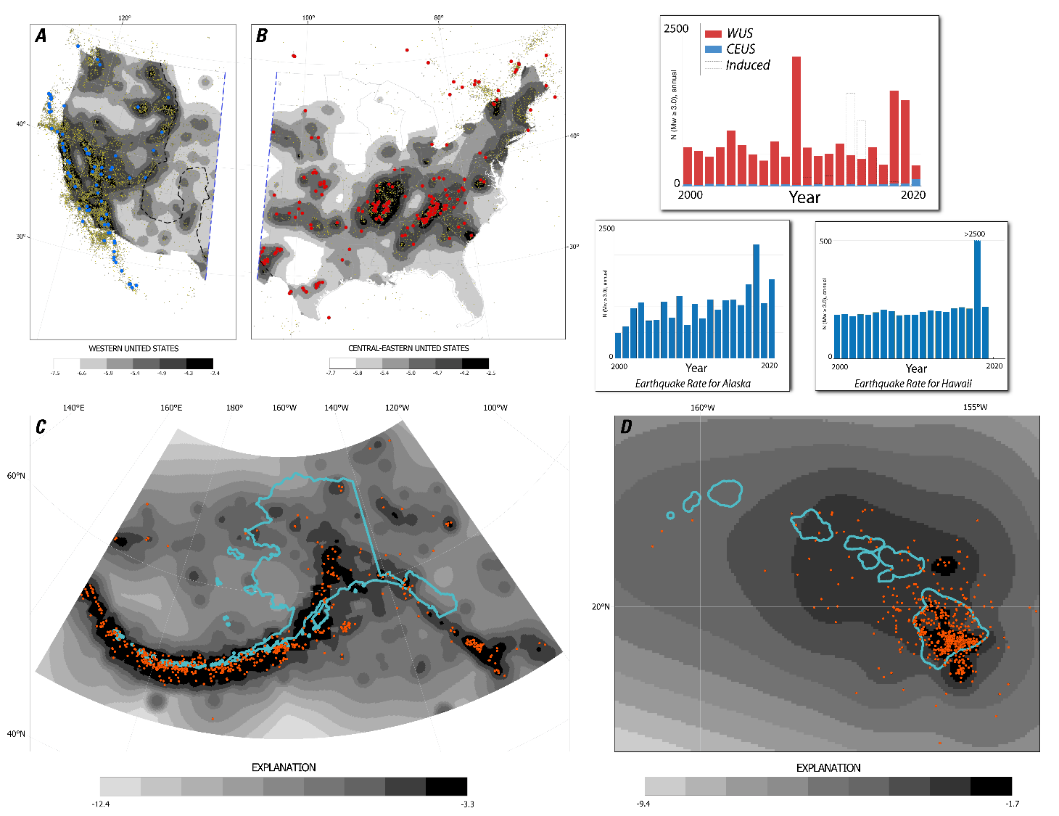

Figure 2. Normalized probability density function (PDF) grids of earthquake rate are displayed for (a) the western United States (WUS), (b) the central and eastern United States (CEUS), (c) Alaska, and (d) Hawaii. For (a) and (b), values were weighted equally across the three declustering methods and 0.5/0.5 for fixed/adaptive smoothing for CONUS and 1.0 for adaptive smoothing for Alaska and Hawaii; five log bins with natural breaks. Seismicity shown since May 2019 magnitude 4 and greater in the WUS (blue circles); magnitude 2.7 and greater in the CEUS (red circles); and the full catalog shown with yellow circles. The boundary between models used for the eastern and western parts of the United States is shown with a blue dashed line. The updated attenuation boundary is shown with a black dashed line. Averaged and normalized grids for Alaska (c) show the three layers (crustal, interface, and slab) based on equal weights across the three declustering methods with 100% adaptive smoothing: nine bins with natural breaks. Seismicity since May 2019 with magnitude 4 and greater is shown as red circles. (d) Normalized and averaged grids of shallow seismicity for Hawaii showing the nearest neighbor declustering with 100% adaptive smoothing for the three grid regions (northern, southern, and summit); seven bins with natural breaks; magnitude 4 and greater events shown as red circles; state boundary in blue. Inset plots of time-history represent induced seismicity from the 27 zones identified in this study, western U.S. (WUS), and central and eastern U.S (CEUS); plots of total seismicity are included for Alaska and Hawaii.

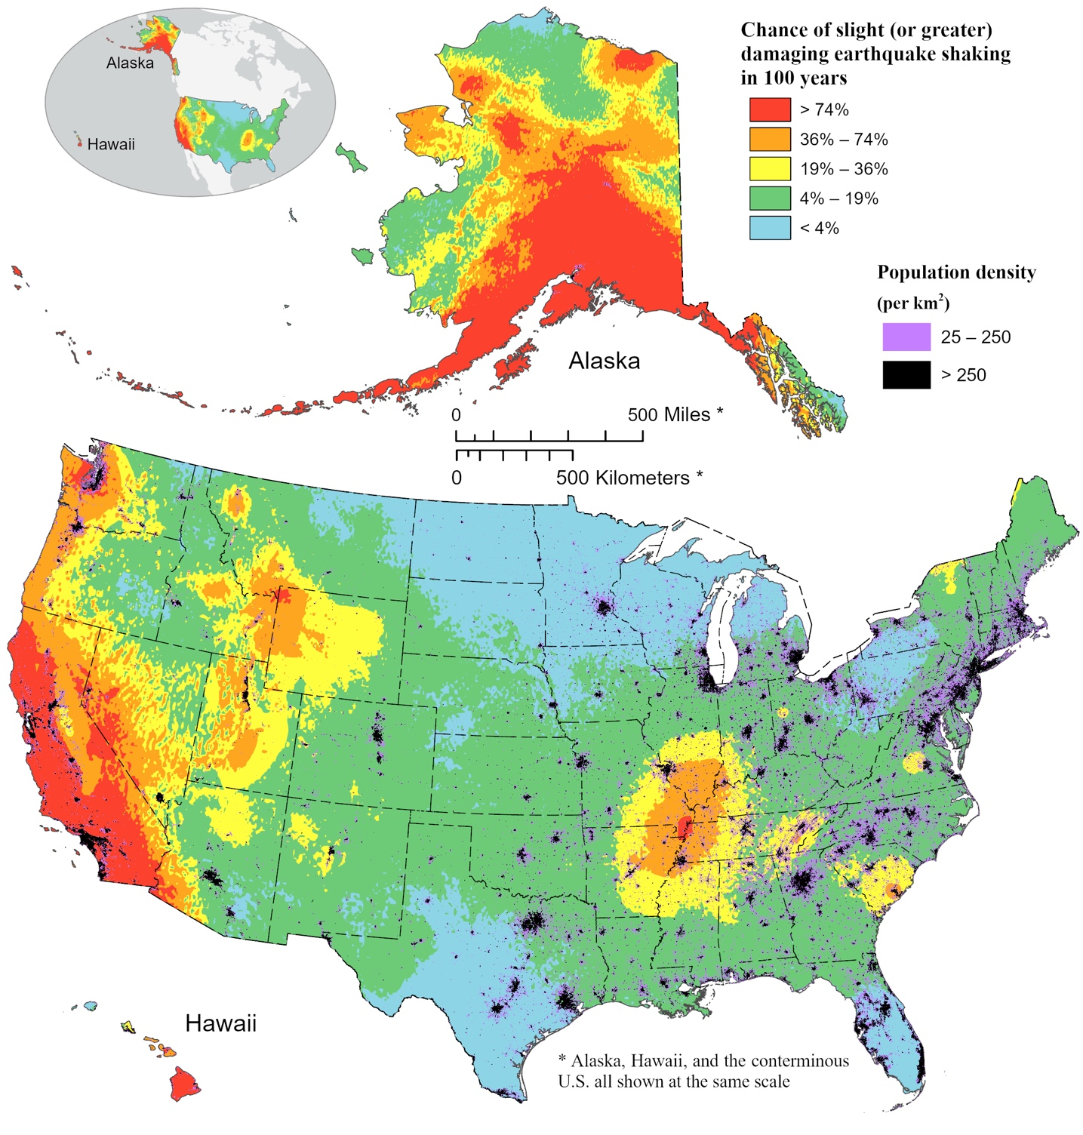

Figure 3. Map showing the chance of any level of damaging earthquake shaking in 100 years from the 2023 NSHM for the U.S. The shaking is equivalent to Modified Mercalli Intensity VI and higher and is based on the average peak ground acceleration and 1s horizontal spectral response acceleration (using Worden et al. 2012 model without uncertainty). Ground motions are amplified using a hybrid V_{S30} estimates (Heath et al. 2020). Population density (from LandScan (2021) with 1 km×1 km resolution from ORNL) is superimposed on the map.

This overview paper is written for a variety of audiences and the scope is broader than in many papers. The introduction was written for the public who are interested in why we calculate seismic hazard, where damaging earthquakes occur, the types of data that are used to assess hazard, the intensity measures of hazard, and a description of how we can mitigate the effects of future events and how the products can be used. The earthquake rupture forecast and ground motion model sections are quite technical and written for scientists and engineers who want to understand broad issues with input models - pointing to other companion papers for details, how models are derived and evaluated, and the basis for weighting models based on best available science criteria. The results section is written for the users of 2023 NSHMs with descriptions of where, why, and how the hazard has changed. The discussion section describes issues that the review committees and scientists tackled including: evaluation of best available science, descriptions of the sensitivities and issues in input models, and assessments of variability/uncertainties, and description of policy and research models that can be applied for various engineering purposes. The references are extensive and will be useful for anyone needing more detailed information than that provided in this overview paper.

The objectives and scope of this 2023 NSHM overview paper are to describe new input data and methods based on the best available science, robust compilations and processing of input data, probabilistic hazard analyses that includes extensive evaluations of reasonable ranges of input models with weighting considerations, reasons for changes in ground motion hazard since the previous update, and seismic hazard models which are based on the expected frequency of exceeding a set of ground motion thresholds for a dense grid of hundreds of thousands of sites that cover all 50-states. To accomplish these objectives, we apply the best available data, models, and methods to inform earthquake rupture forecasts (see Field et al., 2023) and GMMs (see Moschetti et al., 2023 and Rezaeian et al., 2023); convene experts across the country to ensure that the best science findings are being applied, and construct probabilistic hazard curves and derivative products showing earthquake impacts for a variety of intensity types and user-defined outputs. One of the biggest challenges of this 2023 NSHM is to better define the best available or applicable science, which is probably not cutting edge science but is more mature and accepted through peer review and implementation in other hazard and risk models. The ERF review panel suggests the following elements: relevance, inclusiveness, objectivity, transparency and openness, timeliness, and peer review; in their report objectivity is replaced with verification and validation.

Available or applicable science is defined here as science that is based on mature and acceptable science-based models for estimating earthquake rates and ground shaking, supplements and fixes to previous models that are thought to be somewhat inadequate or incomplete, or information that is published in peer-reviewed journals or in this and accompanying articles that have gone through an intensive evaluation and review process. An evaluation of the best available science leads to model weights based on newly available observations, expert opinions, stability issues, acceptability criteria that guide retirement of previous models and acceptance of new models, and evaluations from external review panels. This version of the NSHM is meant for seismic policy applications and only applies the best science that is mature, vetted, and accepted to a reasonable level by our project members and review committees. Applications of this policy model could involve several alternative use-cases including building code, FEMA risk, disaster management, seismic safety applications and for setting insurance rate structures and other industrial based purposes. We plan to follow this policy-based study with research models (see discussion section) that explore additional input parameters and models that were not considered in previous NSHMs so that end-users can evaluate impacts and explore implementation in future policy models and products. Science-based input models included in this update are developed with more uniform applications and with the goal of assessing and incorporating comprehensive and defensible representations of epistemic uncertainty (lack of knowledge that is reducible through additional studies or inclusion of unmodeled parameters) and aleatory variability (intrinsic randomness in the earthquake process). Resulting hazard calculations are tested using historical shaking data and used to produce a variety of products (e.g., ground motion hazard maps, hazard curves, disaggregations, scenario-based earthquake impact assessments, and other products discussed herein). To confirm the models are based on the current best science and the products are useful, the resulting NSHM is evaluated extensively by the science and engineering communities: hundreds of science experts who participate in regional and topical workshops, several dozens of members of four ad-hoc review committees listed in the footnotes who analyze details of input parameters and component models, and our NSHM Steering Committee consisting of nine renowned seismic hazard experts —who review inputs and outputs of models, recommend model improvements, promote comprehensive uncertainty assessments and robust testing of the model, and advocate for improved science directions.

To foster evaluation and feedback of the NSHM from its broad user base, we hosted a user needs workshop in June 2021 with participation from leaders in industry, academia, government, and insurance industry. We had two primary motivations for hosting the workshop: to inform near-term modeling decisions for the 2023 NSHM update, and to enfranchise a larger user base that will employ the NSHM more expansively in the longer term. To accomplish the workshop goals, we discussed five important subtopics: (1) uncertainty quantification, (2) short-return-period ground motions, (3) scenarios and impact products, (4) alternative intensity measures, and (5) site-specific and nonergodic ground motions (Mason et al., 2023). In this paper we include descriptions of engineering impacts to help users understand the consequences of this strong shaking and describe strategies for assessing weights for alternative models and discussions of future directions and improvements. The weights are discussed separately in each section below. These models will continue to be revised during the review process until the final model is developed.

OVERVIEW OF METHODOLOGY

For assessing the probabilistic hazard (Baker et al., 2022), we develop gridded seismicity (Fig. 2) and fault rupture rate models (Fig. 1) that define the locations and sizes of potential future earthquakes considered in the NSHM and ground motion models that define the shaking levels for various oscillator periods and site classes at hundreds of thousands of sites across the 50-state region. The highest hazard areas in this update are concentrated in places where large damaging earthquakes have or are thought to have occurred in historic and prehistoric times as discerned through historic intensity recordings and geologic fault studies or where historic seismicity is focused and persistent. Nevertheless, seismic hazard can also be significant in places where earthquakes are less frequent, and these are areas where seismicity models are important components of the total hazard model.

We develop seismicity rates across the United States by applying the assumption that future damaging earthquakes are more likely to occur along faults with late Quaternary or Holocene activity and near areas with higher seismic activity in the past and infer that earthquakes will follow a Gutenberg and Richter (GR; Gutenberg and Richter, 1944) exponential magnitude frequency distribution (MFD) truncated at a maximum magnitude (Mmax) based on the physics based consideration of fault area or global analogs. The gridded seismicity model accounts for moderate- or large-sized earthquakes across the United States in places where fault sources have not been identified or where faults are known but details of the science on forecasting earthquake rates are not available or sufficient for this purpose. The fault rupture model accounts for potential locations, rates, and sizes of future earthquakes on mapped faults (Field et al., 2023) and considers both GR, characteristic (Schwartz and Coppersmith, 1984), fault-section-based MFDs that are based on multi-fault ruptures, and floating ruptures that consider a certain size of earthquake rupture anywhere along the fault. Figure 1 shows locations of faults included in the model (Hatem et al., 2022a,b). For evaluating the ERF, we analyze deformation rates on faults, size distributions of potential earthquakes, and forecasted rates of future earthquakes. Deformation models were constructed and run using geologic and geodetic deformation studies and geologic slip rate studies (Hatem et al., 2022a,b; Pollitz et al., 2022), and a collection of moment magnitudes (M) of potential earthquakes based on empirical rupture areas and physics-based energy constraints (Shaw, 2023).

The new WUS fault database contains about 1000 fault sections and slip rates based on both geologic and geodetic interpretations, an increase of about 350 faults compared to the previous NSHM. These slip rates are used to inform earthquake rate models composed of (1) classic or prescriptive model — this model was applied in most previous versions of the NSHMs and prescriptively assesses earthquake rates based on fault slip rates using combinations of GR and characteristic MFDs, expert opinion of fault ruptures, and floating earthquakes that account for multi-segment ruptures (Frankel et al., 1996, 2002; Petersen et al., 1996, 2008, 2014, 2015, 2020), and (2) the UCERF-type generalized simulated annealing inversion model initially developed for California (Field et al., 2009 and 2013) but which is extended across the WUS for 2023 (Milner et al., 2022). This model constrains the overall rate of earthquakes, allows for multiple GR a- and b-values, Coulomb stress analysis, and connects sections of sub-parallel faults to arrive at the most likely spatial and temporal distributions of earthquake ruptures. We account for alternative ERFs to populate logic trees that are applied for assessing uncertainty in the NSHM ground motions.

Semi-empirical GMMs account for probabilistic distributions of shaking levels using empirical ground motion recordings from past earthquakes, 3D computer simulations of large earthquakes, and amplification models that are conditioned on the characteristics of the rock/soils beneath the site (e.g., V_{S30} is the time-averaged velocity in the upper 30 m, Z_{1.0} is the depth to the 1.0 km/s shear wave velocity, and Z_{2.5} is the depth to the 2.5 km/s shear wave velocity horizon). We use community velocity models to estimate the velocities applied in the amplification models. These datasets and methodologies form the basis of this hazard analysis. The 2023 NSHM uses empirical GMMs, 3D simulations for Seattle and Los Angeles, sedimentary thickness-based amplification models for the CEUS (Gulf and Atlantic Coastal plains) and WUS (Seattle, Portland/Tualatin, San Francisco/California Central Valley, Los Angeles), and a revised CEUS-WUS attenuation boundary. Details of these models, implementations, and sensitivity studies are found in (Rezaeian et al., 2023) for subduction zone GMMs, and in Moschetti et al. (2023) for the remaining GMMs in WUS and CEUS. Moschetti et al. (2023) also provides details on sediment-thickness- and seismic-velocity-based amplification models and 3D numerical simulations of large ruptures. Details of GMMs for Alaska and Hawaii NSHMs are provided in Powers et al. (2023a) and Petersen et al. (2023), respectively. Selected GMMs for all regions and their assigned weights are summarized in Table 2 and are based on the revised GMM selection criteria published in Rezaeian et al. (2021). The weight assignments, as in previous cycles of NSHM, are based on a consensus building process that involves consideration of expert opinions, data residual analyses, and a thorough review of each model’s characteristics such as magnitude and distance scaling and limitations such as applicability ranges of the model parameters.

EARTHQUAKE RUPTURE FORECAST (ERF) MODELS AND WEIGHTS

Details of the input models and forecasts for CONUS, Alaska, and Hawaii are described in Field et al. (2023), Powers et al. (2023), and Petersen et al. (2021), respectively. In this section we discuss model issues, sensitivity, weighting schemes, and hazard results. The input ERF component models include: the earthquake catalog, declustering models, spatial smoothing applications, fault models (geologic and geodetic), magnitude-scaling equations, Mmax assessments, and earthquake rate models for all 50 states.

An ERF, also referred to as a seismic source characterization in some studies, gives a complete list of potentially damaging fault ruptures in a region and over a specified timespan (and/or suites of synthetic earthquake catalogs, especially for fully time-dependent models). This section summarizes the time-independent ERFs developed for the 2023 NSHM, restricting attention here to changes that are new and innovative and/or consequential with respect to implied hazard. The ERFs presented here represent updates to those utilized in the 2018 NSHM (Petersen et al., 2020), which largely utilized unmodified ERF components from the 2014 NSHM (Petersen et al., 2014, 2015).

The Field et al. (2023) also describes a number of broader goals with respect to ERF developments, including 1) a more comprehensive representation of epistemic uncertainties; 2) increased uniformity in model assumptions and methodologies across regions (involving de-regionalization of model component developments), 3) simplification wherever it can be achieved without degrading model usefulness; 4) more operationalization of model component creation; 5) model extensibility with respect to adding time dependencies (including spatiotemporal clustering, swarms, and induced seismicity); 6) utilizing more physics to make up for sparse data at larger magnitudes; and 7) and providing more complete documentation to minimize the need to comb through previous publications when learning about or reproducing models. All these goals, which will be a perpetual work in progress, are aimed at improving the rate and efficiency with which future model improvements can be rolled out nationwide. A related goal is to deploy a “research model” ERF to enable more continuous explorations of potential model improvements, from which versions could be time stamped for specific official uses.

ERF development is a system-level problem that uses constraints from a broad range of disciplines (e.g., earthquake geology, tectonic geodesy, statistical seismology, and earthquake physics). As such, a modular design is critical to keep things manageable and to enable different groups of scientists to focus within their respective areas of expertise. Field et al. (2023) summarizes the various components presently defined and utilized, including 1) fault models (defining physical attributes of explicitly modeled faults); 2) deformation models (specifying fault slip rates as constrained by geology and perhaps geodetic modeling, and in some cases the latter also provide “off fault” deformation rates); 3) earthquake rate models (specifying the long-term rate of each earthquake rupture); and 4) probability models, which specify conditional probabilities based on elastic rebound, spatiotemporal clustering, swarms, and induced events. Given the general time-independent nature of NSHMs, the main topic here are the earthquake rate models, which get applied using Poisson probabilities (with some potential exceptions noted below). More time dependencies will be included in future models and publications.

Each earthquake rate model is composed of various types of earthquake sources, which are generally categorized as fault-based (i.e., explicitly modeled faults) versus off-fault or “gridded” seismicity, with measures often being taken to avoid double counting between these two. Fault-based sources are also distinguished by 1) “Classic” fault models, generally applied to individual faults and with prescribed attributes (e.g., the shape of the magnitude-frequency distribution [MFD]); 2) fault-zones sources where a distinct fault surface is not identifiable (also applied with prescribed attributes); and 3) fault-system solutions, which are aimed at acknowledging and including plausible multi-fault ruptures. The latter are generally inversion based, as described below for WUS, but can also be derived from multi-cycle physics-based simulators (as exemplified by Milner et al., 2021). Again, fuller details and more precise definitions are given in Field et al. (2023), whereas here we summarize salient changes. We start with the CONUS-region because it embodies all types of components, and then follow with differences and exceptions reflected in the Hawaii and Alaska ERFs. Each section also discusses epistemic uncertainty representation, treatment of aftershocks, and the review process.

CONUS ERFs

The most consequential updates for the CONUS ERF are the addition of faults, new slip rate constraints, changes in gridded seismicity components, and the inclusion of multi-fault ruptures in WUS. We also expanded the representation of epistemic uncertainties for most components, and we were able to conduct extensive branch sensitivity studies with respect to WUS hazard. The model update relied on a number of component developments, including those represented in the publications listed in Table 1 of Field et al. (2023).

Fault and Deformation Models

Fault model and geologic constraint updates for WUS were provided by Hatem et al. (2022a,b), with about 350 new faults being added (mostly outside California), which were previously excluded due to lack of site-specific geologic slip rate constraints. Hatem et al. (2022a,b) also provided geologic slip-rate estimates at points where site-specific studies are available, and applied default categorical estimates for the faults that lack such explicit constraints.

The five WUS Deformation Models utilized in the 2023 NSHM are described in a special issue of Seismological Research Letters (e.g., see the overview paper by Pollitz et al. (2022)). Again, the main inferences from these models are slip-rate estimates for each fault section in the WUS Fault Model. One model is based almost entirely on geologic constraints (Hatem et al., 2022b), whereas the four others also utilize Global Positioning System (GPS) constraints that were updated by Zeng (2022a). Two of these models represent updates to those utilized in the 2018 NSHM (Zeng (2022b) and Shen and Bird (2022)), both of which generally honor the geologic constraints unless GPS data strongly insist otherwise. The other two models are new; that from Pollitz (2022) effectively permits wider excursions from geologic values, and that from Evans (2022) permits even wider excursions. Further enhancements include corrections for potential viscoelastic effects (the “ghost transients” described by Hearn, 2022), and much more thorough inferences and corrections for fault creep processes (Johnson et al., 2022).

Given the complexity and importance of these models, a special review team (Deformation Review Panel for CONUS¹) was convened to advise on the reliability of each modeling approach (and to suggest logic-tree branch weights). This analysis, led by Kaj Johnson, involved scoring each model based on 15 different metrics. They recommended relatively low branch weights for the two new models, Pollitz (2022) and Evans (2022), due mostly to their having more anomalous slip rates, but also emphasized that these models are nevertheless viable and therefore represent potentially valuable epistemic uncertainty. However, and as discussed in Field et al. (2023), initial hazard calculations revealed that some slip-rate outliers were having a disproportionate and concerning effect on mean hazard, which led to further branch weight reductions for the Pollitz (2022) and Evans (2022) models (weights are shown in Table 1). As noted below, further deformation-model development is one of our highest priorities with respect to future work, especially with respect to better quantification of slip-rate uncertainties and covariance between faults. Another priority research topic is the off-fault deformation estimates provided by some of these models, which were deemed too immature for application (e.g., as a gridded seismicity constraint) at this time.

The fault model and geologic constraints for the CEUS were updated by Thompson Jobe et al. (2022 a,b), including the addition of five new faults (Central Virginia, Saline River, Joyner Ridge, Crowley’s Ridge [South], and Crowley’s Ridge [West]). They also made fault-geometry adjustments to four previously utilized faults (Axial, Bootheel, New Madrid West, and Reelfoot), and added explicit surfaces to five faults previously represented with zones (Commerce, Eastern Margin [north], Eastern Margin [south], Crittenden County, and Meeman-Shelby, the latter of which was previously called River Picks). They also summarize the slip rate or paleo event-rate constraints available for each fault, with the latter typically involving some number of paleo-liquefaction events inferred over some time period. No WUS-style deformation models were developed for CEUS faults, owing mostly to the lack of GPS constraints.

Table 1. Summary of ERF Models (see Field et al. (2023) [CONUS], Powers et al. (2023a) [AK], and Petersen et al. (2021) [HI]).

NSHM | Region | Model | Deformation | Smoothing | Declustering
CONUS | CEUS | Classic Fault, Fault Zone |  | N/A | N/A
 |  | Gridded Seismicity | N/A | Adaptive (0.5), Fixed (0.5) | GK74 (0.333), R85 (0.333), ZB20 (0.334)
 | WUS | Fault System Solution, Classic Fault, Fault Zone | Geologic (0.26), Shen-Bird (0.32), Zeng (0.32), Pollitz (0.08), Evans (0.02) | N/A | N/A
 |  | Gridded Seismicity | N/A | Adaptive (0.5), Fixed (0.5) | GK74 (0.333), R85 (0.333), ZB20 (0.334)
AK | N/A | Classic Fault, Fault Zone |  | N/A | N/A
 |  | Gridded Seismicity | N/A | Adaptive (1.0) | GK74 (0.333), R85 (0.333), ZB20 (0.334)
HI | N/A | Fault Zone
 |  | Gridded Seismicity | N/A | Adaptive (1.0) | R85 (0.5), Z08 (0.5)
 |  | Caldera Collapse | N/A | N/A | N/A

Earthquake Rate Models

WUS Fault System Solutions
The biggest innovation with respect to earthquake rate models is the inclusion of multi-fault ruptures throughout the WUS, made possible by a new inversion-based fault system solution developed by Milner and Field (2023). This builds off the so-called “grand inversion” approach used in UCERF3 (Field et al., 2014; Page et al., 2014), but with significant improvements with respect to computational efficiency, better control with respect to fitting various data constraints, an expanded set of diagnostics and model-evaluation plots, and better reproducibility (our intent is to enable anyone to conduct such calculations themselves). Perhaps most importantly, we added variable segmentation constraints, enabling us to define a much wider range of models with respect to multi-fault ruptures; specifically, we have a “Classic” segmentation branch that is consistent with previous models outside California (where multi-fault ruptures are prohibited), three branches that apply a range of jump-distance based penalties, and an unsegmented branch that applies no penalty for jumps up to 15 km (UCERF3 had one branch that applied no penalty for jumps up to 5 km). Note that the extreme branches are partially a proxy for the Fault Model being incorrect with respect the actual distance between faults (i.e., the classic branch might be most appropriate where jump distances are much larger than implied by the fault model, or the unsegmented branch might be appropriate where an unknown connector fault exists).

Another improvement is the ability to map out a wider range of models via a supra-seismogenic b-value constraint (which sets the slope of a GR distribution at large magnitudes). In UCERF3, inversion solutions were constrained to stay as close as possible to the previous model (UCERF2), which might have been justifiable from a policy perspective (don’t change the model any more than needed to fit the data), but this did limit the range of models considered. In other words, there exists a wider range of models that may fit the data equally well, which represents epistemic uncertainty that should really be accounted for. The supra-seismogenic b-value constraint is our way of doing this, with five discrete branches between values of 0.0 and 1.0, which is effectively a way of adjusting the total rate of events on each fault section; in fact, we do not constrain the entire implied MFD on each fault section in the inversion, but rather we constrain this implied total rate. We do, however, sum the fault-section MFDs to also provide a total regional MFD constraint in the inversion (which we believe is also an improvement over how the total fault MFD target was defined in UCERF3).

This inversion approach starts with the fault model and applies a new plausibility filter (Milner et al., 2022) to define the ruptures that have a non-zero likelihood of occurrence (to reduce an effective infinite number of ruptures to a manageable and representative set, resulting in 580,000 different WUS ruptures here). Figure 9 of Field et al. (2023) shows the implied inter-connectivity among WUS faults (where multi-fault ruptures can occur in the model). The magnitude and average slip for each of these ruptures is computed from one of six scaling relations, the options of which are based on new recommendations from Shaw (2023). The inversion then solves for the rate of each rupture by satisfying the chosen deformation model slip rates, as well as the paleoseismic recurrence intervals updated by McPhillips (2022) for sites in California and those compiled by Valentini et al. (2020) for the Wasatch fault. Because slip rates may be inconsistent with nearby paleoseismic recurrence intervals, we added three paleoseismic data fit branches that adjust how well these data are fit (relative to slip rates), providing a wider range of models than utilized in UCERF3. Fault creep is assumed to reduce rupture area, except for highly creeping faults where it is applied as a slip-rate reduction as well.

In summary, we have five deformation models, six scaling relationships, five target supra-seismogenic b-values, five segmentation models, and three paleoseismic data fit options represented on the logic tree, which amounts to 2250 different inversion-based fault system solutions for WUS. As such, we believe we now have a fully comprehensive representation of the viable range of models, at least with respect to the propensity of multi-fault ruptures (i.e., leaving aside slip-rate uncertainty questions mentioned above and discussed below). A much more detailed summary of inversion-based fault-system solutions is available in Field et al. (2023), including further information on how branch weights were decided and references to other studies we built from, and full implementation details, quantification of data-fit improvements, and various sensitivity analyses are given in Milner and Field (2023).

CEUS Fault Sources
CEUS fault-based sources, described by Shumway et al. (2023), are based on the updated fault models and geologic constraints discussed above (Thompson Jobe et al., 2022 a,b). All are either represented with a fault-zone (area source) or with an explicit fault surface. All these models also adopt the Repeating Large Magnitude Earthquake (RLME) hypothesis introduced by the CEUS SSCn (2012), which assumes that each source produces only a narrow range of magnitudes (or a single-magnitude event in the case of past and present USGS NSHMs). The magnitude of these characteristic events is inferred from a scaling relationship using either fault-surface area, the maximum length of a fault-zone, or the spatial extent of paleoliquifaction deposits. The mean rate of the RLME source is either inferred by moment balancing if a slip-rate estimate is available, or from an observation of N events having occurred in some timespan T (e.g., from paleoliquefaction deposits). While there is no aleatory variability in source magnitude, considerable epistemic uncertainties are accounted for with respect to what the characteristic magnitude is, the recurrence rate implied by the geologic constraints, and sometimes the area assigned to fault-zone sources.

With respect to fault-zone sources, the following changes have occurred since the 2018 NSHM: three have been added in the New Madrid seismic zone (Joiner Ridge, Crowley’s Ridge [south], and Crowley’s Ridge [west]) two were added elsewhere in CEUS (Saline River and Central Virginia), five were converted from zones to explicit fault surfaces, and four were unchanged (Wabash Valley, Charleston, Charlevoix, and Marianna). Only the addition of Saline River and Central Virginia produced a discernable impact on inferred hazard (Shumway et al., 2023a, Field et al., 2023).

There are 12 CEUS faults modeled with an explicit fault surface, none of which is new, none of which has had any changes in source magnitudes or rates, and only one of which is outside the New Madrid seismic zone. The latter, the Meers fault in Oklahoma, had its fault trace extended to the West, which increased computed hazard in that area. The only other consequential modification is with respect to the Axial fault, which was extended to the southwest and produced a computed hazard increase in that area too (again, see Field et al., 2023; Shumway et al., 2023a). Although the other fault-based sources in the New Madrid seismic zone did not undergo any other consequential changes since the 2018 NSHM, it is worth noting that they embody additional complexity with respect to some single and multi-fault ruptures (each of which still honors the RLME assumption) and there are branches that assume ruptures always come as a doublets or triplets. A more extensive summary of these fault-based sources in given in Field et al. (2023) and full details, including logic-tree descriptions for each, are given by Petersen et al. (2014).

Field et al (2023) also describe some improvements that could be made to these models. One is to relax the RLME assumption to acknowledge a wider range of possibilities (i.e., increase aleatory variability in source magnitudes). Another would be to streamline logic trees to a more common, necessary, and sufficient set of branches; current models seem both overly complicated and quite variant between sources, which makes the types of map-based sensitivity analyses we have conducted in WUS virtually impossible. Finally, the interconnected fault system in the New Madrid seismic zone seems like a prime candidate for an inversion-based fault-system solution.

Cascadia Subduction Zone
The Cascadia subduction zone model is essentially a fault-based source with a more sophisticated 3D representation of the subducting interface. Updates relative to the 2018 NSHM, provided by Frankel and Petersen (2023), are based on new paleoseismic constraints and discussions at a virtual workshop in February 2021. These led to the addition of an alternative segmentation model proposed by Goldfinger et al. (2017), which has ruptures extending further north, and swapping out a 2000-year M≥8 recurrence branch with two alternatives (800-year versus 2300-year recurrence) inferred from on-shore data by Nelson et al. (2021). They also added a cluster model where, 10% of the time, a sequence of smaller M8+ ruptures sweep down the subduction zone over a short period of time. Finally, they include an optional time-dependent probability for full subduction-zone ruptures assuming a Brownian Passage Time distribution, a recurrence interval of 529 years, and a coefficient of variation of 0.5; with the last event having occurred in 1700, this produces a 50-year probability of 12.5%, which is a factor of ~1.4 greater than the time-independent probability of 9% (Petersen et al., 2002). The changes in computed hazard produced by these modifications are generally less than 10% (Field et al., 2023).

Gridded Seismicity Sources

Gridded seismicity sources are meant to account for the fact that our fault models are incomplete with respect to representing all possible fault-rupture surfaces, especially at smaller magnitudes. These sources are generally composed of the following: 1) a polygon defining the region and a spatial discretization interval (0.1 degrees here) to define the grid cells; 2) a spatial probability distribution defining the relative rate of earthquake nucleation within each grid cell; 3) a total M≥5 rate and b-value for the region; 4) an assumed maximum magnitude for the region or a set of subregions; 5) a probability distribution of focal mechanisms for each grid cell; and 6) rules for converting a nucleation point into a finite rupture surface. Steps are also often taken to ensure that gridded-seismicity sources are not double counted with fault-based sources.

The models utilized here are based on observed seismicity, so the first step was to update the earthquake catalog through 2022 using the methodology of Mueller (2019), taking care to exclude induced-seismicity events. Due to catalog completeness heterogeneities and other differences, the following steps were conducted separately for the WUS, CEUS, and the deep-seismicity near the Cascadia subduction zone. The total M≥5 rate and b-value for each region was inferred by Llenos and Michael (2023), including a best estimate and 95% confidence bounds (a rate and b-value pair for each). The spatial probability distribution of grid-cell rates was inferred by Llenos (2023), which involved declustering the earthquake catalog to avoid bias from aftershock sequences, spatially smoothing the resultant catalog, and normalizing by the total rate so that grid-cell values sum to 1.0. Additional epistemic uncertainty was accounted for in the declustering process, where the algorithms of Reasenberg (1985) and Zaliapin and Ben-Zion (2020) were added to the traditional approach (Gardner and Knopoff, 1974), resulting in three equally weighted logic-tree branches. The same two spatial smoothing algorithms applied in the 2018 NSHM were again utilized here, both of which utilize 2D Gaussian kernel. The first applies a "fixed" smoothing width (the standard deviation of the Gaussian), which was set as 50 km in the WUS and between 50 and 70 km in the CEUS (depending on assumed minimum magnitude of completeness). The second "adaptive" approach sets the width as the distance to the Nth rearrest event (N=8 in the WUS and N=4 in CEUS), providing greater spatial resolution in higher seismicity areas. The fixed smoothing approach can produce dubiously low seismicity rates in areas that have had few or no observed events, in which case rates are prevented from going below a specified floor rate; this is now only applied in CEUS.

Three branches are utilized for gridded seismicity Mmax, with the options and weights for the WUS being adopted from UCERF3 and those for the CEUS being adopted from the 2018 NSHM (Figure 2). Likewise, the spatial distribution of focal-mechanism likelihoods remains unchanged since the 2018 NSHM, as is the procedure for assigning finite-rupture surfaces to gridded seismicity events. Finally, adjustments made to avoid double counting with faults in the WUS have been modified in anticipation of adding spatiotemporal clustering later, but these changes are non-consequential with respect to inferred hazard, and we continue to make no such adjustments in the CEUS.

Treatment of Aftershocks in Hazard Calculations

As noted above, the removal of aftershocks is arguably necessary when inferring the long-term spatial distribution of seismicity rates. The question addressed here is whether aftershocks should be included in time-independent hazard assessments. Previous NSHMs applied declustered models in an effort to honor the Poisson hazard assumption, a decision that had only a minor impact on results because the declustering algorithm used at that time, Gardner and Knopoff (1974), does not generally remove events above M6.5. The problem is that more modern, best available declustering algorithms (e.g., based on the ETAS model of Ogata [1988, 1998] or the Zaliapin and Ben-Zion [2020] approach applied here), tend to remove about half the events at all magnitudes, which would be highly inappropriate for hazard assessments. There is also now a significant body of literature asserting that, for 2% or 10% in 50-year hazard, we are better off keeping aftershocks and assuming a Poisson process than declustering with antiquated or biasing methodologies (Marzocchi and Taroni, 2014; Field et al., 2021; Wang et al., 2022; Michael and Llenos, 2022).

We therefore follow UCERF3 in terms of including all events in the time-independent ERFs presented here. UCERF3 included an optional Gardner-Knopoff filter for hazard calculations, which was applied in the 2018 NSHM for consistency with other regions, but there is no longer any scientific rational or sensible procedure for perpetuating this practice, especially given the two additional declustering algorithms. Fortunately, the consequence of this modification is minimal compared to other model changes, at least with respect to 2% or 10% in 50-year hazard (Field et al., 2023). Furthermore, our best hope for improvements here is to build time-dependencies like spatiotemporal clustering into our models and to do the hazard calculations correctly (as exemplified by Field et al. (2021)).

MODEL EVALUATIONS

A number of model evaluation metrics are presented and described in Field et al. (2023), including model-implied MFDs and their comparison with observations for various regions, inversion misfits with respect to slip-rate and paleo recurrence interval constraints, implied segmentation and rates of multi-fault ruptures, implied hazard curves and hazard maps, an explanation of changes with respect to the 2018 NSHM (summarized below), and sensitivities of the above with respect to the WUS logic-tree branches. Figure 23 of Field et al. (2023) exemplifies the latter with respect to maps of the PGA that has a 2% chance of exceedance in 50-years. Unfortunately, we cannot create such plots for CEUS fault-based sources due to the logic-tree complexity and heterogeneity described above.

In addition to the Deformation Model Review Panel for CONUS discussed above, we also had a 20-member participatory review panel chaired by Thomas Jordan¹. Their feedback led to a number of model improvements, including better handling of the slip-rate outliers and additional constraints on the rate of very long ruptures (≥700 km). The WUS fault-system solutions were also carefully scrutinized by an ad hoc group of USGS geologists, which also led to a number of model adjustments as well as some future recommendations (Hatem et al., 2023a,b). All these model evaluations allow us to conclude that this new model not only represent best available science, but also a significant improvement with respect to representing epistemic uncertainties.

MODEL LIMITATIONS AND FUTURE IMPROVEMENTS

Despite improvements, the new model is a limited representation of the system in terms of embodying assumptions, approximations, and data uncertainties. For example, we continue to differentiate between “on-fault” and “off-fault” ruptures, whereas nature will surely violate this model distinction. We also acknowledge that our fault model is a simplification of reality, and that future large ruptures will not exactly match it.

While we believe the logic-tree branch weights are applicable in general, adjustments may be warranted in certain situations. This is particularly true when it comes to assumed correlation among branches. For example, a 20% weight on the Classic and no-segmentation branches seems rational for site-specific hazard (because the actual connectivity of nearby faults may be more or less than implied by the fault model), but the likelihood that either of these branches applies to all fault in a region is more doubtful, so weight adjustments might be appropriate for spatially distributed hazard and risk metrics (e.g., statewide portfolio losses).

Another presently unresolved issue is the best way to combine sources that have completely different (uncorrelated) logic tree branches. For example, if Cascadia has X branches, do we combine these with all N Western U.S. branches, yielding N^{X} branches? Alternatively, should we keep them separate and combine the consequent hazard probability density functions (PDFs), or resort to Monte Carlo sampling, both of which might complicate quantifying the influence of different branches? Or do we construct philosophically similar sets of branches for each source and assume correlation? Until we address these questions, full consideration of all epistemic uncertainties will remain a challenge in hazard and risk analyses.

As mentioned, we plan to add time dependent components as soon as possible (e.g., elastic rebound, spatiotemporal clustering, induced seismicity, and swarms). But in terms of improving the time independent model presented here, effort is clearly warranted with respect to improving the deformation models, as fault slip rates continue to be one of the most influential factors on seismic hazard. Given the outlier problem with respect to the five models applied here, attention should be given to not only the viability of different modeling approaches, but also with respect to how each maps out any solution null space; in fact, it would be ideal if each approach provided a suite of viable models that represents both a systematic traversal of null spaces and a basis for determining slip-rate covariance. We also want to improve the reliability of the off-fault deformation estimates from these models, both in terms of total moment rate and the spatial distribution of off-fault earthquakes (on which we have made no progress since UCERF3).

We also want to explore applicability of fault system solutions in other areas (New Madrid and Alaska faults, and the Cascadia and the Aleutian subduction zones), in part to enable computing implied attributes, such as subduction slip rates, and for adding time dependencies. Another high priority is better quantification of epistemic uncertainties associated with the gridded seismicity model, especially given the limited sample of instrumental and historical earthquakes; we need better procedures for quantifying the implications of this sampling error.

HAWAII ERFs

As in other parts of the U.S., the Hawaii seismicity source model was developed using gridded seismicity and fault-based deformation models. To update the gridded seismicity model, we applied a new earthquake catalog, declustering methods, spatial smoothing algorithms, and earthquake rate models for moderate to large earthquakes and caldera collapses to update the previous model developed in 2001 (Klein et al., 2001). The new Hawaii earthquake catalog was first separated into two regions (north and south) and five sub-regions based on alternative earthquake mechanisms and depths (shallow summit, shallow non-summit, deep summit, deep non-summit, and caldera collapse, with shallow and deep defined as less than or greater than 20 km, respectively). Rate models were computed for each sub-region independently. The catalog was further subdivided into three different time periods (1840–1899, 1900–1959, 1960–2019) to account for spatial and time-dependent variability in the earthquake rates. We used the same decluster methods now considered in CONUS and Alaska but have excluded Gardner and Knopoff (1974) because it does not fit the clustered earthquake behavior observed across Hawaii. Full and declustered catalogs can be found at the USGS ScienceBase Catalog (Rukstales et al., 2021). Seismicity across the Hawaii island chain varies spatially from the dense distribution of earthquakes on the Island of Hawai’i to the much sparser distribution of earthquakes found across the islands located to the northwest. In 2001 the spatial distribution of this seismicity was characterized using fixed-kernal spatial smoothing combined with a ramp type smoothing model that allowed for a linear spatial decay of earthquake rates toward the less seismically active northern islands (Klein et al., 2001, Petersen et al., 2022). For the 2021 NSHM, we only applied the adaptive smoothing model because it naturally results in decaying rates from the southern to the northern islands and does not require the complex ramp (fixed smoothing) modeling techniques of Klein et al. (2001). We also apply a caldera collapse shaking model to account for ground motions near the Kilauea caldera that caused damage to nearby structures during the 2018 Kilauea eruption (Michael and Llenos, 2022). We apply maximum magnitudes ranging from M7.5 to M8 that account for seismicity that was observed on the southern and western flanks of the islands as well as a new interpretation of a large earthquake with M 7.5 located near Lana’i (Butler, 2020). The earthquake rates are based on a GR distribution of earthquakes with b-values derived from each declustered catalog (Petersen et al., 2022). As an alternative, the rates and b-values were also calculated using the full catalog (to avoid underestimating hazard) combined with declustered catalog spatial distributions (to avoid biasing the long-term spatial distribution of seismicity with short-term clustering) (e.g., Field et al., 2021; Marzocchi and Taroni, 2014).

The Hawaii fault-based model was updated with 20 years of additional seismicity data, fault deformation data, and a new Quaternary fault database (Klein et al., 2001; Petersen et al., 2021). The new fault model considers moderate to large earthquakes on low angle dipping decollement faults recognized or inferred on the southern and western portions of the Island of Hawai’i at between 8 and 12 km depth based on seismic reflection studies and seismicity patterns. The ERF fault model allows for several alternative (epistemic) south and west flank sources derived from seismic moment of large historic earthquakes, geodetic based slip rates across the southern and western flank regions, and historical inter-event earthquake recurrence information. Forecasted earthquakes on major low-dipping decollement sources are similar to the 1868 Ka’u (M7.9, M7.0 aftershock) and the 1975 and 2018 Kalapana earthquakes (M7.7, M6.9) on the southern coast and the 1929 M_{s}6.5 near Hualālai and the 1951 M6.9 earthquake near Kona along the western coast of the Island of Hawai’i. The geologic and geodetic deformation model is based on slip rates inferred across a network of 66 telemetered GPS stations on the Island of Hawai’i and shows significantly higher potential for large earthquakes in the southern flank region compared to the western flank area. Maximum magnitudes were increased to M7.5-8.2 across the southern and western flanks of the island of Hawai’i to account for potential large earthquakes, similar to those observed historically on the south flank. The decollement zones were weighted with recurrence information described in Petersen et al. (2021).

ALASKA ERFs

The update includes numerous additions to the finite fault model, considers two deformation models, and introduces updated declustering and smoothing algorithms in the gridded, background seismicity model. For the Alaska-Aleutian subduction zone, megathrust earthquakes occur on an updated structural and segmentation model and a modified rupture and rate model includes a branch that considers geodetic slip rates. The megathrust model incudes two down-dip widths constrained to depth contours from the Slab2 model, and magnitudes are computed using newly developed summary scaling relations. For subduction intraslab events and smaller subduction interface events, the 2023 update uses a smoothed seismicity model with rupture depths also derived from Slab2.

GROUND MOTION, SITE AMPLIFICATION, AND WEIGHTING

The 2023 NSHM uses empirical GMMs, 3D simulations for Seattle and Los Angeles, sedimentary thickness-based amplification models for the CEUS (Gulf and Atlantic Coastal plains) and WUS (Seattle, Portland/Tualatin, San Francisco/California Central Valley, Los Angeles), and a revised CEUS-WUS attenuation boundary. Details of these models, implementations, and sensitivity studies are found in (Rezaeian et al., 2023) for subduction zone GMMs, and in Moschetti et al. (2023) for the remaining GMMs in WUS and CEUS. Moschetti et al. (2023) also provides details on sediment-thickness- and seismic-velocity-based amplification models and 3D numerical simulations of large ruptures. Details of GMMs for Alaska and Hawaii NSHMs are provided in Powers et al. (2023a) and Petersen et al. (2023), respectively. Selected GMMs for all regions and their assigned weights are summarized in Table 2 and are based on the revised GMM selection criteria published in Rezaeian et al. (2021). The weight assignments, as in previous cycles of NSHM, are based on a consensus building process that involves consideration of expert opinions, data residual analyses, and a thorough review of each model’s characteristics such as magnitude and distance scaling and limitations such as applicability ranges of the model parameters.

Table 2. Summary of Ground Motion Models (GMMs) used in the 2023 50-State NSHMs compared to the older NSHMs.

NSHM | Abbreviation | Old Weight | Updated Weight
Conterminous U.S. |  | 2018 | 2023
CEUS Stable Crust
NGA-East | NGA-EAST | 0.67 | 0.67
NGA-East Updated Seeds | NGA_EAST_SEEDS | 0.33 | 0.33
WUS Active Shallow Crust
Abrahamson et al. (2014) | ASK_14_BASIN | 0.25 | 0.1875
Abrahamson et al. (2014) CyberShake | ASK_14_CYBERSHAKE |  | 0.0625
Boore et al. (2014) | BSSA_14_BASIN | 0.25 | 0.1875
Boore et al. (2014) CyberShake | BSSA_14_CYBERSHAKE |  | 0.0625
Campbell and Bozorgnia (2014) | CB_14_BASIN | 0.25 | 0.1875
Campbell and Bozorgnia (2014) CyberShake | CB_14_CYBERSHAKE |  | 0.0625
Chiou and Youngs (2014) | CY_14_BASIN | 0.25 | 0.1875
Chiou and Youngs (2014) CyberShake | CY_14_CYBERSHAKE |  | 0.0625
Subduction Interface
Abrahamson and Gülerce (2021) – Cascadia Adj. | AG_20_CASCADIA_ADJ_INTERFACE |  | 0.25
Abrahamson et al. (2016) | BCHydro12 | 0.3334
Atkinson and Macias (2009) | AM_09_INTERFACE | 0.3333 | 0.08
Kuehn et al. (2021) - Cascadia | KBCG_20_CASCADIA_INTERFACE |  | 0.125
Kuehn et al. (2021) - Seattle | KBCG_20_SEATTLE_INTERFACE |  | 0.125
Parker et al. (2021) - Cascadia | PSBAH_20_CASCADIA_INTERFACE |  | 0.125
Parker et al. (2021) - Seattle | PSBAH_20_SEATTLE_INTERFACE |  | 0.125
Zhao et al. (2006) | ZHAO_06_INTERFACE | 0.3333 | 0.17
Subduction Intraslab
Abrahamson and Gülerce (2021) - Cascadia | AG_20_CASCADIA_SLAB |  | 0.0825
Abrahamson and Gülerce (2021) – Cascadia_Adj | AG_20_CASCADIA_ADJ_SLAB |  | 0.1675
Abrahamson et al. (2016) | BCHydro12 | 0.5
Kuehn et al. (2021) - Cascadia | KBCG_20_CASCADIA_SLAB |  | 0.25
Parker et al. (2021) - Cascadia | PSBAH_20_CASCADIA_SLAB |  | 0.25
Zhao et al. (2006) | ZHAO_06_SLAB | 0.5 | 0.25
Alaska |  | 2007 | 2023
Active Shallow Crust
Abrahamson et al. (2014) | ASK14 |  | 0.25
Abrahamson and Silva (1997) | AS97 | 0.25
Boore et al. (1997) | B97 | 0.25
Boore et al. (2014) | BSSA14 |  | 0.25
Campbell and Bozorgnia (2003) | CB03 | 0.25
Campbell and Bozorgnia (2014) | CB14 |  | 0.25
Chiou and Youngs (2014) | CY14 |  | 0.25
Sadigh et al. (1997) | S97 | 0.25
Subduction Interface
Abrahamson and Gülerce (2021) – Alaska | AG20 |  | 0.1111
Abrahamson and Gülerce (2021) – Alaska Adj. | AG20 |  | 0.2223
Kuehn et al. (2021) – Alaska | KBCG20 |  | 0.3333
Parker et al. (2021) – Alaska | PSBHA20 |  | 0.3333
Sadigh et al. (1997): 0-7km | S97 | 0.5
Youngs et al. (1997): 0-70 km | Y97 | 0.5
Youngs et al. (1997): 70-1000 km | Y97 | 1.0
Subduction Intraslab
Abrahamson and Gülerce (2021) – Alaska | AG20 |  | 0.1111
Abrahamson and Gülerce (2021) – Alaska Adj. | AG20 |  | 0.2223
Atkinson and Boore (2003) | AB03 | 0.5
Kuehn et al. (2021) – Alaska | KBCG20 |  | 0.3333
Parker et al. (2021) – Alaska | PSBHA20 |  | 0.3333
Youngs et al. (1997) | Y97 | 0.5
Hawaii |  | 2001 | 2021
Active Shallow Crust
Abrahamson et al. (2014) | ASK14 |  | 0.2
Atkinson (2010) | A10 |  | 0.2
Boore et al. (1997) | B97 | 0.25/0.33/0.5 [0/0/0]²
Boore et al. (2014) | BSSA14 |  | 0.2
Campbell (1997) | C97 | 0.25/0/0 [0/0/0]³
Campbell and Bozorgnia (2014) | CB14 |  | 0.2
Chiou and Youngs (2014) | CY14 |  | 0.2
Munson and Thurber (1997) | MT97 | 0.25/0.33/0 [0.5/0.5/0]⁴
Sadigh et al. (1997) | S97 | 0.25/0.34/0.5 [0.5/0.5/1.0]⁵
Caldera Collapse
Atkinson (2010) Caldera | A10_Caldera¹ |  | 1.0
Deep
Atkinson (2010) | A10 |  | 0.4
Abrahamson et al. (2016) | BCHydro12 |  | 0.2
Wong et al. (2015, 2021) | W15 |  | 0.2
Youngs et al. (1997) | Y97 | 1.0
¹The A10 GMM was used with modified parameters to be used with caldera collapse earthquakes for the 2021 HI NSHM (Petersen et al., 2022).
²For the 2001 HI NSHM, B97 weights for M5-7 [PGA (0.25), 0.2s (0.33), 1s (0.5)], for M7-8.2 [PGA (0), 0.2s (0), 1s (0)]
³For the 2001 HI NSHM, C97 weights for M5-7 [PGA (0.25), 0.2s (0), 1s (0)], for M7-8.2 [PGA (0), 0.2s (0), 1s (0)]
⁴For the 2021 HI NSHM, MT97 weights for M5-7 [PGA (0.25, 0.2s (0.33), 1s (0)], for M7-8.2 [PGA (0.5), 0.2s (0.5), 1s (0)]
⁵For the 2021 HI NSHM, S97 weights for M5-7 [PGA (0.25, 0.2s (0.34), 1s (0.5)], for M7-8.2 [PGA (0.5), 0.2s (0.5), 1s (1.0)]

GROUND MOTION MODELS

Past NSHMs used semi-empirical GMMs applicable to the WUS and subduction zones and combined (stochastic- and physics-based simulations, hybrid- and reference-empirical, etc.) GMMs in the CEUS., however in this 2023 NSHM we supplement these equations with additional numerical simulations that use realistic 3D basin-specific geometries and shear-wave velocity profiles to guide ground motion model development. We implement new empirical GMMs: NGA-Subduction GMMs for Cascadia and Alaska, modifications to the NGA-East amplification models, and new GMMs based on both global and statewide data for Hawaii. We evaluated and implemented new directivity models but decided to delay their use in NSHM until we have more complete vetting and agreement in the ground motion modeling community concerning how to represent these earthquake effects (Withers et al., 2023). Table 2 shows how the 2018 NSHM GMMs were revised for the 2023 NSHM and the weights that were applied. Weights were presented at workshops and evaluated by the review panels with more explanations on the reasons behind our weight assignments provided in the respective references mentioned above. In addition to what is listed in Table 2, we considered the Graizer (2018) GMM for WUS that was not incorporated in this cycle due to obstacles in implementation but may be included in future versions. Comparisons of the average weighted GMMs with some of the older GMMs are shown in Figure 4 for the median response spectral ground motions and standard deviations. Generally, the median ground motions for shallow crustal, subduction interface, and subduction intraslab earthquakes are similar to one another within about a factor of 2. However, the CEUS model median and sigmas are considerably higher than WUS models, especially at short periods. Alaska model standard deviations are much higher than the earlier versions.

To evaluate earthquake ground shaking, it is important to understand details of how ground motions are influenced by the earthquake magnitude, distance from earthquake, shallow soils, deep sedimentary basin deposits, directivity, and other factors. Tens of thousands of strong ground motion records from earthquakes have been recorded over the past century that provide insights into ground shaking characteristics. The Pacific Earthquake Engineering Research (PEER) Center has developed ground motion databases for earthquakes located within different tectonic regimes. For shallow crustal earthquakes, the NGA-West2 project (Bozorgnia et al., 2014) used 21,192 three-component records from 599 shallow crustal events M3 to M7.9 (Ancheta et al., 2014). For stable continental earthquakes, the NGA-East project used 27,000 two- or three-component records from 82 earthquakes M2.5 to M6.9 (Goulet et al., 2021a,b) enhanced by simulations for larger magnitude earthquakes. For subduction zone earthquakes, the NGA-Subduction project (Bozorgnia et al., 2022) used 71,340 three-component recordings from 1883 events M4 to M9 (Mazzoni et al., 2022). These data were used to develop several semi-empirical GMMs. We do not apply all the available GMMs for this 2023 modeling but try to implement models that form a reasonable distribution of alternative input models so that we can properly assess model uncertainty.

We consider region-specific measurements and proxy-based maps of time-averaged shear-wave velocities in the upper 30 m of the crust (V_{S30}) (e.g. Wald and Allen, 2007; Heath et al., 2020) and community velocity models that define the deeper sedimentary sequences quantified by Z_{1.0} and Z_{2.5}—the depths to the 1.0 and 2.5 km/s shear-wave velocity horizons (Stephenson et al., 2017, Aagaard and Hirakawa, 2021, Aagaard, 2023c, Lee et al., 2014, Aagaard, 2023a, Magistrale et al., 2008, Shah and Boyd, 2018, Simpson and Louie, 2020, Ahdi et al., 2023)—to test basin-scaling models developed in the NGA-West2 GMMs to the Great Valley of California, Reno, Nevada, and Portland/Tualatin, Oregon basins and the Atlantic and Gulf Coastal Plains. In addition to the empirical GMMs, 3D numerical computer simulations are now used for Seattle (Frankel et al, 2009; 2018; Wirth et al., 2018) and Los Angeles (CyberShake; Graves et al., 2011). For the 2023 update we have implemented shallow and deep basin-depth information and associated amplification equations for select WUS basins described above, and a new amplification model that uses the depth of sediments across the deep sedimentary deposits found across coastal plain regions of the CEUS.

WUS ACTIVE CRUSTAL GMMS

We apply the same equations as in the 2018 NSHM using NGA-West2 (Bozorgnia et al., 2014). We considered implementation of Graizier (2016) WUS GMM but had difficulties in implementation details.

WUS SUBDUCTION GMMS

We updated the subduction GMMs by using three of the new NGA-Subduction models (Abrahamson and Gülerce, 2022-AG20; Kuehn et al. 2021-KBCG20; Parker et al. 2022-PSBAH20). Various weighting schemes were considered that allow for combining regional (Cascadia and Alaska) and global versions of the new NGA-Subduction models and some of the older 2018 NSHM models. We considered a broad range of potential GMMs since the regional Cascadia models of AG20, KBCG20, and PSBAH20 suffer from very limited data. The final selected weights include the three new NGA-Subduction GMMs while maintaining two of the three older models (Atkinson and Macias, AM09, 2009, and Zhao et al., Zhao06, 2006) for epistemic uncertainty at longer periods above 1 sec. The AG20 GMM was considered as an update to the Abrahamson et al. (2016) or BCHydro12 and replaced that older 2018 GMM. To represent epistemic uncertainty, two versions of AG20 were used that are referred to as the Cascadia adjusted and unadjusted models (different for interface and intraslab earthquakes); in weight assignments, considerations were given that one version produced lower residuals with the limited strong motion strong motion data (Smith et al., 2023). An important improvement with two of the NGA-Subduction GMMs (KBCG20 and PSBAH20) is the incorporation of epistemic uncertainties on their medians, which were implemented as a three-point representation of a lognormal distribution. In the past we have applied a three-point distribution with weights 0.185, 0.63, and 0.185 representing the 95% confidence levels for NGA-Subduction, sometimes these were applied as one instead of two standard deviations in previous NSHMs. These branches do not represent commonly used percentiles of a normal distribution and we currently apply μ–1σ, μ, and μ+1σ instead to these weights (Bodily and Keefer, ?).

The ground-motion space and epistemic uncertainty have improved in the subduction zones considerably compared to 2018 NSHM (Rezaeian et al, 2023). Although equal weights of 0.25 are assigned to each of the NGA-Subduction groups, only a weight of 0.25 is given to the older GMMs as a group because they have not benefited from the latest database of recorded strong motions, but still provide additional information based on earthquake simulations or other regional empirical alternatives (Rezaeian et al., 2023). We weight the AM09 half of that of the Zhao06 because the AM09 model is only applicable for large interface earthquakes and suffered from magnitude scaling issues but is still useful for representing epistemic uncertainties. We only apply the Zhao06 model for intraslab earthquakes.

There is a new magnitude-scaling break point parameter in the NGA-Subduction GMMs (Campbell, 2020). This can make significant differences to ground motion forecasts for large earthquakes where the rate of increase flattens beyond the break point. We did not incorporate variations of this parameter in this cycle, but sensitivity analyses are provided in Rezaeian et al. (2023) and this might be a topic for consideration in future versions of NSHM.

We considered weighting the median GMMs and the lognormally distributed aleatory variabilities separately in logic tree branches, but this was considered at a late stage in the update process and consensus on how to weight these models was not readily agreed upon.

CEUS GMMS AND SITE AMPLIFICATIONS

The 2018 NSHM applied 17 final NGA-East models and 14 updated seed models with weights described by Rezaeian et al. (2021). For this 2023 NSHM, the CEUS ground motion modeling implementations include two changes. One change involves a new correction to the non-linear portion of the amplification model (Hashash et al., 2020) that is used in applying the NGA-East GMMs (V_{S30} = 3000 m/s) to other V_{S30} site conditions. The linear portion of the site amplification model as described by Stewart et al. (2020) has not changed. We were unable to implement this change in the 2018 update because the results were not yet available, but we are now in a position to consider this in the current update. The second change involves a period-dependent modification to NGA-East GMMs to improve the fits of the residuals to updated compilations of CEUS strong-motion data (Ramos-Sepulveda et al., 2023; Thompson et al., 2023). Data misfit indicates an overprediction of ground motions for oscillator periods less than about 1 sec SA and an underprediction at long periods greater than 3 sec SA (Ramos-Sepulveda et al., 2023; Moschetti et al., 2023). These corrections apply to all V_{S30} soil classifications. Factors were applied that reduce the misfit between the observed CEUS data and models. This potential modification to the NGA-East GMMs is under discussion with the Nuclear Regulatory Commission (NRC) and review committee and is not applied here until we have further discussions with the GM Review Panel for CONUS.

ALASKA AND HAWAII GMMS

We apply the Alaska versions of the NGA-Subduction models to update the older models by Youngs et al. (1997, Y97), and Sadigh et al. (1997, S97) for interface earthquakes and Y97 and Atkinson and Boore (2003-global, AB03) for slab events. We apply equal weights to the three Alaska specific NGA-Subduction models in the Alaska model and do not consider older models because they were not thought to provide additional information (note: we are considering replacing the Alaska specific Kuehn et al. model with the global Kuehn et al. model and are currently discussing this with the authors). We apply equal weights to the new NGA-Subduction models of AG20, KBCG20, and PSBAH20 because we did not find any reasons to down-weight any of the models compared to the Alaska strong motion data (Smith et al., 2023).

We also updated the Hawaii shallow and deep GMMs in developing the 2023 NSHM (Petersen et al., 2022, Table 2). The new 2023 NSHM considers five shallow GMMs and three deep GMMs that were compared to the strong ground motion records on Hawaii to identify the equations that best fit the data. We used a total residual approach that compares the PDF for both mean and standard deviations and a log-likelihood test that considers the best GMMs for use in the model (McNamara et al., 2020). The new equations for Hawaii are shown in Table 2 with weights described in Petersen et al. (2022). We applied additional epistemic uncertainty similar to the 2018 NSHM (Petersen et al., 2020). We apply the A10 model for estimating ground motions from caldera collapses (A10_Caldera). We also consider site effects by evaluating soil profiles for Hawaii.

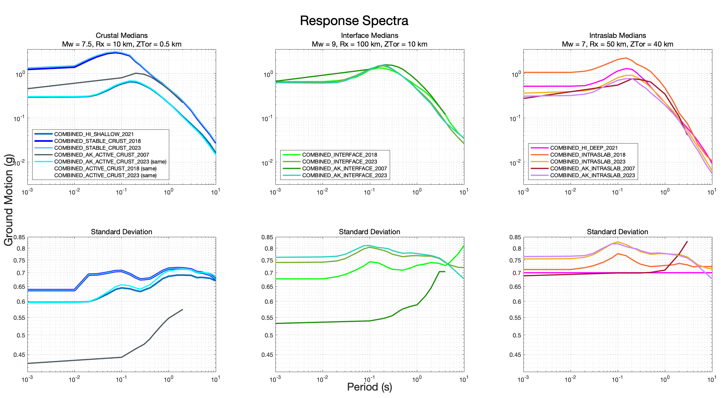
Figure 4. GMM comparisons for the median response spectral ground motions (top) and standard deviations (bottom) for shallow (left), interface (center), and deep (right) earthquakes. Shallow plot parameters: M7.5; interface plot parameters: M9, R_{x} = 100 km, Z_{TOR} = 10 km; deep plot parameters: M7, R_{x} = 50 km, Z_{TOR} = 40 km.

SEDIMENT DEPTH-BASED AMPLIFICATION MODELS

SEMI EMPIRICAL GMMS

For the 2018 NSHM we applied sedimentary depth-based amplification models for WUS basins (Seattle, San Francisco, Los Angeles, and Salt Lake City) but we did consider other basin-depth models in the WUS because we did not have time to study these models and get acceptance from the scientific community. Depth-based amplification models were not available for the CEUS. For this 2023 NSHM, we apply basin-depth amplification models for CONUS where local basin depth models are available, but not for Alaska or Hawaii where such data is not readily available. We apply the semi-empirical models conditioned on depth to a particular velocity horizon to account for amplification effects related to deeper velocity structure.

We applied basin-depth scaling terms of NGA-West2 models in producing the 2018 NSHMs for the San Francisco Bay Area, greater Los Angeles, Seattle, and Salt Lake City regions. For updating the basin amplification models in 2023, we considered updated community seismic velocity models in the San Francisco Bay Area (Ahdi et al., 2023), new basin-depth models for the California Great Valley (Ahdi et al., 2023), Reno (which was not ultimately implemented), and Portland-Tualatin basins (Ahdi et al., 2023), as well as the M9 simulations for the Puget Lowlands region (Frankel et al., 2018; Wirth et al., 2018) and the CyberShake simulations in the greater Los Angeles metropolitan region (Graves et al., 2011). The M9 and CyberShake simulations are not used to establish ground motion levels, but have been applied to evaluate the scaling of amplification factors with sediment depth, which has been validated (e.g., Nweke et al. 2022a).

3D SIMULATIONS

In this 2023 NSHM, we consider the CyberShake simulations (Graves et al., 2011) that are based on known earthquake sources across the Los Angeles region, a kinematic rupture generator, reasonable structural and velocity representations of the Los Angeles basin, and calculations that utilize physics-based principles in waveform modeling. In this update, we use the simulated ground motions in the southern California region to develop alternative basin-depth scaling terms for the NGA-West2 GMMs. Discussions at our ground motion workshop and comments from the review panel focused on whether there are non-zero amplifications at ∆Z=0 and if these should be corrected to be consistent with the NGA-West2 medians. After considerable discussions, correction factors were applied that are described further in Moschetti et al. (2023). Modified basin amplification factors apply the functional forms of each of the NGA-West2 equations which are intended to work in tandem with the V_{S30} scaling relations in the respective models. The resulting ground motion hazards across the region result in minor reductions at periods between 1-4s and small increases at 5-10s periods compared to applying the NGA-West2 equations. We weight the new CyberShake based amplification model 0.25 because there is abundant strong motion data in southern California to constrain the GMMs and simulations are important but not as critical in constraining the equations since the data is more abundant.

For the 2018 NSHMs, we applied Seattle amplifications based on Z_{1.0} and Z_{2.5} but we did not directly consider the M9 simulations (Frankel et al., 2018 and Wirth et al., 2018). In this 2023 revision we have applied additional period dependent and V_{S30} independent amplifications (up to a factor of 2) for long-period ground motions to account for the 3D simulations in a deep basin (Chang et al., 2014; Z_{2.5} >6km). These new M9 ground motion levels are quite similar at long periods to the AG20 empirical and AM09 simulated amplifications, which gives us confidence in the M9 results. However, the results are higher than the other NGA-Subduction GMMs of Kuehn et al. (2022) and Parker et al. (2022) considered for this update (Smith et al., 2023). Consideration of these simulations along with the full suite of NGA-Subduction models provides a broad range of epistemic uncertainty, which is probably warranted. For the 2023 NSHM, we apply the new Seattle amplification model with 0.5 weight with the other 0.5 weight given to the amplification models provided in the NGA-Subduction GMMs for interface sources, only. The M9 amplification factors are not used for intraslab sources. The simulations are quite important in this Pacific NW region where we lack empirical data for large subduction interface earthquakes and only have limited data for intraslab earthquakes. Therefore, we gave higher weight than usual for a branch of the logic tree that considers simulated data.

ATLANTIC AND GULF COASTAL PLAIN AMPLIFICATION MODELS

Several period-dependent amplification models were evaluated for amplifying ground motions on Gulf and Atlantic Coastal Plain sites that overlie deep wedges of sediments that continue offshore. We considered five spectral-response oscillator-period-dependent amplification models based on sediment thickness and the distance traversed across the Gulf Coastal plain: Chapman and Guo (2021, CG21), natural-site-period- and sediment-thickness-based models by Harmon et al. (2019), and the period-dependent and -independent NGA-East Gulf Coast adjustment factors. Maps of coastal plain sediment thickness (generally Cretaceous and younger post-rift sediments) were compiled for this purpose (Boyd et al., 2023). In addition, strong motion data from the CEUS for events M>3.5 were also compiled and reprocessed to develop a uniform database of earthquake records (Thompson et al., 2023). Boyd et al. (2023) used this database in addition to those prepared by CG21 and NGA-East (Goulet et al. 2021) for comparison to GMM predictions and found that the variance of total ground motion residuals in the Coastal Plains could be reduced by about 20 percent using the CG21 amplification model. The other amplification models reduced residuals by about half as much. One complication with the CG21 model is that it is derived relative to reference stations outside of the Coastal Plain, shown in Figure 2, which do not have a V_{S30} of 3,000 m/s, the reference V_{S30} assumed for the NGA-East GMMs. Boyd et al. (2023) sought to estimate the reference condition, finding a range 1000-2000 m/s, indicating that the reference condition that should be used with CG21 is highly uncertain.

We apply a weight of 0.25 to the CG21 model to account for the amplification and deamplification effects of the Coastal Plains. The other amplification models are not used for this update of the NSHM policy maps because they have not been implemented in the NSHM codebase. The partial weight on the Coastal Plains amplification model was chosen because of the relative newness of the CG21 model and implementation in the NSHM coupled with its substantial impact on predicted ground motions (maximum reduction of ~80% at 0.03 sec and maximum increase of ~100% at 2 sec SA for 1 km of sediment), uncertainties about Coastal Plains’ resonances and sediment velocity and thickness, and limited data from larger magnitude earthquakes and close-in stations.

WUS AMPLIFICATION MODELS

We apply the basin depths from community velocity models for Seattle, San Francisco, Central Valley, Los Angeles/Ventura, Reno, Portland/Tualatin, and Salt Lake City (Aagaard, 2023a, Aagaard, 2023c, Aagaard and Hirakawa, 2021, Lee et al., 2014, Magistrale et al., 2008, Simpson and Louie, 2020, Stephenson, 2007, Stephenson et al., 2017) to assess Z_{1.0} and Z_{2.5} depth parameters, which characterize the depths to the 1.0 m/s and 2.5 m/s shear-wave velocity isosurfaces. The basin amplification models are derived along with the NGA-West2 equations (ASK14; BSSA14; CB14; CY14). We evaluated the basin depth models in Reno (Aagaard, 2023b, Simpson and Louie, 2020) and found that because the basins were relatively shallow, the equations did not predict significant amplifications in those regions, and using the local basin-depth models did not provide additional predictive power (Ahdi et al., 2023)—like our 2018 analysis for Salt Lake City (Petersen et al., 2020). Ground motion amplifications have been observed in each of these regions but little strong motion data from large earthquakes is available to assess basin amplifications. We feel that additional work is required to make comparisons evaluate amplification characteristics, and differences in geometry between these shallow basins and the deeper basins in California where most of the strong motion data is located that underlie the development of these amplification models. We weight each of the basin depth models with 100% weight since we are improving the information using Z_{1.0} and Z_{2.5} depth information that is not applied in the pre-2018 NSHMs.

We plan to give full weight to the Great Valley Z_{1.0} and Z_{2.5} models because there are no other alternatives that we are aware of. We applied the Z_{1.0} and Z_{2.5} in zones shown in Figure 5. Basin depth models for Reno, the Wasatch front, and Portland/Tualatin are quite a bit shallower than the basins in California, resulting in amplification at very few sites, relative to the basin-amplification effects implicit in V_{S30}-scaling models built into the NGA-West2 GMMs. The central valley of California is much deeper and results in amplifications for long-periods, especially in the south-western portion of the zone.

For the 2018 NSHM we considered how to amplify ground motions based on sedimentary thickness and discussed potential alternatives with our GMM review panel and in user workshops (Petersen et al., 2020). In the end, we decided that we did not have sufficient information to warrant lowering predicted ground motions from GMMs at the basin-edge regions where past earthquakes caused extensive damage (e.g., Santa Monica, CA, West Seattle, WA) and uncertainties seemed quite high. For that hazard assessment, we planned to amplify ground motions only in the deepest portions of the sedimentary basin deposits and leave everything else the same. For the 2023 NSHM we are revisiting this decision in light of new region-specific analyses for the San Francisco Bay area and the greater Los Angeles region presented here in Moschetti, et al. (2023) and in Nweke et al. (2020, 2022b). We develop a logic tree that accounts for amplifications in areas outside of basins, at basin edges, and inside of basins (Moschetti et al., 2023). We assigned half weight to the 2018 model that only amplifies ground motions within the deepest portion of the basins where amplifications are positive, and half weight to empirical basin-depth amplification models (Z_{1.0}/Z_{2.5}) of NGA-West2 which deamplify long-period ground motions for relatively shallow sediments, which mainly occur outside of basins or in relatively small or shallow sedimentary structures (e.g., the valley province in Nweke et al. 2022b). We give weight to the previous model because our studies indicate that the NGA-West2 model is appropriate for use with the current database of strong motion in the San Francisco and Los Angeles regions which lower ground motions by about 30% in these urban areas. Additionally, it is important to recall that there are many epistemic uncertainties that have not been explored or explained that could cause these reductions to be smaller than predicted. For example, there are several reasons we are concerned about the applications of the basin depth NGA-West2 models without further consideration: (1) we do not have strong motion recordings from large San Andreas system earthquakes, so these effects have not been recorded or explained; (2) there exist unmodeled uncertainties at basin-edge sites due to converted waves for future damaging earthquakes; and (3) recent work by Withers et al. (2023) shows about 15% increases in the hazard at the 2% in 50 year level when applying the Watson-Lamprey (2018) directivity equations for the San Francisco Bay area, which had not been considered in the previous models and could ultimately offset the ground motion reductions from basin-depth models when applied to shallow sediment sites.

We did not develop basin amplification models for Alaska or Hawaii.

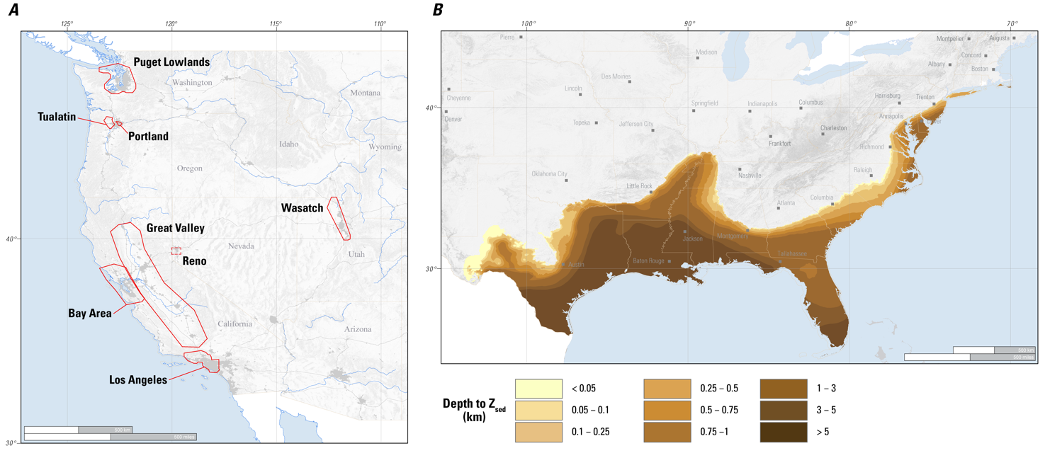
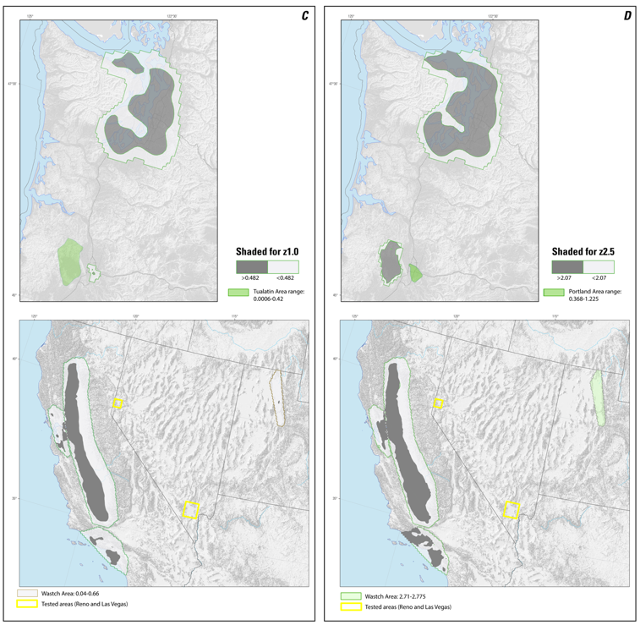

Figure 5. (a) The seven western United States (WUS) basin polygons (solid lines) that were assessed for amplification; dashed lines represent two zones that were tested but not incorporated into the final model. (b) The extent of the coastal plain shaded for the depth to sediment base (Boyd et al., 2023). (c) Seven WUS basins assessed for amplification for Z_{1.0} at V_{S30} 260 m/s. (d) Seven WUS basins assessed for amplification for Z_{2.5} for V_{S30} 260 m/s; green shading fills areas too shallow for amplification.

CEUS-WUS ATTENUATION BOUNDARY

Since the publication of the 1996 NSHM for CONUS (Frankel et al., 1996) the same boundary running through the eastern Intermountain West region, separating active tectonic WUS crust from stable CEUS crust, has been used (Frankel et al., 1996, 2002; Petersen et al., 2008, 2014, 2020). This boundary is applied by separating earthquakes into CEUS and WUS regions. When calculating hazard at a site from a given fault or seismicity grid cell, the GMMs appropriate for the source region (CEUS or WUS) are used (e.g., CEUS earthquakes are always used with CEUS GMMs). For the 2018 NSHM, a transition zone between -115 and -100º west longitude (the overlap zone) was used to add rates of exceedances derived from CEUS and WUS GMMs together to compute total mean hazard. Recent studies of earthquakes in the overlap zone show that some of the areas classified as CEUS behave more like WUS GMMs (e.g., Darragh et al., 2019). We have performed Lg crustal attenuation tomography and stress drop studies in the region (Levandowski and McNamara, 2022) that support these findings and have proposed a new boundary that slightly modifies the area around the Colorado Plateau and includes the central and northern portions of the Central and Southern Rocky Mountains in WUS instead of CEUS (Shumway et al., 2023b; Figure 2). A sensitivity analysis using the 2018 NSHM and transition zone methodology compared sites in the overlap zone using the old boundary and the new proposed boundary, resulting in small (<10% in most places) changes in hazard (Shumway et al., 2023b). We use 100% weight for this new model because it is an update of the older model that is based on additional tomography studies and stress drop analyses. In the future, GMMs can be treated using alternative methods (e.g., dependence on the fraction of the paths in the CEUS and WUS).

HAZARD RESULTS AND PRODUCTS

Seismic hazard calculations were performed using the USGS PSHA computer code, nshmp-haz (Powers et al., 2022). This code is available publicly on GitLab. The 2023 CONUS NSHM (Powers and Altekruse, 2022b), 2023 AK NSHM (Powers and Altekruse, 2023c), and 2021 HI NSHM (Powers and Altekruse, 2022a) are also available publicly on GitLab.

SEISMIC HAZARD GROUND MOTION MAPS AND COMPARISONS TO OLDER MODELS

The Version 1 model applies the new ERF and GMMs discussed above with the proposed weights and we generate 2%, 5%, and 10% PE in 50 years hazard, difference, and ratio maps for 0.2s, 1s, and 5s SA at V_{S30} of 760 m/s and 260 m/s. Seismic hazard at 2% in 50-years probability of exceedance (PE) for 0.2s SA with a 760 m/s V_{S30} is greater than 1g along coastal California, Oregon, and Washington; across the Wasatch front in Utah and into the Yellowstone region of Wyoming, Montana, and Idaho; within the CEUS New Madrid region of Tennessee, Arkansas, Missouri, Illinois, and Kentucky, eastern Tennessee and Central Virginia seismic zones, and Charleston region of South Carolina; across the southern portions of Alaska; and within the Island of Hawai’i and Maui (Figure 6). For 5s SA at 2% in 50-years PE with a 260 m/s V_{S30}, the ground motions that exceed 0.1g occur in similar areas as those shown for the 1g threshold at 0.2s in the short period maps (Figure 7).

The general map patterns of the 2023 NSHM are very similar to previous NSHMs, but details of ground shaking differences and ratios are quite different (Figures 8-11). Many of the changes in the model are caused by new fault and deformation models that have broad epistemic uncertainties and influence the immediate region surrounding the faults. Newly modeled faults across the region have caused increases in the hazard, especially in low seismicity regions of the WUS. Within the CEUS many of the broad changes in the model observed, especially in the ratio maps, are in low seismicity areas that are influenced by the gridded seismicity model. There are several reasons for the gridded seismicity changes: (1) catalog, (2) decluster models, (3) weighting of the fixed and adaptive smoothing models, (4) b-value changes, (5) application of the full vs declustered rates, and (6) methodology changes caused by the catalog being cut-off at 104-degree longitude and a slightly altered CEUS-WUS attenuation/catalog boundary. In addition, there were several changes to the GMMs that result in changes in the 2023 NSHM. For example, we implemented new NGA-Subduction GMMs which tend to lower the ground motions within a few hundred kilometers of the coast in most places and for long period GMMs (1s). The ground motions are increased along a narrow strip of land located along coastal California, Oregon, and Washington for short periods (0.2s) but decay with distance from the coast. The application of amplification models also make significant long-period (1s) changes to the maps. For example, adding Central Valley, Portland/Tualatin, and updating the San Francisco Bay area and Los Angeles regions result in increased long-period hazard in the deepest portions of the sedimentary basin. Modifying the long-period ground motions with 3D simulations increases the computed hazard in Seattle and does not cause significant changes in Los Angeles (Moschetti et al., 2023). The application of the coastal plain amplification model causes changes in ground motions about a factor of two, with decreases in computed hazard at short periods (0.2s) and increases in hazard at long periods (1s). Alaska changes are also very significant with changes along the Aleutian arc due to fault model revisions and changes in peninsular Alaska due to new gridded seismicity changes. Hawaii changes are caused by the new fault zone characterization and new GMMs. For these return periods and short periods (0.2s), the entire main island has ground motions that are higher than in the previous NSHM whereas the outer islands decrease due to these updates. For long periods (1s), the changes are mixed with highs along the coasts and lows in a saddle across the middle of the Island of Hawai’i and lower hazard again on the northern islands.

Figures 8-11 are annotated to show where, why, and how the 2023 final computed hazard changed compared to the 2018 NSHM. We published similar comparisons for the 2018 NSHM with the 2014 NSHM (Petersen et al., 2021). Comparisons with the 2018 NSHM (Figures 8-11, and Table 3) indicate that ground motions decrease for short periods (0.2s) near New Madrid and Charleston. For the Cascadia subduction zone region of the Pacific NW, our sensitivity studies holding either ERF or GMM models fixed to 2018 NSHM while varying the other parameters show that ground motions are slightly elevated near the coastline due to the addition of the NGA-Subduction models and slightly decreased inland due to the ERF model changes. Short period ground motions are elevated in the Seattle due to NGA-Subduction and the M9 amplification model. Much of the western coast of California is elevated due to the new fault models. Colorado, Wyoming, and Montana increased significantly due to changes in the methodology which put earthquakes classified previously as CEUS into the WUS category for rates, allowing for a lower b-value, higher minimum magnitude threshold, and other factors, even though uniform floor zones were removed in these areas. Ground motions for longer periods (1s SA) increased in regions of New Madrid, central California, Seattle, and Portland/Tualatin basins due to, respectively, the coastal plain amplification, addition of the Central Valley basins, NGA-Subduction and M9 3D simulations, and addition of basin depth amplification models. Long period ground motions decrease along the Pacific NW region at 1s SA oscillator period due to addition of new GMMs (NGA-Subduction). The model for Alaska results in changes along the arc of greater than a factor of 2 due to fault rate changes and significant changes on peninsular Alaska due to the gridded seismicity model. The Hawaii NSHM released in 2021 (Petersen et al., 2021) was based on declustered catalog rates which are about 10% lower than the full catalog rates that are applied in CONUS and Alaska. Hazard in Hawaii increased in portions of the Island of Hawai’i but decreased in areas to the north compared to the 2001 NSHM due to changes in the fault, gridded seismicity, and ground motion models.

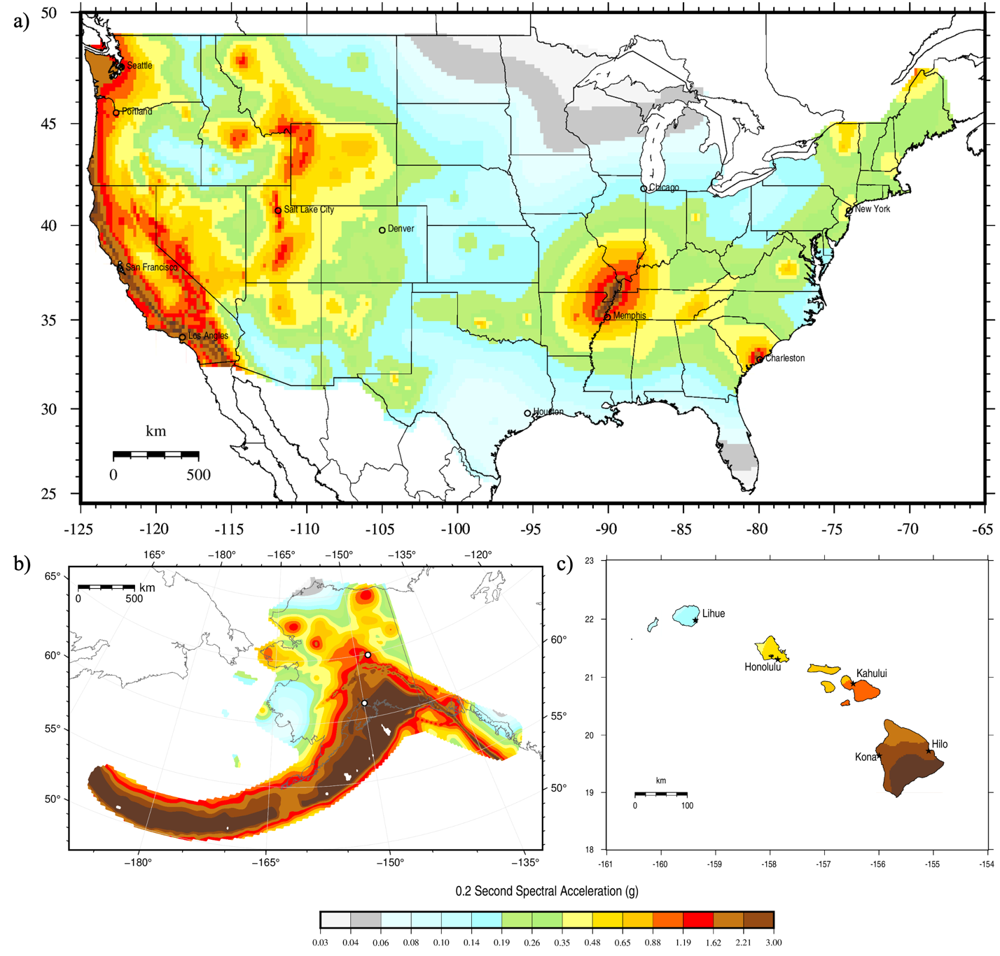

Figure 6. 0.2s spectral acceleration total mean hazard maps for 2% probability of exceedance in 50 years, NEHRP site class boundary B/C (V_{S30} = 760 m/s), calculated for the 2023 NSHM for: (a) the conterminous US, (b) Alaska, and (c) Hawaii.

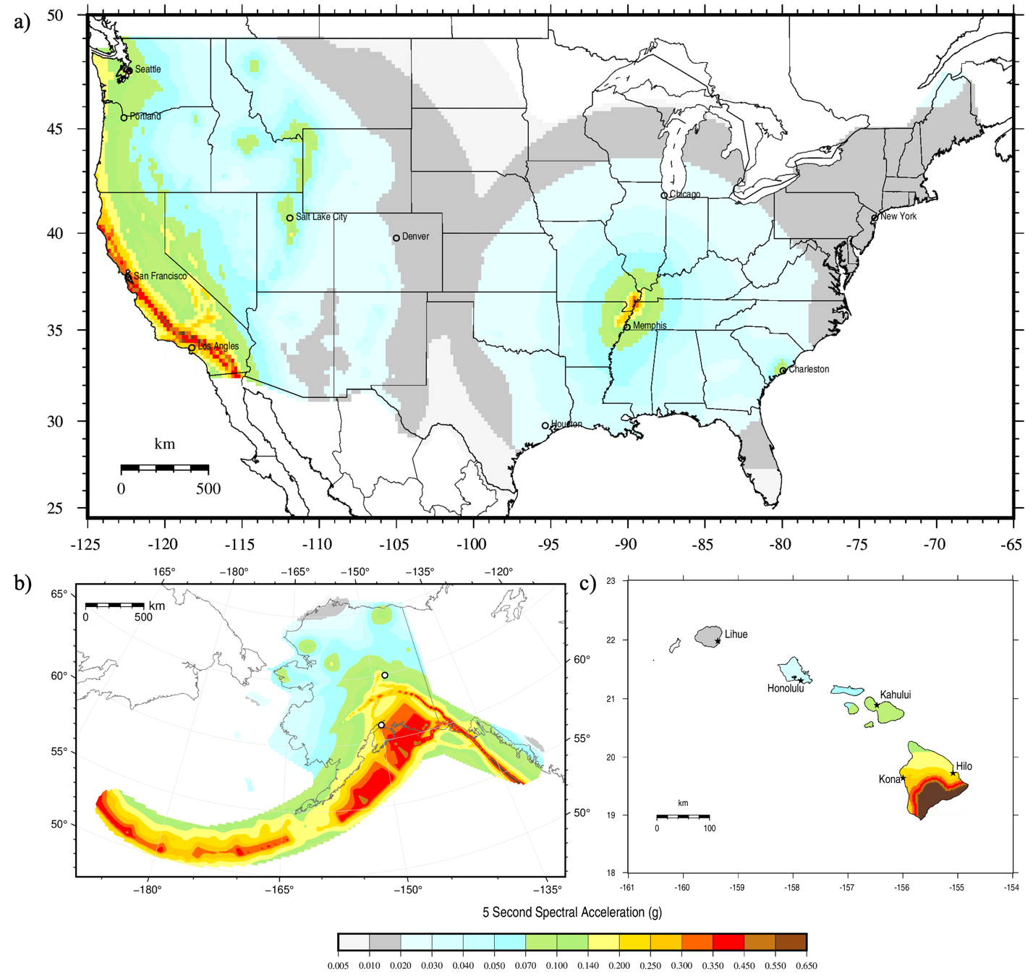

Figure 7. 5s spectral acceleration total mean hazard maps for 2% probability of exceedance in 50 years, NEHRP site class D (V_{S30} = 260 m/s), calculated for the 2023 NSHM for: (a) the conterminous US, (b) Alaska, and (c) Hawaii.

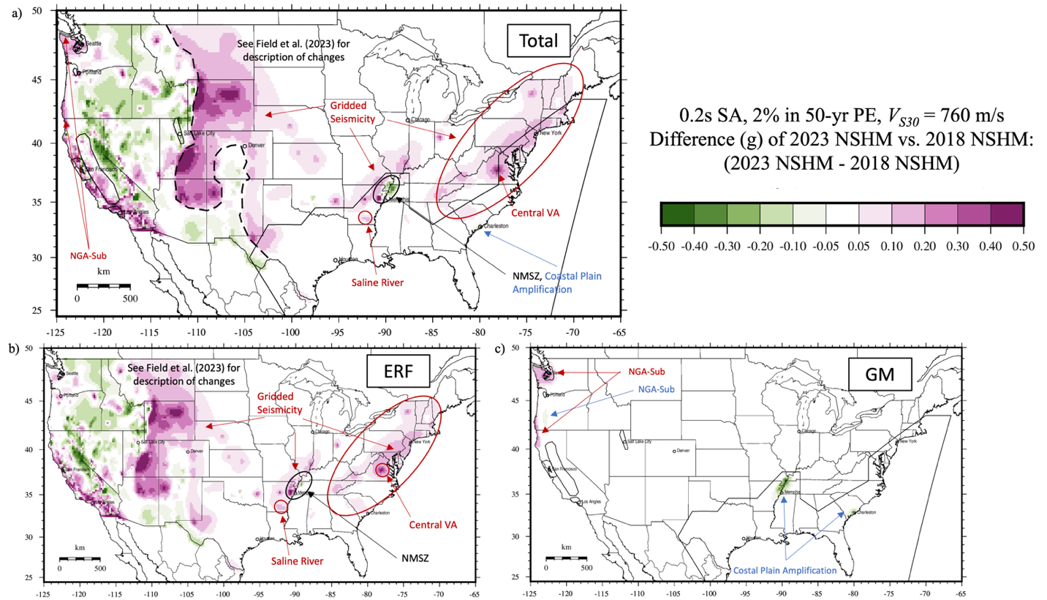
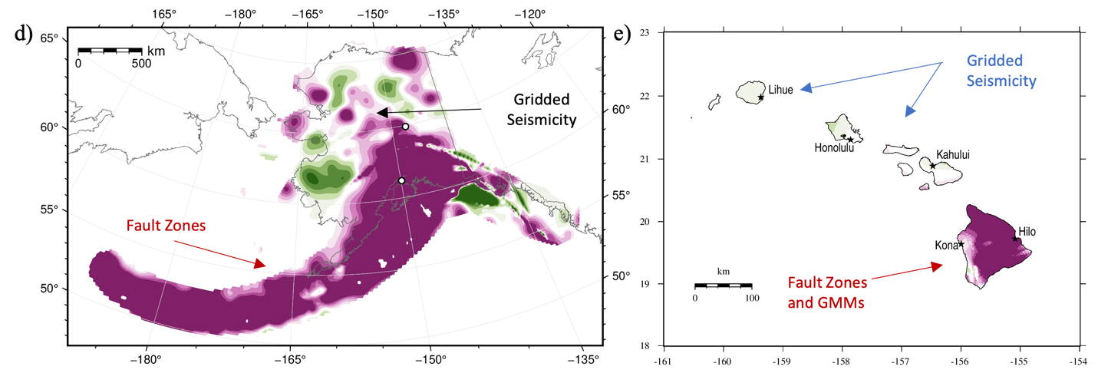

Figure 8. Difference maps for 0.2s spectral acceleration showing comparisons between total mean hazard from (a,b,c) the 2023 CONUS NSHM and 2018 CONUS NSHM, (d) 2023 AK NSHM and 2007 AK NSHM, and (e) 2021 HI NSHM and 2001 HI NSHM for 2% probability of exceedance in 50 years, and NEHRP site class boundary B/C (V_{S30} = 760 m/s).

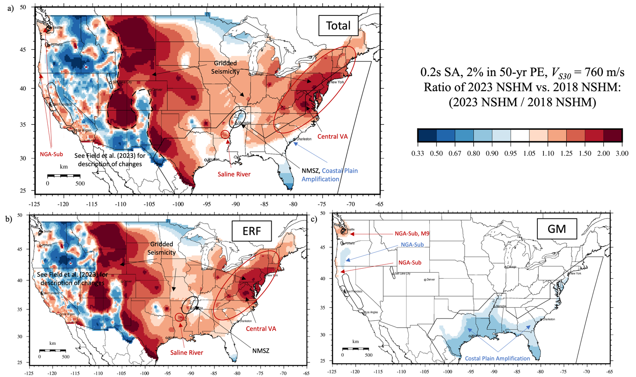
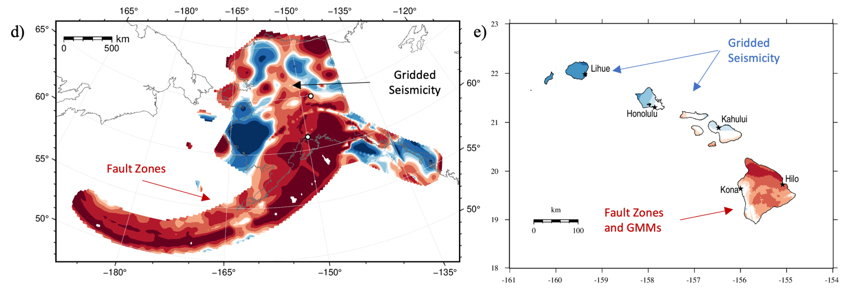
Figure 9. Ratio maps showing comparisons between total mean hazard from the (a,b,c) 2023 CONUS NSHM and 2018 CONUS NSHM, (d) 2023 AK NSHM and 2007 AK NSHM, and (e) 2021 HI NSHM and 2001 HI NSHM for 0.2s spectral acceleration, 2% probability of exceedance in 50 years, and NEHRP site class boundary B/C (V_{S30} = 760 m/s).

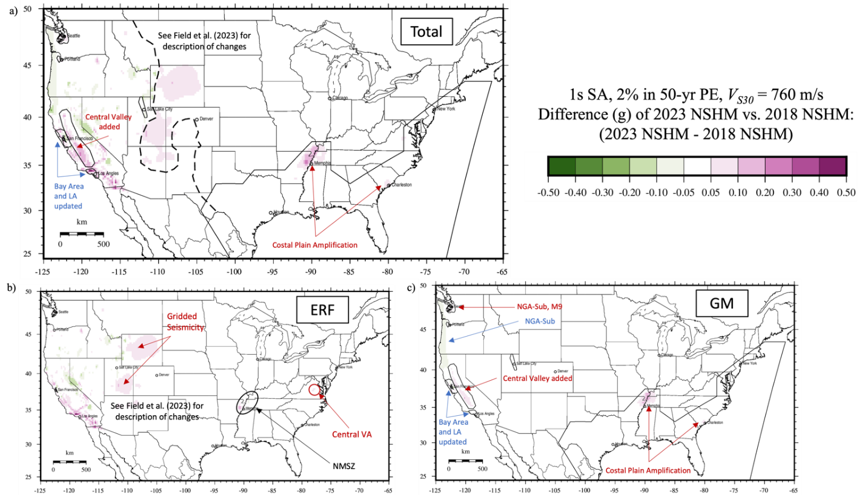
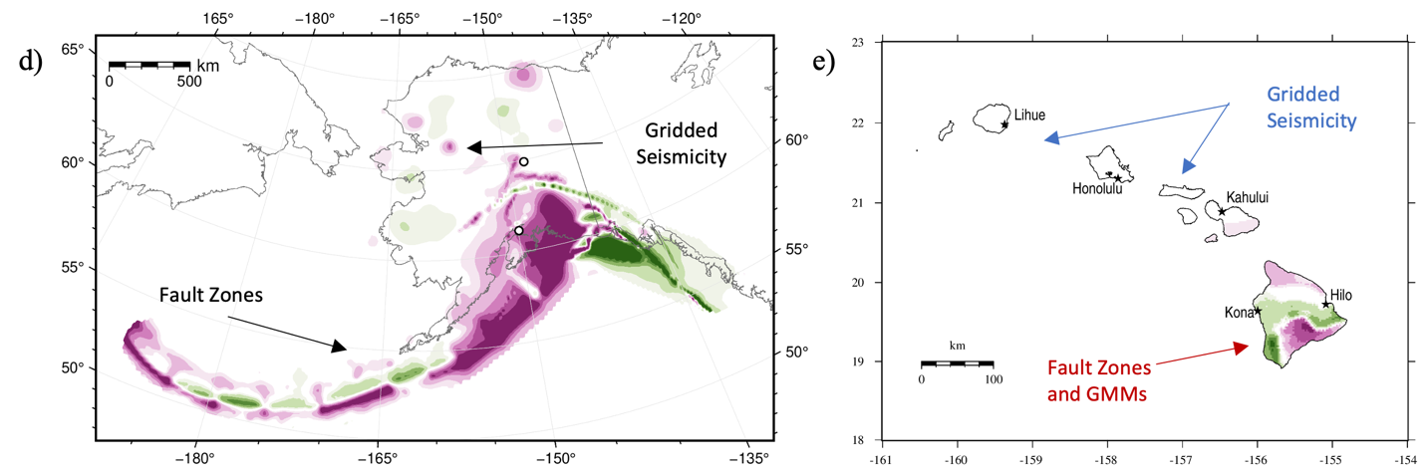
Figure 10. Difference maps showing comparisons between total mean hazard from the (a,b,c) 2023 CONUS NSHM and 2018 CONUS NSHM, (d) 2023 AK NSHM and 2007 AK NSHM, and (e) 2021 HI NSHM and 2001 HI NSHM for 1s spectral acceleration, 2% probability of exceedance in 50 years, and NEHRP site class boundary B/C (V_{S30} = 760 m/s).

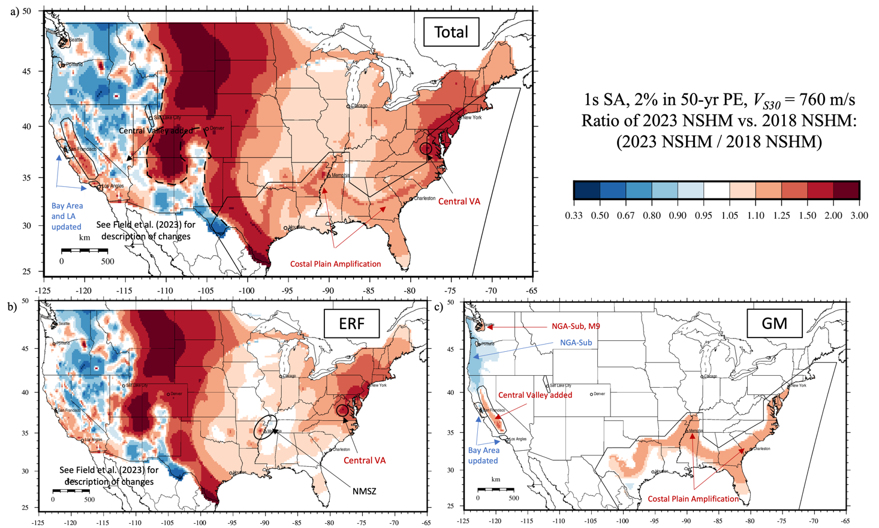
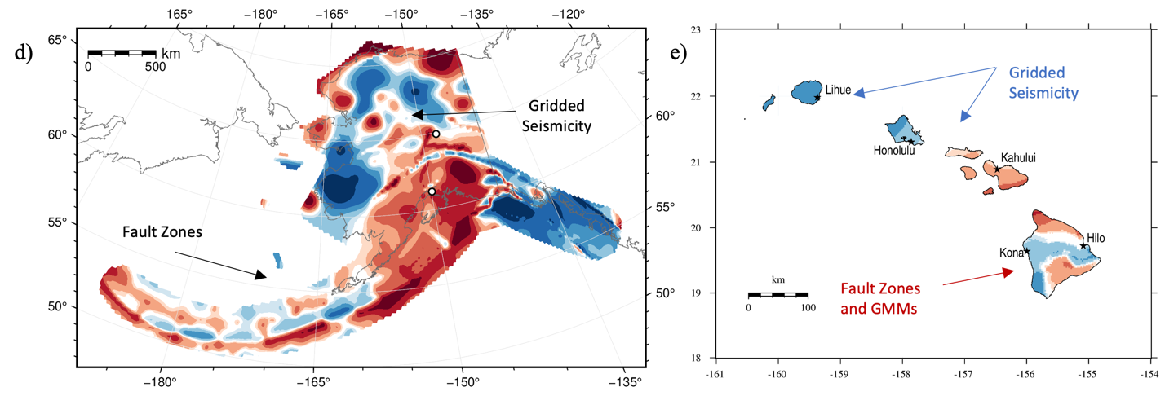
Figure 11. Ratio maps showing comparisons between total mean hazard from the (a,b,c) 2023 CONUS NSHM and 2018 CONUS NSHM, (d) 2023 AK NSHM and 2007 AK NSHM, and (e) 2021 HI NSHM and 2001 HI NSHM for 1s spectral acceleration, 2% probability of exceedance in 50 years, and NEHRP site class boundary B/C (V_{S30} = 760 m/s).

Table 3. Comparison of total mean hazard for sites across the United States. 2% in 50-year probability of exceedance ground motions (g); NEHRP site class boundary B/C (V_{S30} = 760 m/s) for 0.2 and 1s spectral acceleration and NEHRP site class D (V_{S30} = 260 m/s) for 5s spectral acceleration.

Site Name | Lat | Lon | 2023 NSHM | 2021  NSHM | 2018  NSHM | 2007 NSHM | 2001 NSHM | Diff (g) | Ratio (%)
0.2 Second Spectral Acceleration
Anchorage, AK | 61.20 | -149.90 | 3.16 |  |  | 1.55 |  | 1.61 | 104%
Fairbanks, AK | 64.90 | -147.70 | 1.22 |  |  | 0.94 |  | 0.28 | 30%
Los Angeles, CA | 34.05 | -118.25 | 2.26 |  | 2.07 |  |  | 0.19 | 9%
San Francisco, CA | 37.75 | -122.40 | 1.92 |  | 1.77 |  |  | 0.15 | 8%
Denver, CO | 39.75 | -105.00 | 0.25 |  | 0.17 |  |  | 0.07 | 43%
Hilo, HI | 19.70 | -155.06 |  | 2.40 |  |  | 1.80 | 0.60 | 34%
Honolulu, HI | 21.30 | -157.86 |  | 0.60 |  |  | 0.61 | -0.02 | -3%
Chicago, IL | 41.85 | -87.65 | 0.16 |  | 0.14 |  |  | 0.02 | 12%
New York, NY | 40.75 | -74.00 | 0.39 |  | 0.25 |  |  | 0.15 | 60%
Portland, OR | 45.50 | -122.65 | 1.22 |  | 0.68 |  |  | 0.54 | 80%
Charleston, SC | 32.80 | -79.95 | 1.45 |  | 1.57 |  |  | -0.12 | -8%
Memphis, TN | 35.15 | -90.05 | 1.19 |  | 1.26 |  |  | -0.07 | -6%
Houston, TX | 29.75 | -95.35 | 0.07 |  | 0.07 |  |  | 0.00 | 3%
Salt Lake City, UT | 40.75 | -111.90 | 1.76 |  | 1.71 |  |  | 0.05 | 3%
Seattle, WA | 47.60 | -122.30 | 1.66 |  | 1.44 |  |  | 0.22 | 15%
1.0 Second Spectral Acceleration
Anchorage, AK | 61.20 | -149.90 | 0.87 |  |  | 0.61 |  | 0.26 | 43%
Fairbanks, AK | 64.90 | -147.70 | 0.34 |  |  | 0.29 |  | 0.05 | 16%
Los Angeles, CA | 34.05 | -118.25 | 0.70 |  | 0.64 |  |  | 0.06 | 10%
San Francisco, CA | 37.75 | -122.40 | 0.65 |  | 0.61 |  |  | 0.04 | 7%
Denver, CO | 39.75 | -105.00 | 0.07 |  | 0.04 |  |  | 0.03 | 74%
Hilo, HI | 19.70 | -155.06 |  | 0.71 |  |  | 0.77 | -0.06 | -8%
Honolulu, HI | 21.30 | -157.86 |  | 0.16 |  |  | 0.18 | -0.02 | -12%
Chicago, IL | 41.85 | -87.65 | 0.07 |  | 0.06 |  |  | 0.00 | 7%
New York, NY | 40.75 | -74.00 | 0.07 |  | 0.04 |  |  | 0.02 | 57%
Portland, OR | 45.50 | -122.65 | 0.38 |  | 0.33 |  |  | 0.06 | 17%
Charleston, SC | 32.80 | -79.95 | 0.39 |  | 0.34 |  |  | 0.05 | 16%
Memphis, TN | 35.15 | -90.05 | 0.38 |  | 0.33 |  |  | 0.05 | 16%
Houston, TX | 29.75 | -95.35 | 0.04 |  | 0.04 |  |  | 0.00 | 9%
Salt Lake City, UT | 40.75 | -111.90 | 0.57 |  | 0.57 |  |  | 0.00 | 0%
Seattle, WA | 47.60 | -122.30 | 0.68 |  | 0.59 |  |  | 0.09 | 16%
5.0 Second Spectral Acceleration
Anchorage, AK | 61.20 | -149.90 | 0.27
Fairbanks, AK | 64.90 | -147.70 | 0.13
Los Angeles, CA | 34.05 | -118.25 | 0.24 |  | 0.23 |  |  | 0.01 | 3%
San Francisco, CA | 37.75 | -122.40 | 0.36 |  | 0.34 |  |  | 0.02 | 5%
Denver, CO | 39.75 | -105.00 | 0.02 |  | 0.01 |  |  | 0.01 | 89%
Hilo, HI | 19.70 | -155.06 |  | 0.21
Honolulu, HI | 21.30 | -157.86 |  | 0.04
Chicago, IL | 41.85 | -87.65 | 0.03 |  | 0.03 |  |  | 0.00 | 4%
New York, NY | 40.75 | -74.00 | 0.01 |  | 0.01 |  |  | 0.00 | 45%
Portland, OR | 45.50 | -122.65 | 0.12 |  | 0.15 |  |  | -0.03 | -20%
Charleston, SC | 32.80 | -79.95 | 0.09 |  | 0.07 |  |  | 0.01 | 20%
Memphis, TN | 35.15 | -90.05 | 0.12 |  | 0.10 |  |  | 0.02 | 20%
Houston, TX | 29.75 | -95.35 | 0.03 |  | 0.02 |  |  | 0.01 | 60%
Salt Lake City, UT | 40.75 | -111.90 | 0.16 |  | 0.16 |  |  | 0.00 | 0%
Seattle, WA | 47.60 | -122.30 | 0.20 |  | 0.24 |  |  | -0.04 | -17%
Values have been rounded to two decimal places. Difference and ratio values were calculated prior to rounding.

HAZARD CURVES

A comparison of total mean hazard curves for the 15 selected test sites are shown in Figure 12 for 0.2s and 1s SA, V_{S30} = 760 m/s. 2023 hazard curves are shown with solid lines, and older model hazard curves are shown with dashed lines. For 0.2s SA, for return periods exceeding 10% in 50 years PE, Anchorage, Hilo, Los Angeles, San Francisco, and Salt Lake City show the highest ground motions. For 1s SA, for return periods greater than 2% in 50 years PE, Charleston and Memphis show high ground motions. Ground motions are significantly lower (a factor of 10 or more) at Denver, Chicago, New York, and Houston for both short and long periods.

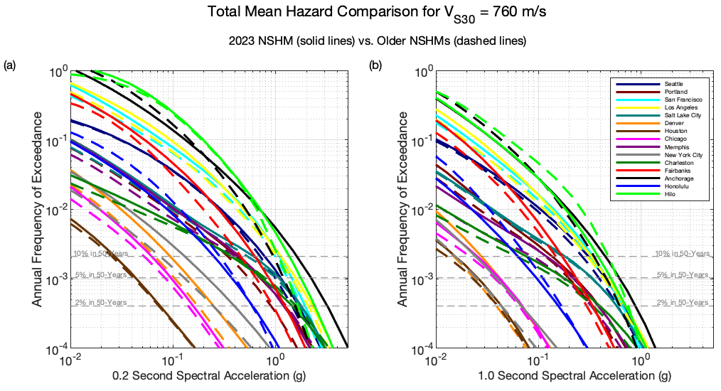

Figure 12. Comparison of total mean hazard curves for 15 sites across the United States is shown for the 2023 NSHM (solid lines; conterminous U.S. and Alaska) and 2021 NSHM (solid lines, Hawaii) versus the 2018 NSHM (conterminous U.S., dashed lines), 2007 NSHM (Alaska, dashed lines), and 2001 NSHM (Hawaii, dashed lines). Hazard curves are plotted for (a) 0.2s spectral acceleration and (b) 1s spectral acceleration, NEHRP site class boundary B/C (V_{S30} = 760 m/s).

UNIFORM HAZARD RESPONSE SPECTRA (UHRS)

Uniform hazard response spectra (UHRS) were also generated for each of the 15 test sites for 2% PE in 50 years. UHRS for six of these sites are shown below (Figure 13). Ground motions for all six sites show similar response spectra shapes but differ for Anchorage where site conditions appear to be playing a significant role between 0.1 and 1s SA. Ground motions at all these sites exceed 1g acceleration for most site conditions and fall off for longer periods.

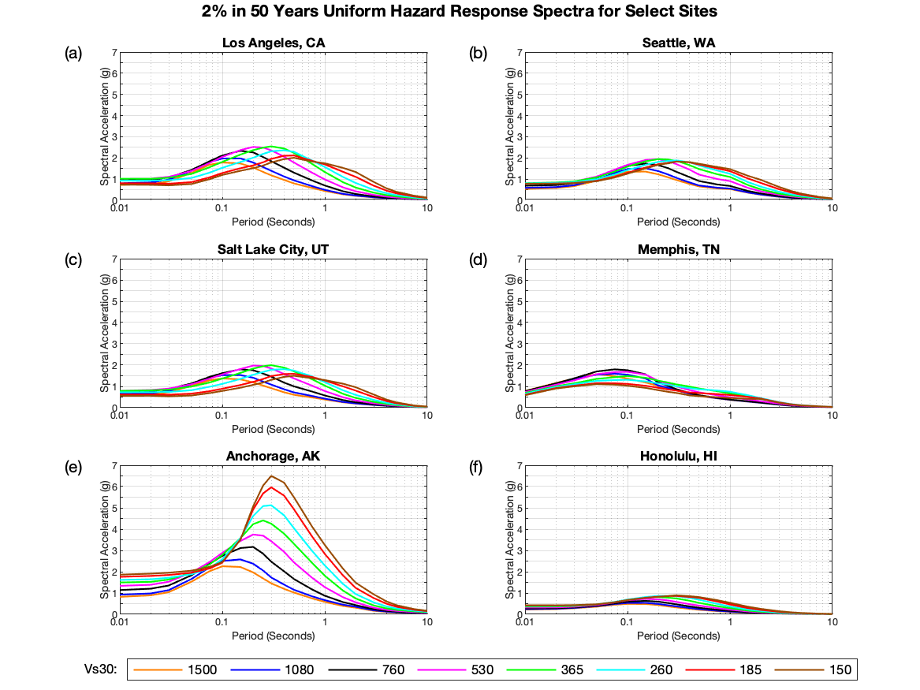

Figure 13. Uniform hazard response spectra are plotted for six sites in the United States for a 2% probability of exceedance in 50 years. Values are calculated for NEHRP site classes B (V_{S30} = 1080 m/s), C (V_{S30} = 530 m/s), D (V_{S30} = 260 m/s), and E (V_{S30} = 150 m/s) and site class boundaries AB (V_{S30} = 1500 m/s), BC (V_{S30} = 760 m/s), CD (V_{S30} = 365 m/s), and D/E (V_{S30} = 185 m/s).

DISAGGREGATIONS AT SELECT SITES

For the 2023 NSHM we examined several disaggregations at several sites to determine the controlling features in the model. The NSHM webtool (www.staging-earthquake.usgs.gov/nshmp/hazard/disagg) will produce disaggregations for the 50-state 2023 model that can be generated for any site, location, period, or site class. For example, Figure 14 below shows disaggregations for Los Angeles, CA, 5s SA at V_{S30} = 260 m/s and 2% in 50-years PE. This site includes information from the new ERF, new basin amplification model for CyberShake and for NGA-West2. The controlling feature are local faults (~90%) and grid sources (~10%).

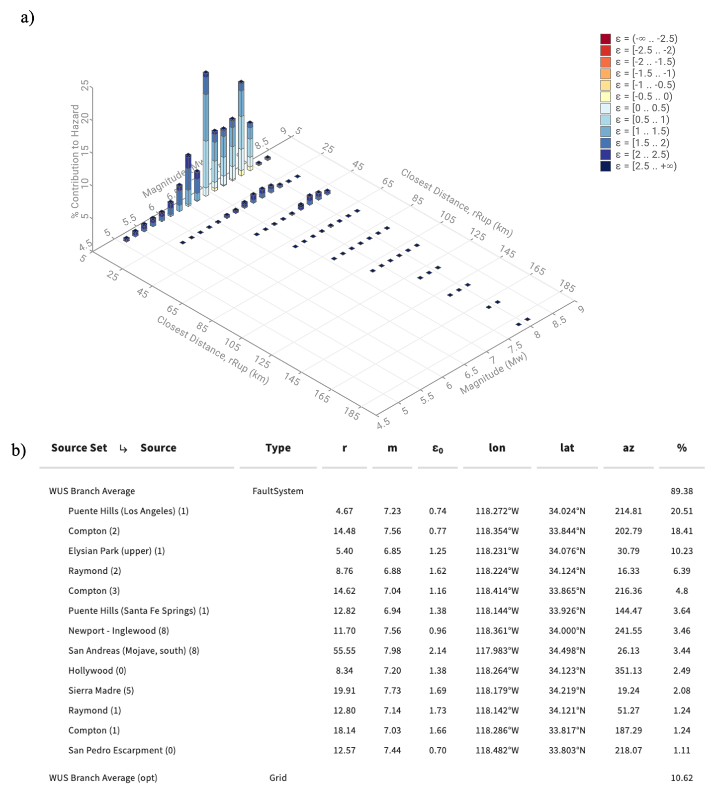

Figure 14. (a) Disaggregation for a site in Los Angeles, CA (34.05, -118.25). Results for 2% in 50-year probability of exceedance, 5s SA, V_{S30} = 329 m/s. (b) Table showing percent contribution of sources.

HAZARD CURVE FRACTILES

The mean hazard curves like those in Figure 12 are weighted averages across the epistemic uncertainties—i.e., logic-tree branches—of the earthquake-rupture-forecast and ground-motion models summarized above. To quantify the epistemic-uncertainty distribution around each mean hazard curve, it is common to compute hazard curve fractiles—e.g., see Figure 15. These fractiles can be calculated from a suite of hazard curves, each totaled across all the pertinent earthquake sources, that result from combinations of the logic-tree branches. As the number of combinations of earthquake sources and logic-tree branches can be unmanageably large, the suite of hazard curves is often generated via Monte Carlo simulation. The current version of nshmp-haz has been refactored to facilitate such simulations, but doing so at selected sites, and then at all the national grid points, is future work. Also, the epistemic uncertainty shown is not exhaustive and site specific studies may lead to greater epistemic uncertainties than those depicted in this analysis. In addition to more nshmp-haz development, this work requires the further research described in the Discussion and Conclusions section below.

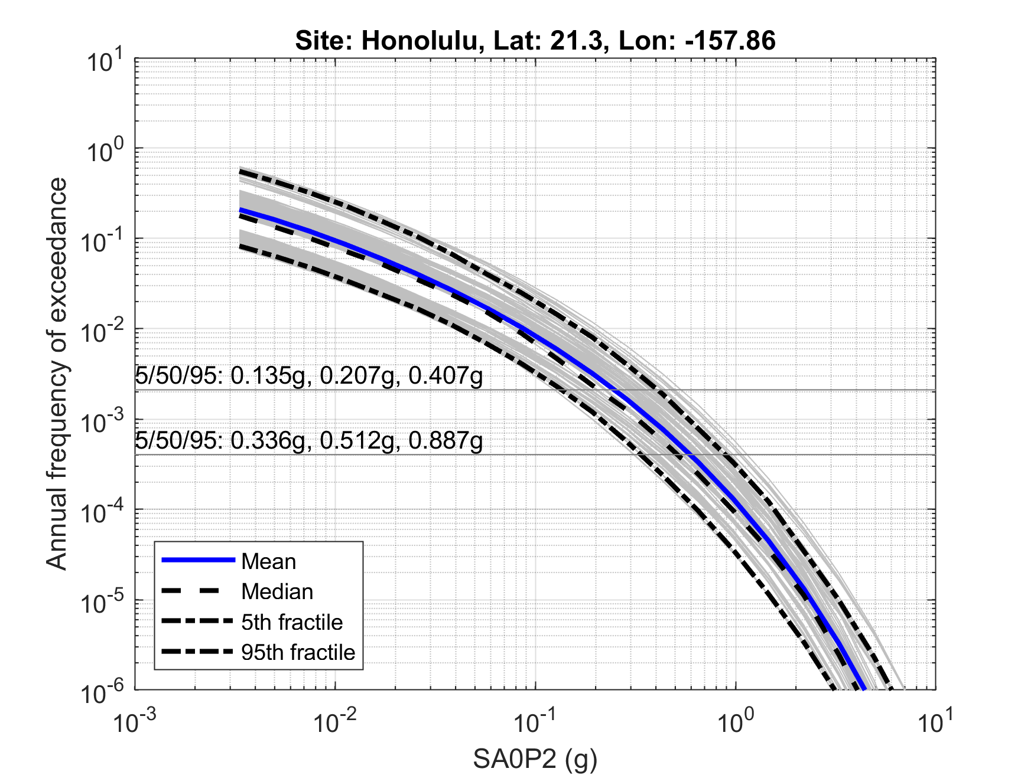
Figure 15. Example of hazard curve fractiles (5th, 50th, and 95th) from results in Petersen et al. (2021) for a site in Honolulu, HI (21.3, -157.86). Results for 0.2s SA, V_{S30} = 760 m/s.

POPULATION EXPOSURE ESTIMATES

We make use of the mean PGA hazard curve derived from the 2023 and previous versions (e.g., 2018 NSHMs for CONUS) at each mapped location assuming a reference rock site condition (Vs=760 m/s) for performing shaking intensity-exposure analyses, analogous to our previous work (Jaiswal et al. 2015). The use of modified Mercalli Intensity (MMI) as a shaking intensity measure type in portraying probabilistic seismic hazard offer number of advantages over more traditional ground motion intensity measures like PGA, PGV, or spectral accelerations at various periods/frequencies. The 2012 Worden et al. study provides regression relationships for converting PGA into a numeric value of MMI, which were rounded to integer values for further analyses. The exposure analysis relies on the latest 2021 global LandScan population database (~30 arc second resolution layer, roughly 1 km x 1 km grid) from the Oak Ridge National Laboratory as a baseline for deriving total population counts at each MMI bin. The probabilistic estimate of exceedance of intensities associated with various predefined recurrence thresholds were used to sum and then tabulate the total population count at each intensity bin (Table 4). This allows us to document changes in shaking estimates between successive map versions relying on same baseline population layer representing the current built environment. Clearly, the increase in population counts as shown in Table 4 at all shaking intensities and recurrence intervals highlight that the new mean hazard estimates have increased over previous map versions. The new hazard assessment identifies that approximately 47 million (an increase by 2% from our previous iteration of hazard, 172 million (an increase by 57%), and 282 million (an increase by 4%) are at risk of experiencing damaging shaking (MMI V or greater) with 50%, 10% and 2% chance of occurrence in the next 50 years.

Table 4. Estimated counts of population in 50 U.S. states using 2021 LandScan at various Modified Mercalli Intensity (MMI) shaking thresholds.
Map Year | Total Population Estimates at MMI
 | ≥ V | ≥ VI | ≥ VII | ≥ VIII | ≥ IX
50% PE in 50 years (~72 years recurrence interval)
Previous* | 46,218,000 | 34,601,000 | 11,990,000 | 127,000 | -
2023.v1 | 47,111,000 | 37,332,000 | 21,415,000 | 159,000 | -
10% PE in 50 years (~475 years recurrence interval)
Previous* | 109,403,00 | 66,264,000 | 48,784,000 | 31,302,000 | 3,866,000
2023.v12 | 171,983,00 | 72,476,000 | 53,299,000 | 33,145,000 | 6,983,000
2% PE in 50 years (~2,475 years recurrence interval)
Previous* | 272,066,000 | 186,644,000 | 107,984,000 | 58,095,000 | 38,561,000
2023.v1 | 281,733,000 | 215,189,000 | 139,808,000 | 63,857,000 | 39,621,000
* CONUS 2018, AK 2007, and HI 1998

SEISMIC SCENARIOS TO HIGHLIGHT NEWLY MAPPED HAZARDS (HAWAI’I AND SALT LAKE CITY)

Seismic scenarios serve a variety of different purposes and are traditionally developed to evaluate the seismic preparedness efforts in a given study region and most importantly, to raise awareness about the underlying seismic risk. The USGS NSHM products (e.g., 2% in 50-year map) provide a probabilistic forecast of strong ground motions expected to occur within an observation window. Such products are largely targeted to be used within the building code applications. As a part of NSHM 2023 effort, we also developed a set of new earthquake scenarios to highlight the underlying hazard and associated risk that the community faces, and where possible, incorporate new changes associated with the new model (e.g., new GMMs, source characteristics).
Accordingly, scenarios were developed for Hawai’i (8 new scenarios) and Salt Lake City (SLC) (9 new scenarios) to highlight the updates to the hazard characterization in these regions. Chase et al. (2023) discusses the details of this entire scenario development effort. One scenario in the new Hawai’i suite includes a M8.0 scenario on southern flank of the Big Island near Hilo, consistent with the rupture of a decollement. Ground shaking intensities are estimated to be an MMI of VII in Hilo with the potential for losses to exceed $1 billion and a few fatalities. In addition, USGS Ground Failure product was used to find that there was a high probability of both liquefaction and landslides across the Big Island. In SLC, one of the scenarios developed models a M7.12 earthquake occurring of the SLC segment of the Wasatch Fault. Shaking intensities of MMI IX in SLC and the potential for losses to exceed $100 billion with numerous fatalities is estimated in this event. A high probability for landslides and liquefaction is also estimated in the region.

USE OF NSHM IN U.S. SEISMIC PROVISIONS

As with previous NSHM editions, the 2023 update will be proposed to serve as the basis for provisions in U.S. seismic codes for buildings, bridges, railways, and defense facilities, among other types of infrastructure. The hazard curves at the 22 spectral periods (including peak ground acceleration) and 8 site classes produced by the NSHM are used as the primary inputs in the development of earthquake design load parameters for structural and geotechnical design and analysis. For seismic design guidelines that specify a uniform hazard design basis (i.e., performance objectives that are conditional on a particular hazard level of ground shaking), design ground motion parameters are interpolated from the NSHM-based hazard curves (see Figure 12) at target annualized exceedance frequencies as specified by a particular design code. For example, the American Society of Civil Engineers Seismic Evaluation and Retrofit of Existing Buildings (ASCE 41 [ASCE, 2017]) design document specifies a range of design criteria that require design ground motions to be developed for return periods of 225 years (20% PE in 50 years), 975 years (5% PE in 50 years), and the 2,475-year Maximum Considered Earthquake (MCE, 2% PE in 50 years). Similarly, the American Railway Engineering and Maintenance-of-Way Association (AREMA, 2019) design provisions require design ground motions for return periods ranging from 100 years (39% PE in 50 years) to the MCE. Within the context of seismic codes, ground motion values extracted from the NSHM-based hazard curves are generally referred to as probabilistic ground motions.

Depending on the design code, probabilistic ground motions extracted from NSHM hazard curves are modified prior to their use as design values. In the case of guidelines that use uniform-risk performance
criteria, rather than the uniform-hazard criteria described above, design motions are developed by integrating the full hazard curves with probabilistic representations of system fragility (e.g., Luco et al., 2007). The foregoing computations yield design parameters that produce uniform levels of system performance, such as a targeted annualized probability of structural collapse. For the National Earthquake Hazards Reduction Program (NEHRP) Recommended Seismic Provisions for New Buildings and Other Structures (e.g., Building Seismic Safety Council, 2020), subsequently adopted in the ASCE 7 Minimum Design Loads for Buildings and Other Structures (e.g., ASCE, 2021), this risk target corresponds to a 1% in 50-year collapse probability, while the forthcoming update to the American Association of State Highway and Transportation Officials (AASHTO) Guide Specifications for LRFD Seismic Bridge Design will use 1.5% in 75-year collapse risk target. The 2023 NSHM will also be used to compute deterministic ground motion parameters, which often govern the seismic design in certain parts of the U.S. where they exceed probabilistic motions. Per the 2020 NEHRP provisions, deterministic ground motions are calculated as the maximum 84th percentile spectral acceleration computed from “scenario earthquakes on all known faults within the region”, with the candidate scenario earthquakes determined from hazard disaggregation (see Figure 14). Once adopted, design ground motion parameters for a variety of code documents are computed and made freely available to users by the USGS through various means, such as web services (e.g., USGS, 2020) or online databases (e.g., Luco et al., 2021).

The 2023 NSHM update will be taken under consideration by the Building Seismic Safety Council (BSSC) Provisions Update Committee (PUC) to serve as the basis for the 2026 update of the NEHRP provisions, with partial funding from FEMA. The NEHRP provisions update process began in 2022, involving hundreds of earthquake engineering experts from academia, industry, and public agencies – this includes USGS personnel, who serve as federal agency liaisons to the update committee. Many of those involved in the NEHRP provisions update also participate in NSHM workshops, such as the user needs workshop, throughout the model development process. More broadly, building code development occurs in parallel with NSHM updates, as the needs of users across different sectors will influence how NSHM data are made available and presented to the public.

IMPACT OF EPISTEMIC UNCERTAINTIES ON SEISMIC RISK

There have been a number of studies in the literature that have highlighted the need to report epistemic uncertainties in the hazard (e.g., Kennedy et al. 1980; Kulkarni et al. 1984; Bradley 2009; NASEM 2019). From an engineering and risk perspective, incorporating the epistemic uncertainties in hazard enables estimates that are scientifically credible and defensible (e.g., risk-targeted ground motions, average annual loss). However, reporting estimates of epistemic uncertainties in the hazard involves various challenges; for example, see fractile-based UHGMs for Hawaii in Petersen et al. (2022) and see further research described in the Discussion and Conclusions section below.

Reporting epistemic uncertainties in hazard is important for understanding both hazard and risk. For instance, Kwong and Jaiswal (2023) study provides specific example uses of fractile hazard curves, including visualization of epistemic uncertainties in maps of UHGMs, comparison of UHGMs over time, and an open-source Jupyter notebook for end-users of NSHM to interactively explore impacts of epistemic uncertainties in hazard in seismic risk assessments.

TESTING (CONUS ONLY)

For the first time, we evaluate the performance of the NSHM over much of the CONUS region simultaneously. Evaluating the performance of the NSHM is an essential aspect of the update process. Input data sets and models are constantly being improved and incorporated, and these changes influence the final hazard estimate. Ideally, forecasts would be evaluated with data that was collected after the model was created. However, due to the nature of earthquakes and the infrequent occurrence of large magnitudes and strong ground motions, it is more advantageous to compare models with prior data, which give a longer history of shaking.

Seismic intensity is a good source for long shaking histories and has the benefit of not being directly included in the hazard calculations, so provide an independent source for evaluation. Historical seismic intensities are derived from first-hand accounts of shaking by eyewitnesses, typically using a questionnaire, and are assigned a value by an expert or team or experts (Byerly and Dyke, 1936). Modern seismic intensities like the USGS Did You Feel It? (DYFI) product are collected via the internet through multiple-choice questionnaires, then spatially aggregated and assigned an intensity by an algorithm (Wald et al., 1999). These two types of intensity data products have fundamental differences, although they are often combined to make longer histories. For example, the USGS ShakeMap product combines historical intensities, modern intensities, instrumental data, and earthquake source information with ground-motion models to achieve a more complete record of ground shaking (Marano et al., in review). The composite ShakeMap Atlas, which stacks ShakeMaps to reveal the history of shaking at a point and the maximum shaking over time, is particularly useful for the hazard model evaluation exercise because it provides a comprehensive and spatially complete depiction of shaking for CONUS (Figure 16).

There are two ways to portray hazard spatially – point-based methods, as the hazard over different return periods (inverse of the probability of exceedance) at a single location; or area-based methods, as the hazard over an area at a single return period. Point-based evaluation methods have been applied in the past to the NSHM using historical intensities, with varied results: the hazard model was found to slightly exceed historical observations in the westernmost U.S., while in the CEUS and the southern California sub-region, the hazard tended to be lower than historical observations (Stirling and Petersen, 2006). In Oklahoma/Kansas, point-based results showed good agreement with modern DYFI intensities when applied to the short-term forecasts for natural and induced seismicity (White et al., 2018). Recent area-based evaluations of the NSHM have been applied to U.S. sub-regions with similarly varied results. In California, area-based results showed the hazard model substantially exceeding historical intensities (Salditch et al., 2020). However, area-based results showed good agreement with modern intensities when applied to the short-term forecasts in Oklahoma/Kansas, similar to the point-based assessments in that region (Brooks et al., 2018; Brooks et al., 2019).

Both point- and area-based methods are applied to the NSHM23 using modern intensity products. See Salditch et al., in prep for a complete description of the analysis.

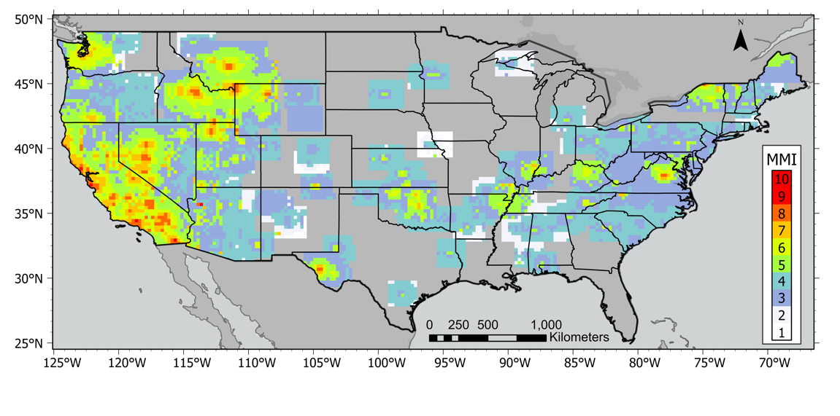
Figure 16. Maximum intensities from ShakeMap Composite Atlas 1900–2020. These augmented observations will be used to compare against the predicted shaking from NSHM. Intensity unit is Modified Mercalli Intensity (MMI).

DISCUSSION

Our hazard assessment considers the best available science on earthquakes and related ground shaking available in the published literature as evaluated by the NSHM project members, review committees, and our Steering Committee. This 2023 NSHM represents a major multi-year effort to improve the basis of the seismic hazard assessment across all 50 states with several new ERF components (Field et al., 2023) and GMM components (Moschetti et al., 2023, Rezaeian et al., 2023). Dozens of researchers inside and outside of the USGS provided input models, methods, and data for this update. More than a hundred reviewers, scientists, and end-users gave important guidance, participated in workshops, and provided public review comments. While we were not able to complete all the technical requests suggested for this update, this model uses more data, models, and methods than previous NSHMs and is, as a result, more complex. We provide several types of outputs including (1) hazard curves for 23 periods, including PGV and PGA, and 8 site conditions agreed upon with building-code users, (2) maps for these outputs as well as for MMI with topographic based amplification factors, and (3) deterministic based earthquake rupture scenarios, that we feel could be useful for other end-users. As discussed above, the NSHMs are considered by many end-users who each have different requirements for their individual use-cases. Therefore, a variety of products are needed to satisfy the needs of these alternative users, as considered in our user-needs workshop. Below, we examine several challenges in developing the NSHM.

CHALLENGES IN ASSESSING EPISTEMIC UNCERTAINTIES OF INPUT MODELS

Earthquakes are challenging to forecast, and it is important to keep in mind that fully correlated uncertainties in the NSHMs are high and span factors of more than two to four in ground motions and a factor of up to 10 in frequency of exceedance (e.g., see Figure 15). One reason the uncertainties are high is that we have not considered all inputs that we know can influence the hazard because robust models are not always available or applications are difficult for regional hazard assessments (e.g., spatial and temporal variability of earthquake rupture properties, directivity effects that are rupture orientation dependent, non-ergodic shaking which demands many local and regional ground motion observations). In addition, there are many data and methodological limitations that inhibit the construction of more accurate ERF and GMM input models, resulting in larger epistemic uncertainties. For example, the five different geologic and geodetic based inversion models show very high epistemic uncertainty in the fault slip rates (Field et al., 2023), especially those with very low slip rates and long recurrence intervals. The new slip rate models rely on incomplete datasets and include imperfect input models/parameters and analytical methods. For example, our models have only included about half of the known and mapped fault sources in the U.S. because we lack fault information to define the detailed geometry and history of known earthquake generating faults. Even if we have access to such information, the geologic studies typically only characterize the uppermost portions of faults even though properties can vary significantly with depth, slip rates are typically sampled at only a few sites located randomly along the fault trace instead of with uniform sampling, trenching and fault studies are sometimes made at sites with atypical or unusual characteristics which were chosen because of their irregularities or interesting but abnormal observations, and sufficient geodetic data are often not available to assess fault slip rate differences across each fault. In addition, large events observed across the globe sometimes occur on both mapped and previously unmapped faults so it is important to allow for rupture contributions off the known faults. We sometimes lack important parameters for modeling earthquakes. For example, the dip of the Wasatch fault is quite uncertain which makes it difficult to assess the rupture sizes (widths) and connections with other subsidiary faults and observed earthquakes such as the recent Magna, Utah earthquake (discussed above). Rate models also have large uncertainties when considering the grand inversion or classic ERF. We have focused on accounting for a wide range of rupture models and rates, but it is often quite difficult to assign weights to these alternatives and now they are introduced with uniform weights that span a large range of characteristics. Assigning physics and observational based constraints would improve these forecasts in future NSHMs.

The current ergodic GMMs and amplification models also show significant aleatory variability and high epistemic uncertainties between alternative models. However, further work is needed to refine estimates of aleatory variability and to characterize the epistemic uncertainties in ground motion that exist across the U.S. We apply additional epistemic uncertainty to the WUS NGA-West2 and Hawaii GMM equations; the CEUS GMMs allow for a broad range of epistemic uncertainty from the Sammons mapping techniques of NGA-East; and the new subduction-zone GMMs from NGA-Subduction provide estimates of epistemic uncertainty (Bozorgnia et al., 2022; Goulet et al., 2021; Petersen et al., 2018). These models are mostly built on smaller- to moderate- sized earthquakes or global (ergodic) observations of large earthquakes, since large earthquake observations are not readily available for most urban faults. Large earthquakes like the M7.9 1857 Fort Tejon and M7.9 1906 San Francisco San Andreas fault earthquakes were not recorded by strong motion instrumentation, and other faults such as the Cascadia subduction zone and Wasatch fault have not ruptured in several hundreds of years, so no large earthquake recordings are available. Therefore, it is difficult to constrain future shaking levels with observations and modelers must rely on global analogs or computer simulations if available. Large epistemic uncertainties are also related to the rock/soil deamplification/amplifications. Amplification models for various soil types currently use broad proxies such as V_{S30} or depth to shear-wave velocity horizons (Z_{1.0} or Z_{2.5}), themselves based on surface geology maps or topographic slopes, to estimate shaking levels; these models are insightful but uncertain site- and basin-response estimation vehicles. The response of shallow basins, such as those near Salt Lake City, Reno, and Portland, remains poorly understood, and amplification models may need to be modified for these basins which have different V_{S} gradients compared to the deeper basins in the WUS, such as the Los Angeles basin from which much of the NGA-West2 database is derived. Modifications may also be needed for amplification factors that incorporate a proxy of the depth of sediments to model amplification in the Atlantic and Gulf Coastal plains and deamplification of shallow soils outside of basins (with respect to the centered equations of NGA-West2 as a function of V_{S30}) in urban areas. Models do not account well for the totality of ground-shaking effects (e.g., directivity or topographic amplification) and unobserved or unmodeled earthquakes.

CHALLENGES IN ASSIGNING WEIGHTS

A very important element of the hazard assessment is the assignment of weights which reflect the perception of using best available science, comparisons with empirical data, comparisons with physical principles, comparisons with other models and their ability to reduce residuals with observations, and expert opinions. This weighting analysis depends on discussions of whether a new model is mature and vetted enough to include in the assessments, whether an older model still has merit and should be considered in the analysis, whether it is time to retire an older model that doesn’t perform as well, whether to consider an older model with lower weight to increase epistemic uncertainty, whether to allow for viable alternatives to increase epistemic uncertainty or add additional uncertainty to the model, and how to produce more scientifically stable results for end-users. The inclusion of a model in the maps should be based on a robust assessment of the available science data and expert opinion and should not be biased by either a desire to maintain the status quo or to quickly adopt new methods that lack proper testing and validation. There is a delicate balance between applying new models that are perhaps not as mature and accepted in the science community or including older models that considered the same data but in a different way using alternative and perhaps simpler techniques. Our project members, Steering Committee, and review panels challenge the introduction of new inputs by requesting explanations about why a new model is better at modeling sources or predicting ground motions than previous models, if it is sufficiently mature to include in the policy application, or if we should include it in the research model for further testing and scrutiny.

We faced several challenges in weighting the inputs which we discussed with our review panels and Steering Committee. In our ERF models we account for a broad range of potential models that span the range of acceptability. However, the challenge is to constrain or limit the model using physics and observations to only allow ruptures that are reasonable in a 50-year period and exclude those that are considered as extreme or very unlikely events that can drive the hazard and risk results, especially for insurance or reinsurance applications. Application of alternative assumptions could influence hazard for some use-cases more than the building code hazard inputs that currently only require the mean ground motions and do not consider fractiles of shaking hazard. We typically use logic trees that are quite complex to represent the large uncertainties considered in the input models and it is difficult to separate aleatory variability and epistemic parametric or modeled uncertainty in assessing the overall uncertainties. Where data is lacking to make more quantitative assessments, we typically use expert opinion to assess best available science, which allows professional judgement to be applied. Often, models are evaluated equally to begin with and then through residual analysis with observations, workshops, discussions with our project members, review panels, Steering Committee, and assessment of impacts, we modify those initial weights to be consistent with our collective best judgements. For this assessment we have worked very hard to understand the consensus of the science community on best available science concerning earthquake ruptures and ground motions in assigning the weights. These weights were reviewed by many scientists. Nevertheless, weights will continue to evolve as new information is brought to light on these important issues.

CHALLENGES IN PRESENTING UNCERTAINITY IN THE MODELS

As introduced above, computing hazard curve fractiles remains future work that entails both additional development of nshmp-haz to implement Monte Carlo simulations of epistemic uncertainties and further research. As mean hazard curves like those computed in prior NSHM updates are not affected by the partitioning of epistemic versus aleatory uncertainties (of the earthquake-rupture-forecast and ground-motion models), but hazard curve fractiles are, this partitioning for the 2023 NSHM is one research need.
Another is research and deliberate decisions on the extents to which the various epistemic uncertainties (logic-tree branches) are correlated across the earthquake sources. For example, the epistemic uncertainty in forecasted seismicity rate can be assumed to be either fully (and positively) correlated or uncorrelated across the earthquake sources, or perhaps more realistically but difficultly, partially correlated. The same can be said of the logic-tree branches of ground motion models, and the other epistemic uncertainties. The appropriate amount of correlation depends on how each epistemic uncertainty was developed and the characteristics of the earthquake sources to which the uncertainty is applied. Relative to partial (and positive) correlation, assuming full correlation will increase the spread of the fractiles (i.e., the standard deviation), and assuming no correlation will decrease it. Thus, our best estimates of the correlations of the various epistemic uncertainties are needed to avoid knowingly biasing the quantification of hazard curve fractiles. Unbiased estimation of the spread of the fractiles is important because they will undoubtedly be used to ascertain whether changes in the mean hazard are statistically significant. Overestimation of the spread would downplay the significance of mean hazard changes, which could lead some users to ignore the updated NSHM. Of course, underestimation of the spread of the fractiles would make the changes in mean hazard appear more significant than they are, which is also undesirable. Thus, extensive review of the hazard curve fractiles will be needed, to check whether their spread aligns with expectations across different geographic regions (e.g., WUS vs. CEUS), return periods and spectral periods (short vs. long), and site classes (firm vs. soft). Review may identify sources of epistemic uncertainty that require further research for more rigorous quantification. Finally, to optimize the usefulness of the modeled uncertainties, further research on the “use cases” (end-user applications) is needed.

MODELS FOR ALTERNATIVE USERS: POLICY AND RESEARCH MODELS

As mentioned in the introduction, we are planning to develop both policy and research models for the 2023 NSHM. These are new products that are introduced here and provide an alternative information stream for end users. Both policy and research terms are a little ambiguous and there are currently debates about the best nomenclature for describing these products. For now, we consider policy to signify models that are primarily made for a narrow range of applications that are based on well-accepted data, models and methods, and that have been vetted with published and peer-reviewed papers documenting the limitations of each model. By research we mean models that consider inputs not generally included in the building code provisions but that may be applied for other uses such as risk assessment or insurance. The previous NSHMs mostly focused on the policy - building code applications but were applied and modified for use in the risk, insurance, seismic safety, and other important applications. The building code committees desired the incorporation of unbiased, well vetted, and stable elements of the hazard model that are broadly agreed on within the science community as reflecting the best available science. Building code provisions required specific outputs so previous Applied Technology Council (ATC) workshops focused on defining parameters applied in the NSHMs; they recommended the USGS produce maps of 2% PE in 50-year level of hazard for a firm rock site condition (V_{S30}=760 m/s) applying Poissonian rate models that would be stable through the 50-year life of a building. As technology advanced these same end-users requested further outputs such as risk-targeted models that define the probabilistic risk of collapse (or risk-targeted). The code committees requested maps with the average direction of the ground motion models (RotD50 values) that they amplified by period dependent factors in the building code to obtain maximum direction shaking levels. More recently, engineers from the code committee considered whether to apply epistemic uncertainty calculations to assess whether or not to update building code criteria if the hazard level fall inside/outside uncertainty bounds of the previous hazard model. Other products may be more useful to alternative end users that have either shorter or longer time horizons, or higher or lower risk acceptability requirements. The policy models will provide basic hazard modules that are well vetted and accepted by the science and engineering community.

A parallel track research model will provide important supplemental information useful for future versions of policy models or for users with additional information requirements. For example, the building code requirements do not currently allow for time-dependent hazard, but the risk modeling community requires time-dependence and hazard fractiles for estimating reinsurance coverage. Those models are often more sensitive to outliers of the rupture model (tails of the MFDs) that can result in higher loss estimates. Risk modeling companies often add these additional inputs to suit the needs of the insurance industry. Thus, the policy model could be considered as a beginning point for various use-cases that can be modified as needed by various consulting or user groups who can apply either their own specific research applications or the research contained within the research model to fill the needs of a specific end-user. The research model could also serve an alternative purpose which is to study the effects of new models that are not sufficiently vetted or for which impacts are poorly understood or to analyze the impacts of models that are more mature and based on peer reviewed science but which have not traditionally been included in the policy models (e.g., time-dependent applications). Such models will be presented in a platform where results can be evaluated, tested with empirical and simulated data, and analyzed by user communities for understanding impacts to the engineering and risk models. The research model will be a constantly evolving model that is a single map or it could be a series of maps that show impacts for each potential change in the input models (e.g., directivity, non-ergodic ground motion models, time-dependent fault rate models, etc.).

CONCLUSIONS

The 2023 NSHM provides important new data, models, and methods that improves the hazard characterization and usefulness of the new model. Changes across the country are generally larger than in previous models because the 2023 NSHM update models and techniques are significantly different than models applied in previous NSHMs, especially in the WUS outside of California and in the sedimentary basins or coastal plains where new amplification models are influential. We need to ensure that the new changes are better than previous models or we need to consider logic trees that allow for a broad range of possibilities. The new models generally fall within the uncertainty bounds we calculate for previous NSHMs: a factor of at least two to four epistemic uncertainty bounds (we have not calculated the uncertainty fractiles yet for the 2023 NSHM). The new models consider full catalog rates rather than declustered earthquake rates applied in previous NSHMs, which increase the hazard by about 10% in Hawaii (Petersen et al., 2022) and could have similar or different effects in CONUS and Alaska. This difference in methodology change could translate into a step increase in hazard between 2023 and 2018 NSHMs if we adopt this full catalog rate rather than the declustered catalog rate. New earthquake source model inputs include a new earthquake catalog, new decluster models, new gridded seismicity rate models that can cause significant changes near faults with high uncertainties, new ERFs for the WUS including both a classic forward assessment and a multi-rupture grand inversion methodology, updated geologic and geodetic data, new CEUS sources, new Alaska sources, and new Hawaii sources. The new GMM inputs include: NGA-Subduction GMMs and basin amplifications for the WUS, CEUS, Alaska, and Hawaii; new CEUS coastal plain amplification model; new directivity model for most active faults in California that was not implemented here; new depth-based amplification models for the Central Valley of California and Portland/Tualatin sedimentary basins; and new 3D ground motion simulations in the Los Angeles and Seattle areas implemented in sedimentary basins. In this assessment we attempt to better categorize aleatory variability and epistemic uncertainty and are in the process of characterizing the uncertainty at several sites spread across the country. Results indicate changes compared with the 2018 NSHM for CONUS up to about a factor of 2-4 in very low hazard regions. Many of the largest ratios are caused by changes to the earthquake catalogs, b-values, and declustering methods. We will continue to update these models as new technology and techniques allow us to better define the hazard and uncertainties across the U.S. We welcome any comments, suggestions, research, and inputs that will help us improve models in the future.

ACKNOWLEDGEMENTS

We wish to thank the USGS Earthquake Hazards Program for funding the development of the 2023 50-State NSHM. The NSHMP Steering Committee, the Deformation, ERF, and GMM Review Panels for CONUS, the Alaska Review Panel, and the Hawaii Earthquake and Tsunami Advisory Committee, who acted as the Hawaii Review Panel. We also thank the state geological surveys who provided insights into the quality and usefulness of these models. Each of these panels provided helpful participatory comments and review that improved the product. We also thank participants in the workshops and public review for their insights and assistance in defining the best available science. We thank reviewers and editors of Earthquake Spectra and USGS reviewers David Wald(?) and Brian Shiro. Also, we thank Janet Carter for editing and providing helpful feedback on the manuscript.

REFERENCES

Aagaard BT (2023a) Ground-motion records and basin depth models for Portland, Oregon.

Aagaard BT (2023b) Ground-motion records and basin depth models for Reno, Nevada.

Aagaard BT (2023c) Ground-motion records and basin depth models for the Great Valley, California.

Aagaard BT and Hirakawa ET (2021) San Francisco Bay region 3D seismic velocity model v21.1: US Geological Survey data release. Available at: https://doi.org/10.5066/P9TRDCHE

Abrahamson NA and Gülerce Z (2022) Summary of the Abrahamson and Gülerce NGA-SUB ground-motion model for subduction earthquakes. Earthquake Spectra 38(4): 2638–2681.

Abrahamson NA, Gregor N and Addo K (2016) BC Hydro ground motion prediction equations for subduction earthquakes. Earthquake Spectra 32(1): 23–44.

Abrahamson NA and Silva WJ (1997) Empirical response spectral attenuation relations for shallow crustal earthquakes. Seismological Research Letters 68(1): 94–127.

Ahdi SK, Aagaard BT, Moschetti MP, Parker GA, Boyd OS and Stephenson WJ (2023) Empirical Response of Select Basins in the Western United States. Earthquake Spectra, this issue.

Algermissen ST and Perkins DM (1976) A probabilistic estimate of the maximum acceleration in rock in the contiguous United States. USGS Open File Report 76-416, 2 plates, scale 1:7,500,000. Reston, VA: United States Geological Survey. doi: 10.3133/ofr76416

American Association of State Highway and Transportation Officials (2017) AASHTO LRFD bridge design specifications, customary U.S. units. American Association of State Highway and Transportation Officials.

American Railway Engineering and Maintenance-of-Way Association (2019) Manual for Railway Engineering.

American Society of Civil Engineers (2017) Engineers Seismic Evaluation and Retrofit of Existing Buildings. ASCE/SEI 41-17. Reston, VA: ASCE.

American Society of Civil Engineers (2021) Minimum design loads and associated criteria for buildings and other structures. ASCE/SEI 7-22. Reston, VA: ASCE.

Ancheta TD, Darragh RB, Stewart JP, Seyhan E, Silva WJ, Chiou BSJ, Wooddell KE, Graves RW, Kottke AR, Boore DM, Kishida T and Donahue JL (2014) NGA-West2 database. Earthquake Spectra 30(3): 989–1005.

Atkinson GA (2010) Ground-motion prediction equations for Hawaii from a referenced empirical approach. Bulletin of the Seismological Society of America 100(2): 751–761.

Atkinson GM and Boore DM (2003) Empirical ground-motion relations for subduction-zone earthquakes and their application to Cascadia and other regions. Bulletin of the Seismological Society of America 93(4): 1703–1729.

Atkinson GM and Boore DM (2011) Modifications to existing ground-motion prediction equations in light of new data. Bulletin of the Seismological Society of America 101(3): 1121–1135.

Atkinson GM and Macias M (2009) Predicted Ground Motions for Great Interface Earthquakes in the Cascadia Subduction Zone. Bulletin of the Seismological Society of America 99(3): 1552–1578.

Baker JW, Bradley BA and Stafford PJ (2021) Seismic Hazard and Risk Analysis. Cambridge University Press, 581 pp. Available at: https://www.cambridge.org/core/books/seismic-hazard-and-risk-analysis/177B4BA01FC2600AA53A22B27598A06C.

Bender AM, Haeussler PJ and Powers PM (2021) Geologic inputs for the 2023 Alaska update to the U.S. National Seismic Hazard Model (NSHM): US Geological Survey data release. Available at: https://doi.org/10.5066/P97NRR0F.

Boore DM, Joyner W and Fumal T (1997) Equations for estimating horizontal response spectra and peak acceleration from Western North American earthquakes—A summary of recent work. Seismological Research Letters 68(1): 128–153.

Boore DM, Stewart JP, Seyhan E and Atkinson GM (2014) NGA-West2 equations for predicting PGA, PGV, and 5% damped PSA for shallow crustal earthquakes. Earthquake Spectra 30(3): 1057–1085.

Boyd OS, Churchwell D, Moschetti MP, Thompson EM, Chapman MC, Ilhan O, Pratt TL, Ahdi SK and Rezaeian S (2023) Sediment thickness and ground motion amplification along the United States Atlantic and Gulf Coastal Plains Sediment thickness map of Atlantic and Gulf Coastal Plain strata, central and eastern U.S., and their influence on earthquake ground motions. In prep

Bozorgnia Y, Abrahamson NA, Al Atik L, Ancheta TD, Atkinson GM, Baker JW, Baltay A, Boore DM, Campbell KW, Chiou BS-J, Darragh RB, Day S, Donahue J, Graves RW, Gregor N, Hanks T, Idriss IM, Kamai R, Kishida T, Kottke AR, Mahin SA, Rezaeian S, Rowshandel B, Seyhan E, Shahi S, Shantz T, Silva WJ, Spudich P, Stewart JP, Watson-Lamprey JA, Wooddell KE and Youngs RR (2014) NGA-West2 Research Project. Earthquake Spectra, 30(3): 973–987. doi: 10.1193/072113EQS209M.

Bozorgnia Y, Abrahamson NA, Ahdi SK, Ancheta TD, Al Atik L, Archuleta RJ, Atkinson GM, Boore DM, Campbell KW, Chiou BS-J, Contreras V, Darragh RB, Derakhshan S, Donahue JL, Gregor N, Gulerce Z, Idriss IM, Ji C, Kishida T, Kottke AR, Kuehn N, Kwak DY, Kwok AOL, Lin P, Mazzoni S, Midorikawa S, Muin S, Parker GA, Rezaeian S, Si H, Silva WJ, Stewart JP, Walling M, Wooddell K and Youngs RR (2022) NGA-Subduction research program, Earthquake Spectra, 38(2): 783–798. doi:10.1177/87552930211056081.

Bradley BA (2009) Seismic hazard epistemic uncertainty in the San Francisco Bay Area and its role in performance-based assessment. Earthquake Spectra 25(4): 733–753. DOI: 10.1193/1.3238556.

Brooks E, Stein S, Spencer BD, Salditch L, Petersen MD and McNamara DE (2018) Assessing earthquake hazard map performance for natural and induced seismicity in the central and eastern United States. Seismological Research Letters 89(1): 118–126.

Brooks EM, Neely J, Stein S, Spencer BD and Salditch L (2019) Assessments of the performance of the 2017 one-year seismic hazard forecast for the Central and Eastern United States via simulated earthquake shaking data. Seismological Research Letters 90(3): 1155–1167.

Building Seismic Safety Council (BSSC) (2020) NEHRP recommended seismic provisions for new buildings and other structures. Federal Emergency Management Agency (FEMA) report no. P-2082-1/2020 edition, 555 pp. FEMA. Available at: https://www.fema.gov/sites/default/files/2020-10/fema_2020-nehrp-provisions_part-1-and-part-2.pdf (accessed 10 August 2021).

Butler R (2020) The 1871 Lāna‘i earthquake in the Hawaiian Islands. Seismological Research Letters 91(6): 3612–3621. doi: 10.1785/0220200220.

Byerly P and H Dyk (1936) The questionnaire program for collecting earthquake data, in Earthquake Investigations in California, 1934–1935, N. H. Heck (Editor), Special Publication No. 201, U.S. Department of Commerce Coast and Geodetic Survey, Washington, D.C., 43–48.

Campbell KW (2020) Proposed methodology for estimating the magnitude at which subduction megathrust ground motions and source dimensions exhibit a break in magnitude scaling: Example for 79 global subduction zones. Earthquake Spectra 36(3): 1271–1297.

Campbell KW and Bozorgnia Y (2003) Updated near-source ground-motion (attenuation) relations for the horizontal and vertical components of peak ground acceleration and acceleration response spectra. Bulletin of the Seismological Society of America 93(1): 314–331.

Campbell KW and Bozorgnia Y (2014) NGA-West2 ground motion model for the average horizontal components of PGA, PGV, and 5% damped linear acceleration response spectra. Earthquake Spectra 30(3): 1087–1115.

Chang SW, Frankel AD and Weaver CS (2014) Report on workshop to incorporate basin response in the design of tall buildings in the Puget Sound region, Washington. USGS Open File Report 2014-1196. Reston, VA: US Geological Survey. doi: 10.3133/ofr20141196

Chapman MC and Guo Z (2021) A response spectral ratio model to account for amplification and attenuation effects in the Atlantic and Gulf Coastal Plain. Bulletin of the Seismological Society of America 111(4): 1849–1867.

Chase R, Jaiswal K, Petersen M (2023) Earthquake scenario development using the 2023 National Seismic Hazard Model, EQ Spectra, in prep.

Chiou BS-J and Youngs RR (2014) Update of the Chiou and Youngs NGA model for the average horizontal component of peak ground motion and response spectra. Earthquake Spectra 30(3): 1117–1153.

Cornell CA (1968) Engineering seismic risk analysis. Bulletin of the Seismological Society of America 58(5): 1583–1606.

Darragh R, Wong I and Silva W (2019) Evaluating kappa, Q(f), and stress parameter in the southern Rocky Mountains of central Colorado. Bulletin of the Seismological Society of America 109(2): 586–599. doi: 10.1785/0120180122

Dobson JE, Bright EA, Coleman PR, Durfee RC and Worley BA (2000) LandScan: A global population database for estimating populations at risk. Photogrammetric Engineering and Remote Sensing 66(7): 849–857.

Evans EL (2022) A dense block model representing western continental United States deformation for the 2023 update to the National Seismic Hazard Model. Seismological Research Letters 93(6): 3024–3036.

Federal Emergency Management Agency (FEMA) (2022) Hazus Earthquake Model Technical Manual (Hazus 5.1). Washington, DC: Federal Emergency Management Agency, 467 pp.

Field EH, Dawson TE, Felzer KR, Frankel AD, Gupta V, Jordan TH, Parsons T, Petersen MD, Stein RS, Weldon RJ and Wills CJ (2009) Uniform California Earthquake Rupture Forecast (ver. 2) (UCERF 2). Bulletin of the Seismological Society of America 99(4): 2053–2107.

Field EH, Biasi GP, Bird P, Dawson TE, Felzer KR, Jackson DD, Johnson KM, Jordan TH, Madden C, Michael AJ, Milner KR, Page MT, Parsons T, Powers PM, Shaw BE, Thatcher WR, Weldon RJ and Zeng Y (2013) Uniform California earthquake rupture forecast (ver. 3) (UCERF3)—The time-independent model. USGS Open File report 2013–1165. Reston, VA. Available at: https://pubs.usgs.gov/of/2013/1165/.

Field EH, Arrowsmith RJ, Biasi GP, Bird P, Dawson TE, Felzer KR, Jackson DD, Johnson KM, Jordan TH, Madden C, Michael AJ, Milner KR, Page MT, Parsons T, Powers PM, Shaw BE, Thatcher WR, Weldon RJ and Zeng Y (2014) Uniform California earthquake rupture forecast, version 3 (UCERF3) – The time-independent model. Bulletin of the Seismological Society of America 104(3): 1122–1180.

Field EH, Milner KR and Page MT (2021) Generalizing the inversion-based PSHA source model for an interconnected fault system. Bulletin of the Seismological Society of America 111(1): 371–390.

Field et al. (2023). The USGS 2023 conterminous U.S. time-independent earthquake rupture forecast. EQS, in progress.

Frankel AD, Mueller CS, Barnhard TP, Perkins DM, Leyendecker EV, Dickman N, Hanson SL and Hopper MG (1996) National seismic-hazard maps: Documentation June 1996. USGS Open File Report 96-532, Reston, VA: United States Geological Survey.

Frankel AD, Petersen MD, Mueller CS, Haller KM, Wheeler RL, Leyendecker EV, Wesson RL, Harmsen SC, Cramer CH, Perkins DM and Rukstales KS (2002) Documentation for the 2002 update of the national seismic hazard maps. USGS Open File Report 02-420. Reston, VA: United States Geological Survey. Available at: https://pubs.usgs.gov/of/1996/532/

Frankel A, Stephenson W and Carver D (2009) Sedimentary basin effects in Seattle, Washington: Ground-motion observations and 3D simulations. Bulletin of the Seismological Society of America 99: 1579–1611.

Frankel A, Wirth E, Marafi N, Vidale J and Stephenson W (2018) Broadband synthetic seismograms for magnitude 9 earthquakes on the Cascadia megathrust based on 3D simulations and stochastic synthetics, Part 1: Methodology and overall results. Bulletin of the Seismological Society of America 108(5A): 2347–2369.

Frankel AD and Petersen MD (2023) Proposed revisions to NSHM logic trees for recurrence of M8-9 earthquakes on the Cascadia megathrust, in progress.

Gardner JK and Knopoff L (1974) Is the sequence of earthquakes in southern California, with aftershocks removed, Poissonian? Bulletin of the Seismological Society of America 64(5): 1363–1367.

Goulet CA, Kishida T, Ancheta TD, Cramer CH, Darragh RB, Silva WJ, Hashash YMA, Harmon J, Parker GA, Stewart JP and Youngs RR (2021a) PEER NGA-East database. Earthquake Spectra (37)1: 1331–1353. Available at https://journals.sagepub.com/doi/full/10.1177/87552930211015695.

Goulet CA, Bozorgnia Y, Kuehn N, Al Atik L, Youngs RR, Graves RW and Atkinson GM (2021b) NGA-East ground-motion characterization model part 1: Summary of products and model development. Earthquake Spectra 37(1): 1231–1282.

Graizer V (2018) GK17 ground-motion prediction equation for horizontal PGA and 5% damped PSA from shallow crustal continental earthquakes. Bulletin of the Seismological Society of America 108(1): 380–398.

Graves R, Jordan TH, Callaghan S, Deelman E, Field EH, Juve G, Kesselman C, Maechling P, Mehta G, Milner K, Okaya D, Small P and Vahi K (2011) Cybershake: A physics-based seismic hazard model for southern California. Pure and Applied Geophysics 168(3–4): 367–381.

Gutenberg B and Richter CF (1944) Frequency of earthquakes in California. Bulletin of the Seismological Society of America 34(4): 185–188.

Harmon J, Hashash YMA, Stewart JP, Rathje EM, Campbell KW, Silva MJ, Xu B, Musgrove M and Ilhan O (2019) Site amplification functions for central and eastern North America – Part 1: Simulation data set development. Earthquake Spectra 35(2): 787–814.

Hashash YMA, Ilhan O, Harmon JA, Parker GA, Stewart JP, Rathje EM, Campbell KW and Silva WJ (2020) Nonlinear site amplification model for ergodic seismic hazard analysis in central and eastern North America. Earthquake Spectra 36(1): 69–86.

Hatem AE, Reitman NG, Briggs RW, Gold RD, Thompson Jobe JA and Burgette RJ (2022a) Western U.S. geologic deformation model for use in the U.S. National Seismic Hazard Model 2023. Seismological Research Letters 93(6): 3053–3067.

Hatem AE, Collett CM, Briggs RW, Gold RD, Angster SJ, Powers PM, Field EH, Anderson M, Ben-Horin JY, Dawson T, DeLong S, DuRoss C, Thompson Jobe JA, Kleber E, Knudsen KL, Koehler R, Koning D, Lifton Z, Madin I, Mauch J, Morgan M, Pearthree P, Pollitz F, Scharer K, Sherrod B, Stickney M, Wittke S and Zachariasen J (2022b) Earthquake geology inputs for the U.S. National Seismic Hazard Model (NSHM) 2023 (western US) (ver. 2.0, February 2022): US Geological Survey data release. Available at: https://doi.org/10.5066/P9AU713N

Hearn (2022) Evaluation of viscoelastic-cycle effects on instantaneous deformation rates for the 2023 update to the US National Seismic Hazard Model. Seismological Research Letters 93(6): #-#.

Heath DC, Wald DJ, Worden CB, Thompson EM and Smoczyk GM (2020) A global hybrid V_{S30} map with a topographic slope–based default and regional map insets. Earthquake Spectra, 36(3), 1570–1584.

Jaiswal KS, Petersen MD, Rukstales K and Leith WS (2015) Earthquake shaking hazard estimates and exposure changes in the conterminous United States. Earthquake Spectra 31(1_suppl): S201–S220.

Jaiswal K, Rozelle J, Tong M, Sheehan A, McNabb S, Kelly M, Zuzak C, Bausch D, and Simms J (2023) Hazus estimated annualized earthquake losses for the United States. Report no. P-366. Washington, DC: Federal Emergency Management Agency, 88 pp (https://www.fema.gov/sites/default/files/documents/fema_p-366-hazus-estimated-annualized-earthquake-losses-united-states.pdf).

Johnson KM, Murray JR and Wespestad CE (2022) Creep rate models for the 2023 US National Seismic Hazard Model: Physically constrained inversions for the distribution of creep on California faults. Seismological Research Letters 93(6): 3151–3169.

Kennedy RP, Cornell CA, Campbell RD, Kaplan S and Perla HF (1980) Probabilistic seismic safety study of an existing nuclear power plant. Nuclear Engineering and Design 59(2): 315–338

Kircher C, Rezaeian S and Luco N (2019) Proposed multi-period response spectra and ground motion requirements of the 2020 Recommended Provisions and ASCE 7-22. In: SEAOC 2019 Structural Engineers Association of California Convention, Squaw Creek, 28–31 August.

Kishida T, Bozorgnia Y, Abrahamson NA, Ahdi SK, Ancheta TD, Boore DM, Campbell KW, Darragh RW, Magistrale H and Stewart JP (2017) Development of NGA-Subduction database. Available at: https://escholarship.org/uc/item/49d460v7 (accessed 25 January 2023).

Klein FW, Frankel AD, Mueller CS, Wesson RL and Okubo PG (2001) Seismic hazard in Hawaii: High rate of large earthquakes and probabilistic ground-motion maps. Bulletin of the Seismological Society of America 91(3): 479–498.

Kuehn N, Bozorgnia Y, Campbell KW and Gregor N (2021) Partially non-ergodic ground-motion model for subduction regions using NGA-Subduction database. Earthquake Spectra.

Kulkarni RB, Youngs RR and Coppersmith KJ (1984) Assessment of confidence intervals for results of seismic hazard analysis. In: Proceedings of the Eighth World Conference on Earthquake Engineering, San Francisco, California, pp. 263–270.

Kwong NS and Jaiswal KS (2023) brit: Bridge risk interactive tool for exploring impacts from epistemic uncertainties in USGS NSHMs. USGS software release. doi: 10.5066/P9N5QTIN.

Kwong NS and Jaiswal KS (2023) Uses of epistemic uncertainties in the USGS National Seismic Hazard Models. Earthquake Spectra, in press.

Lee E-J, Chen P, Jordan TH, Maechling PB, Denolle MAM and Beroza GC (2014) Full-3-D tomography for crustal structure in southern California based on the scattering-integral and the adjoint-wavefield methods. Journal of Geophysical Research 119: 6421–6451.

Levandowski W and McNamara DE (2022) Delineating the crustal seismic attenuation boundary between the central/eastern and western United States. Seismological Research Letters 93(2B): 1353 pp. Available at: https://doi.org/10.1785/0220220087.

Llenos et al., 2023 – Andrea’s declustering and smoothing paper, in progress?

Luco N, Ellingwood BR, Hamburger RO, Hooper JD, Kimball JK and Kircher CA (2007) Risk-targeted versus current seismic design maps for the conterminous United States. Proceedings, Structural Engineer Association of California 2007 Convention. Squaw Creek, CA, 13 pp.

Luco, N., Rezaeian, S., Rukstales, K.S., Powers, P.M., Shumway, A.M., Martinez, E.M., & Smoczyk, G.M., 2021, Gridded earthquake ground motions for the 2020 NEHRP Recommended Seismic Provisions and 2022 ASCE/SEI 7 Standard: U.S. Geological Survey data release, https://doi.org/10.5066/P9I0R4O6.

Magistrale H, Olsen KB and Pechmann JC (2008) Construction and verification of a Wasatch Front community velocity model. USGS Technical report no. HQGR.060012. Reston, VA: United States Geological Survey. Available at https://earthquake.usgs.gov/cfusion/external_grants/reports/06HQGR0009.pdf.

Marano KD, Hearne M, Jaiswal KS, Thompson EM, Worden CB and Wald DJ (2023) ShakeMap Atlas 4.0 and AtlasCat: An archive of recent and historical earthquake ShakeMaps and impacts for global hazard analyses and loss model calibration, Seismological Research Letters, submitted.

Marzocchi W and Taroni M (2014) Some thoughts on declustering in probabilistic seismic-hazard analysis. Bulletin of the Seismological Society of America 104(4): 1838–1845.

Mason HB, Luco N, Ahdi AK, Field EH, Jaiswal K, Makdisi AJ, Moschetti MP, Petersen MD, Powers PM, Rezaeian R, Shumway AM and Thompson EM (2023) The 2023 National Seismic Hazard Model (NSHM) user needs workshop outcomes. Earthquake Spectra, this issue.

McNamara DE, Wolin E, Powers PM, Shumway AM, Moschetti MP, Rekoske J, Thompson EM, Mueller CS and Petersen MD (2020) Evaluation of ground-motion models for US Geological Survey seismic hazard forecasts: Hawaii tectonic earthquakes and volcanic eruptions. Bulletin of the Seismological Society of America 110(2): 666–688.

McPhillips D (2022) Revised earthquake recurrence intervals in California, U.S.A.: New paleoseismic sites and application of event likelihoods. Seismological Research Letters 93(6): 3009–3023.

Michael AJ and Llenos AL (2022) An efficient, analytic solution using order statistics for probabilistic seismic-hazard assessment without the poisson assumption. Bulletin of the Seismological Society of America 112(3): 1678–1693. doi: 10.1785/0120210216.

Milner KR, Shaw BE and Field EH (2022) Enumerating plausible multifault ruptures in complex fault systems with physical constraints. Bulletin of the Seismological Society of America 112(4): 1806-1824. Available at: https://doi.org/10.1785/0120210322.

Moschetti MP, Powers, PM, Petersen MD, Boyd OS, Chen R, Field EH, Frankel A, Haller K, Harmsen S, Mueller CS, Wheeler R and Zeng Y (2015) Seismic source characterization for the 2014 update of the U.S. National Seismic Hazard Model. Earthquake Spectra 31(S1): S31– S57.

Moschetti MP et al. (2023) Ground-motion characterization for the 2023 U.S. National Seismic Hazard Model. Earthquake Spectra. In prep.

Mueller CS, Frankel A, Petersen MD and Leyendecker E (2010) New seismic hazard maps for Puerto Rico and the U.S. Virgin Islands. Earthquake Spectra 26(1) 169–185. Available at: https://www.usgs.gov/publications/new-seismic-hazard-maps-puerto-rico-and-us-virgin-islands.

Mueller CS, Haller KM, Luco N, Petersen MD and Frankel AD (2012) Seismic hazard assessment for Guam and the Northern Mariana Islands. USGS Open File Report 2012-1015. Reston, VA: United States Geological Survey. Available at: https://pubs.usgs.gov/of/2012/1015/.

Mueller CS (2019) Earthquake catalogs for the USGS National Seismic Hazard Maps. Seismological Research Letters 90(1): 251–261.

National Academies of Sciences, Engineering, and Medicine (2019) Reproducibility and Replicability in Science. Washington, DC: The National Academies Press, 234 pp. DOI: 10.17226/25303.

Nelson AR, DuRoss CB, Witter RC, Kelsy HM, Engelhart SE, Mahan SA, Gray HJ, Hawkes AD, Horton BP and Padgett JS (2021) A maximum rupture model for the central and southern Cascadia subduction zone—Reassessing ages for coastal evidence of megathrust earthquakes and tsunamis. Quaternary Science Reviews 261: 106922.

Nweke CC, Stewart JP, Wang P and Brandenberg SJ (2022) Site response of sedimentary basins and other geomorphic provinces in southern California. Earthquake Spectra 38(4): 2341–2370.

Ogata Y (1988) Statistical models for earthquake occurrences and residual analysis for point processes. Journal of the American Statistical Association 83(401): 9–27.

Ogata Y (1998) Space-time point-process models for earthquake occurrences. Annals of the Institute of Statistical Mathematics 50(2): 379–402.

Page MT, Field EH, Milner KR, and Powers PM (2014) The UCERF3 grand inversion: Solving for the long-term rate of ruptures in a fault system. Bulletin of the Seismological Society of America 104(3): 1181–1204.

Parker GA, Stewart JP, Boore DM, Atkinson GM and Hassani B (2022) NGA-Subduction global ground motion models with regional adjustment factors. Earthquake Spectra 38(1): 456–493.

Petersen MD, Bryant WA, Cramer CH, Cao T, Reichle MS, Frankel AD, Lienkaemper JJ, McCrory PA and Schwartz D (1996) Probabilistic seismic hazard assessment for the State of California: California Department of Conservation, Division of Mines and Geology, Open File Report 96-08, U.S. Geological Survey Open File Report 96–706. Reston, VA: United States Geological Survey. Available at: https://doi.org/10.3133/ofr96706.

Petersen MD, Cramer CH and Frankel AD (2002) Simulations of seismic hazard for the Pacific Northwest of the United States from earthquakes associated with the Cascadia subduction zone. Pure and Applied Geophysics 159(9): 2147–2168. [Also available at https://doi.org/10.1007/s00024-002-8728-5].

Petersen MD, Frankel AD, Harmsen SC, Mueller CS, Haller KM, Wheeler RL, Wesson RL, Zeng Y, Boyd OS, Perkins DM, Luco N, Field EH, Wills CJ and Rukstales KS (2008) Documentation for the 2008 update of the United States National Seismic Hazard Maps (Version 1.1, May 3, 2008). USGS Open File Report 2008-1128. Reston, VA: United States Geological Survey. Available at: https://doi.org/10.3133/ofr20081128.

Petersen MD, Harmsen SC, Rukstales KS, Mueller CS, McNamara DE, Luco N and Walling M (2012) Seismic hazard of American Samoa and neighboring South Pacific Islands—Methods, data, parameters, and results. USGS Open File Report 2012-1087. Reston, VA: United States Geological Survey. Avaliable at: https://pubs.usgs.gov/of/2012/1087/.

Petersen MD, Moshetti MP, Powers PM, Mueller CS, Haller KM, Frankel AD, Zeng Y, Rezaeian S, Harmsen SC, Boyd OS, Field EH, Chen R, Rukstales KS, Luco N, Wheeler RL, Williams RA and Olsen AH (2014) Documentation for the 2014 update of the United States National Seismic Hazard Maps. USGS Open File Report 2014-1091. Reston, VA: United States Geological Survey. Available at: https://pubs.er.usgs.gov/publication/ofr20081128.

Petersen MD, Moschetti MP, Powers PM, Mueller CS, Haller KM, Frankel AD, Zeng Y, Rezaeian S, Harmsen SC, Boyd OS, Field N, Chen R, Rukstales KS, Luco N, Wheeler RL, Williams RA and Olsen AH (2015) The 2014 United States National Seismic Hazard Model. Earthquake Spectra 31(S1): S1–S30.

Petersen MD, Mueller CS, Moschetti MP, Hoover SM, Rubenstein J, Llenos AL, Ellsworth W, Holland AA (2015) Incorporating induced seismicity in the 2014 United States National Seismic Hazard Models: Workshop and sensitivity studies. USGS Geological Survey Open File Report 2015-1-70. Reston, VA: United States Geological Survey. Available at: https://doi.org/10.3133/ofr20151070.

Petersen MD, Mueller CS, Moschetti MP, Hoover SM, Llenos AL, Ellsworth WL, Michael AJ, Rubinstein JL, McGarr AF and Rukstales KS (2016) 2016 One-year seismic hazard forecast for the Central and Eastern United States from induced and natural earthquakes: USGS Open File Report 2016–1035. Reston, VA: United States Geological Survey. Available at: https://doi.org/10.3133/ofr20161035.

Petersen MD, Mueller CS, Moschetti MP, Hoover SM, Llenos AL, Ellsworth WL, Michael AJ, Rubinstein JL, McGarr AF and Rukstales KS (2016) Seismic hazard forecast for 2016 including induced and natural earthquakes in the central and eastern United States. Seismological Research Letters 87(6): 1327–1341.

Petersen MD, Mueller CS, Moschetti, MP, Hoover SM, Shumway AM, McNamara DE, Williams RA, Llenos AL, Ellsworth WL, Michael AJ, Rubinstein JL, McGarr AF and Rukstales KS (2017a) 2017 One-year seismic hazard forecast for the central and eastern United States from induced and natural earthquakes. Seismological Research Letters 88(3): 772–783.

Petersen MD, Mueller CS, Moschetti MP, Hoover SM, Shumway AM, McNamara DE, Williams RA, Llenos AL, Ellsworth WL, Michael AJ, Rubinstein JL, McGarr AF and Rukstales KS (2017b) 2017 One-year seismic hazard forecast for the central and eastern United States from induced and natural earthquakes: US Geological Survey data release. Available at: https://doi.org/10.5066/F7RV0KWR.

Petersen MD, Mueller CS, Moschetti MP, Hoover SM, Rukstales KS, McNamara DM, Williams RA, Shumway AM, Powers PM, Earle PS, Llenos AL, Michael AJ, Rubinstein JL, Norbeck J and Cochran ES (2018) 2018 One-year seismic hazard forecast for the central and eastern United States from induced and natural earthquakes. Seismological Research Letters 89(3) 1049–1061.

Petersen MD, Shumway AM, Powers PM, Mueller CS, Moschetti MP, Frankel AD, Rezaeian S, McNamara DE, Luco N, Boyd OS, Rukstales KS, Jaiswal KS, Thompson EM, Hoover SM, Clayton BS, Field EH and Zeng Y (2020) The 2018 update of the US National Seismic Hazard Model: Overview of model and implications. Earthquake Spectra 36(1): 5–41.

Petersen MD, Shumway AM, Powers PM, Mueller CS, Moschetti MP, Frankel AD, Rezaeian S, McNamara DE, Luco N, Boyd OS, Rukstales KS, Jaiswal KS, Thompson EM, Hoover SM, Clayton BS, Field EH and Zeng Y (2021) The 2018 update of the US National Seismic Hazard Model: Where, why, and how much probabilistic ground motion maps changed. Earthquake Spectra 37(2): 959–987.

Petersen MD, Shumway AM, Powers PM, Moschetti MP, Llenos AL, Michael AJ, Mueller CS, Frankel AD, Rezaeian S, Rukstales KS, McNamara DE, Okubo PG, Zeng Y, Jaiswal KS, Ahdi SK, Altekruse JS and Shiro BR (2022) 2021 US National Seismic Hazard Model for the State of Hawaii. Earthquake Spectra 38(2): 856–916. Available at: https://doi.org/10.1177/87552930211052061.

Petersen et al., 2023 – The ScienceBase data release associated with this paper – so same list of authors…in progress.

Pollitz FF (2022) Viscoelastic fault-based model of crustal deformation for the 2023 update to the US National Seismic Hazard Model. Seismological Research Letters 93(6): 3087–3099.

Pollitz FF, Evans EL, Field EH, Hatem AE, Hearn EH, Johnson K, Murray JR, Powers PM, Shen Z-K, Wespestad CE and Zeng Y (2022) Western U.S. deformation models for the 2023 update to the U.S. National Seismic Hazard Model. Seismological Research Letters 93(6): 3068–3086.

Powers PM and Altekruse JM (2022a) National Seismic Hazard Model for the State of Hawaii (nshm-hawaii). US Geological Survey software release. Available at: doi: 10.5066/P97SQ3AQ.

Powers PM and Altekruse JM (2022b) National Seismic Hazard Model for the conterminous U.S. (nshm-conus). US Geological Survey software release. Available at: doi: 10.5066/P9J1OVR6.

Powers PM, Clayton BS and Altekruse JM (2022) National Seismic Hazard Model Project hazard applications and web services (nshmp-haz). US Geological Survey software release. Available at: doi: 10.5066/P9STF5GK.

Powers et al. (2023a). 2023 NSHM for Alaska. EQS, in progress.

Powers et al. (2023b). 2023 NSHM for Alaska data release, in progress.

Powers PM and Altekruse JM (2023c) National Seismic Hazard Model for the State of Alaska (nshm-ak). US Geological Survey software release. Available at: doi: #######.

Reasenberg PA (1985) Second-order moment of central California seismicity, 1969–1982. Journal of
Geophysical Research: Solid Earth 90(B7): 5479–5495.

Rezaeian S and Luco N (2019) Updates to USGS national seismic hazard model (NSHM) and design ground motion for 2020 NEHRP Recommended Provisions. In: SEAOC 2019 Structural Engineers Association of California Convention, Squaw Creek, 28–31 August.

Rezaeian S, Powers PM, Shumway AM, Petersen MD, Luco N, Frankel AD, Moschetti MP, Thompson EM and McNamara DE (2021) The 2018 update of the US National Seismic Hazard Model: Ground motion models in the central and eastern U.S. Earthquake Spectra 37(1 suppl): 1354–1390. Available at: https://doi.org/10.1177/8755293021993837.

Rezaeian et al. (2023) NGA-Sub Overview paper, EQS, in progress.

Rubinstein et al., 2023 – Justin’s IS writeup? Is this actually going to be a paper or an appendix in this paper? Writeup in Andrea’s paper but also a ScienceBase?

Rukstales KS, Shumway AM and Petersen MD (2021) Data Release for the 2021 Update of the U.S. National Seismic Hazard Model for Hawaii. US Geological Survey data release. Available at: https://doi.org/10.5066/P91V4SDT.

Sadigh K, Chang C, Egan J, Makdisi F and Youngs R (1997) Attenuation relationships for shallow crustal earthquakes based on California strong motion data. Seismological Research Letters 68(1): 180–189.

Salditch L, Gallahue MM, Lucas MC, Neely JS, Hough SE and Stein S (2020) California Historical Intensity Mapping Project (CHIMP): A consistently reinterpreted dataset of seismic intensities for the past 162 yr and implications for seismic hazard maps. Seismological Research Letters 91(5): 2631–2650.

Schwartz DP and Coppersmith KJ (1984) Fault behavior and characteristic earthquakes: Examples from the Wasatch and San Andreas fault zones. Journal of Geophysical Research 89(B7): 5681–5698.

Shah AK and Boyd OS (2018) Depth to basement and thickness of unconsolidated sediments for the western United States—Initial estimates for layers of the U.S. Geological Survey National Crustal Model. U.S. Geological Survey Open File Report 2018–1115, 13 p. Available at: https://doi.org/10.3133/ofr20181115.

Shaw BE (2022) M-A relationships for the 2023 NSHM. In progress.

Shen Z-K and Bird P (2022) Neokinema deformation model for the 2023 update to the US National Seismic Hazard Model. Seismological Research Letters 93(6): 3037–3052.

Shumway AM, Petersen MD, Powers PM, Rezaeian S, Rukstales KS and Clayton BS (2021) The 2018 update of the US National Seismic Hazard Model: Additional period and site class data. Earthquake Spectra 37(2): 1145–1161.

Shumway AM, Petersen MD, Powers PM, Altekruse JM, Thompson Jobe JA, Hatem AE and Herrick JA (2023a) Earthquake rupture forecast model construction for the 2023 50-state National Seismic Hazard Model Update: Central and eastern U.S. fault and area source models. Seismological Research Letters. In prep.

Shumway AM, Petersen MD, Levandowski WB, McNamara DE, Frankel AD, Llenos AL and Dowden D (2023b) 2023 50-State National Seismic Hazard Model update: Proposed update to the CEUS—WUS attenuation boundary. USGS Scientific Investigations Report, in progress Reston, VA: United States Geological Survey.

Simpson AR Louie JN (2020) Measurements and predictions of Vs30, Z1.0, and Z2.5 in Nevada. Nevada Seismological Laboratory, University of Nevada, Reno, 28 p.

Smith JA, Moschetti MP and Thompson EM (2023) An evaluation of Cascadia ground-motion models with consideration for M9 basin effects. In prep.

Stephenson WJ, Reitman NG and Angster SJ (2017) P- and S-wave velocity models incorporating the Cascadia subduction zone for 3D earthquake ground motion simulations, Update for OFR 2007- 1348: U.S. Geological Survey, Earthquake Hazards Ground Motion Investigations, Open File Rept. 2017-1152, 17 p. Available at: https://doi.org/10.3133/ofr20171152.

Stewart JP, Parker GA, Atkinson GM, Boore DM, Hashash YMA and Silva WJ (2020) Ergodic site amplification model for central and eastern North America. Earthquake Spectra 36(1): 42–68.

Stirling MW and Petersen M (2006) Comparison of the historical record of earthquake hazard with seismic-hazard models for New Zealand and the continental United States. Bulletin of the Seismological Society of America 96(6): 1978–1994.

Thompson EM and others (2023) Data Release CEUS ground motions. U.S. Geological Survey.

Thompson Jobe JA, Hatem AE, Gold RD, DuRoss CB, Reitman NG, Briggs RW and Collett CM (2022a) Revised earthquake geology inputs for the central and eastern United States and southeast Canada for the 2023 National Seismic Hazard Model. Seismological Research Letters 93(6): 3100–3120.

Thompson Jobe JA, Hatem AE, Gold RD, DuRoss CB, Reitman NG, Briggs RW and Collett CM (2022b) Earthquake geology inputs for the National Seismic Hazard Model (NSHM) 2023 (central and eastern United States), version 1.0. US Geological Survey data release. Available at: https://doi.org/10.5066/P94HLE5G.

U.S. Geological Survey (USGS) (2020). NEHRP-2020 Web Service Documentation. https://earthquake.usgs.gov/ws/designmaps/nehrp-2020.html (accessed April 2022).

U.S. Geological Survey, Earthquake Hazards Program (ComCat) (2022) Advanced National Seismic System (ANSS) Comprehensive Catalog of Earthquake Events and Products. Available at: https://doi.org/10.5066/F7MS3QZH.

U.S. Nuclear Regulatory Commission (CEUS–SSCn) (2012) Central and Eastern United States Seismic Source Characterization for Nuclear Facilities. U.S. Nuclear Regulatory Commission, Office of Nuclear Regulatory Research, Washington, D.C.: 1–6. Available at: https://www.nrc.gov/docs/ML1204/ML12048A804.pdf.

Wald DJ and Allen TI (2007) Topographic Slope as a Proxy for Seismic Site Conditions and Amplification. Bulletin of the Seismological Society of America 97(5): 1379–1395.

Wald DJ, Quitoriano V, Dengler LA and Dewey JW (1999) Utilization of the internet for rapid community intensity maps. Seismological Research Letters 70(6): 680–692.

Wang S, Werner MJ and Yu R (2022) How well does poissonian probabilistic seismic hazard assessment (PSHA) approximate the simulated hazard of epidemic-type earthquake sequences? Bulletin of the Seismological Society of America 112(1): 508–526. doi: 10.1785/0120210022.

Watson-Lamprey JA (2018) Capturing directivity effects in the mean and aleatory variability of the NGA-West2 ground-motion prediction equations. PEER 2018–04. Berkeley, Calif.: Pacific Earthquake Engineering Research Center.

Wesson RL, Boyd OS, Mueller CS, Bufe CG, Frankel AD and Petersen MD (2007) Revision of time-independent probabilistic seismic hazard maps for Alaska. USGS Open File Report 2007-1043. Reston, VA: United States Geological Survey. Availabl at: https://pubs.usgs.gov/of/2007/1043/.

White IJO, Liu T, Luco N and Liel AB (2018) Considerations in comparing the U.S. Geological Survey one-year induced-seismicity hazard models with “Did You Feel It?” and instrumental data. Seismological Research Letters 89(1): 127–137.

Wirth EA, Frankel AD, Marafi N, Vidale JE and Stephenson WJ (2018) Broadband synthetic seismograms for magnitude 9 earthquakes on the Cascadia megathrust based on 3D simulations and stochastic synthetics, Part 2: Rupture parameters and variability. Bulletin of the Seismological Society of America 108(5A): 2370–2388.

Withers K, Moschetti MP, Powers PM, et al. (2023) Evaluation and integration of seismic directivity models for the USGS National Seismic Hazard Model. In prep.

Worden CB, Gerstenberger MC, Rhoades DA and Wald DJ (2012) Probabilistic relationships between ground motion parameters and Modified Mercalli Intensity in California. Bulletin of the Seismological Society of America 102(1): 204–221.

Youngs RR, Chiou SJ, Silva WJ and Humphrey JR (1997) Strong ground motion attenuation relationships for subduction zone earthquakes. Seismological Research Letters 68(1): 58–73.

Zaliapin I and Ben-Zion Y (2020) Earthquake declustering using the nearest-neighbor approach in space-time-magnitude domain. Journal of Geophysical Research: Solid Earth 125(4): e2018JB017120. Available at: https://doi.org/10.1029/2018JB017120.

Zeng Y (2022a) GPS velocity field of the western United States for the 2023 National Seismic Hazard Model Update. Seismological Research Letters 93(6): 3121–3134.

Zeng Y (2022b) A fault-based crustal deformation model with deep driven dislocation sources for the 2023 Update to the US National Seismic Hazard Model. Seismological Research Letters 93(6): 3170–3185.

Zhao JX, Zhang J, Asano A, Ohno Y, Oouchi T, Takahashi T, Ogawa H, Irikura K, Thio HK, Somerville PG, Fukushima Y and Fukushima Y (2006) Attenuation relations of strong ground motion in Japan using site classification based on predominant period. Bulletin of the Seismological Society of America 96(3): 898–913.

NSHMP Steering Committee: John Anderson (Chair), Gail Atkinson, Jack Baker, Ken Campbell, Heather DeShon, Tom Jordan, Keith Kelson, Nilesh Shome, and Jon Stewart; Deformation Review Panel for CONUS: Kaj Johnson, Bill Hammond, and Ray Weldon; CONUS ERF Review Panel: Tom Jordan (Chair), Norm Abrahamson, John Anderson, Glenn Biasi, Kenneth Campbell, Timothy Dawson, Heather DeShon, Matt Gerstenberger, Nick Gregor, Keith Kelson, Yajie Lee, Nicolas Luco, Warner Marzocchi, Badie Rowshandel, David Schwartz, Nilesh Shome, Seth Stein, Gabriel Toro, Ray Weldon, and Ivan Wong; CONUS GMM Review Panel: Jon Stewart (Chair), Norm Abrahamson, John Anderson, Gail Atkinson, Ken Campbell, Chris Cramer, Michal Kolaj, and Grace Parker; Alaska Review Panel: Mike West (Chair), Norm Abrahamson, John Adams, John Thorley, Rob Wesson, and Ivan Wong; Hawaii Review Panel: Members of the Hawaii Earthquake and Tsunami Advisory Committee (HETAC).

